World Assembly of the International Council on Education for Teaching (ICET): Australian Catholic University, Melbourne, 7-9 June 2026

Introduction
It was my honour and privilege to represent UCET at this year’s ICET World Assembly, my 14th time at ICET and my 13th as a member of the UCET Board. I am extremely grateful to UCET for giving me this opportunity and to all the friends that I have made at ICET over the years.
The event was hosted by the Australian Catholic University (ACU), a country-wide institution that has seven campuses across Australia. Melbourne itself is, in many ways, a typical high-rise city, although with a lot of Victorian-era architecture, often with a Mediterranean feel and sometimes reminiscent of the French quarter in New Orleans. The weather in Melbourne was chilly (think Newcastle in November). There was a multitude of bars and restaurants, and the city is known for its culinary prowess (although do bear in mind that beer is eye-wateringly expensive).
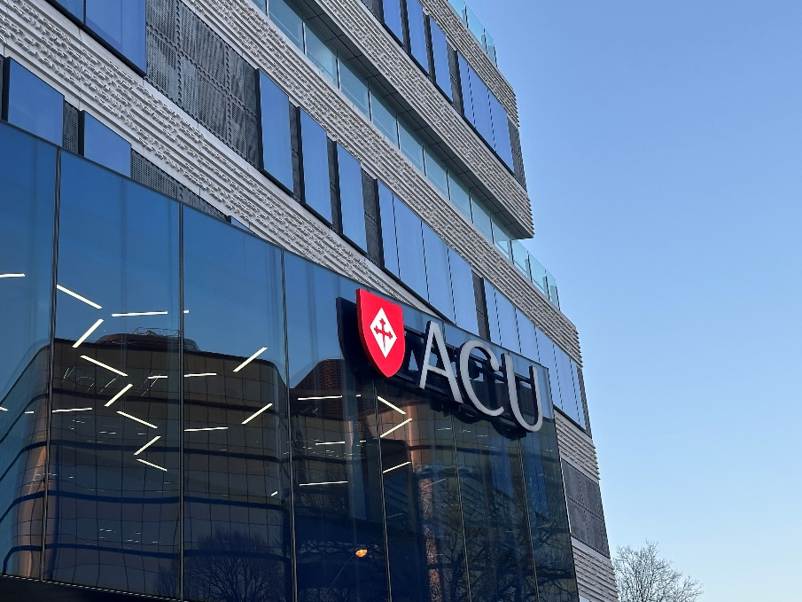
Australian Catholic University
ICET Board meeting
Board meeting
The day before the conference was, as is traditional, taken up by the annual ICET Board meeting with for the first time more people attending virtually than face to face (with a unique experience of the virtual delegates being for a while able to communicate with one another while those attending in person were excluded). Many different times zones were represented, with it being 2am for those attending remotely from the UK. The meeting also clashed with the England - Mexico World Cup match, although regular updates about this were received.
The meeting itself covered a range of important issues, including the frequency of future World Assemblies (where it was agreed to stick with two yearly events, with interim activities to maintain momentum), board committees and representation on the ICET Executive and the role of regional vice presidents. I was very pleased to note that I have been approved for emeritus board status going forward now that my UCET representative role has come to an end.
Conference
The conference proper began with a traditional aboriginal smoking ceremony in which delegates walked through the smoke from burning eucalyptus leaves following a tribute to the owners of the ancestral lands on which the event was taking place (a mark of respect that was repeated at the beginning of each day’s activities).
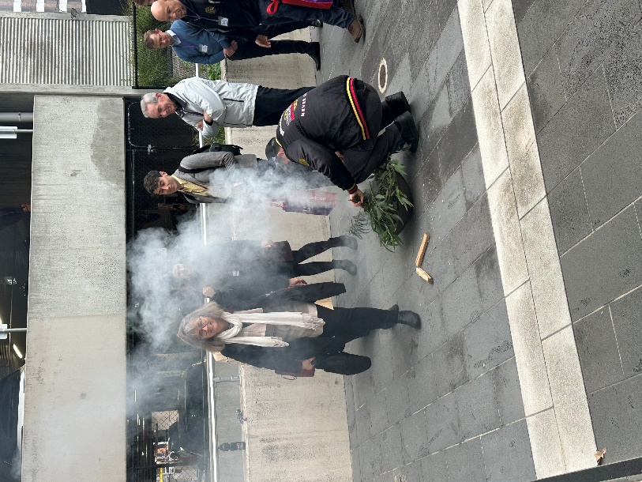
Traditional smoking ceremony
The conference, like the Board meeting, was a hybrid of in person and remote delegates and contributors. Following welcomes from ICET President and CEO Carol Gentles, Chair Joseph Divela and Larrisa Maclean Davies from ACU, the opening keynote was delivered by ACU Pro Vice Chancellor (Indigenous) Kelley Humphreys, who spoke convincingly about teachers, educators and researchers from indigenous communities working in an education system that has not been designed, developed or evolved to meet their needs or draw upon their experiences and contexts. The presentation was titled 'reclaiming the teaching profession: weaving baskets for education and justice' and used an analogy of her family members weaving baskets and, in doing so, identifying areas of the emerging basket that needed adapting to make them fit for purpose and to meet required needs. The education system in Australia had not, she argued, been woven with the needs, history and interests of indigenous people in mind and so was not, from their perspective, fit for purpose.
In 1979, there were just 72 teachers from aboriginal communities when a representative number would have been about 2,000, while today only 1.3-2% of teachers are aboriginal compared to 6% of students. The knowledge and experiences of aboriginal communities are often excluded from educational curricula, while histories and theories from outside Australia are included. More research and policy should be carried out and developed from the perspectives of the dispossessed. In short, we need to change the way in which the baskets are weaved. Further examples given related to giving the few indigenous teachers in education settings specific responsibilities for addressing 'equalities' issues rather than designing (or weaving) the system so that it already meets everyone's needs. Suggestions as to how we might weave differently included: co-design of teacher education (which is more than about just consulting indigenous communities); reframing 'equity' as 'responsibility'; recognising and resourcing the need to address 'colonial load'.

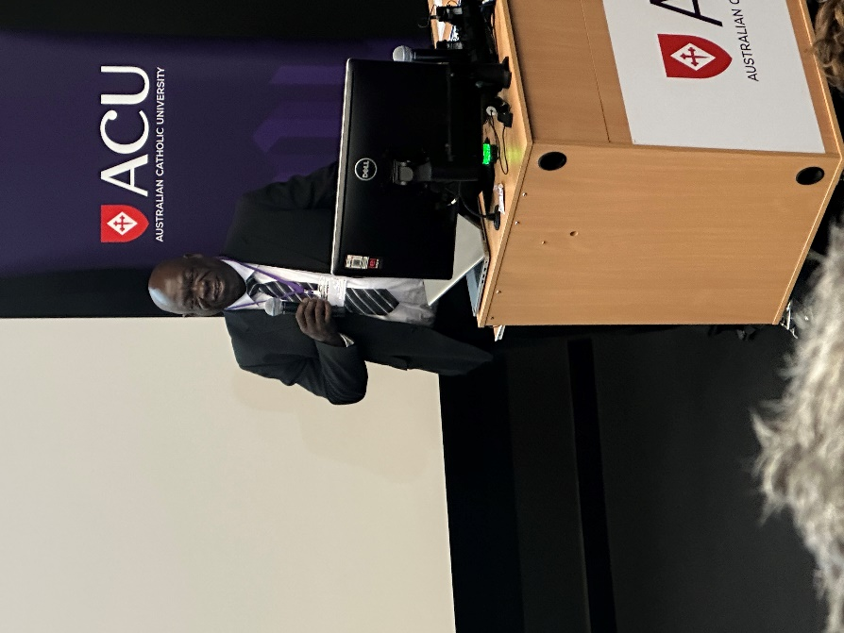
Jospeh Divela welcomes delegates
The second keynote was delivered remotely by ICET Board member Maria Assuncao Flores from the University of Braga in Portugal (the venue for the previous World Assembly in 2024) and was on 'Teacher Shortages, Teacher Education and the role of teacher educators'. The world is currently facing a 'polyunsius' of overlapping challenges relating to, for example, migration, conflict, AI & digitalisation and climate change. These all add to pressures on the teaching profession and on teacher education. The shortage of teachers is a global problem, with some 44 million extra teachers needed to meet the global needs identified by UNESCO. The reasons for teacher shortages are well known and consistent, and include low pay, workload, lack of professionalism, pupil behaviour, over regulation and accountability. The measures being taken by governments to address the shortages also follow a common theme: lowering entry requirements; increasing PTRs; the payment of bursaries & financial incentives; ITE reforms; use of unqualified staff; using teachers to teach subjects outside their areas of expertise; development of flexible ITE programmes; encouraging returners to the profession & career changers; and utilising teachers as technicians rather than as professionals. These measures tend, at best, to have only limited success (in regards to career changers for example, schools are simply not structured to meet their need for flexible working). In Portugal, specific measures include: more time in ITE for supervised teaching practice, up to at least 8 hours per week; replacing practicum requirements for those with some prior teaching experience with a report on that experience; paying mentors or reducing their teaching loads; and reducing the general education component of ITE programmes. Teacher education is, mostly in a top-down way, being reformed across the world, and is seen as a problem that needs to be fixed. Teacher educators have a limited role in policy design and are often only allowed to comment in a reactive way. Time pressures prevent meaningful consultation. Policies are driven by a mixture of economic and political agendas rather than the actual needs of teacher education. We should instead, she argued, move beyond short term and emergency responses and take real account of the views and expertise of teacher educators themselves. Greater investment should also be made in the development of teacher educators. A final quote, from Novoa in 2017, was used to conclude the session: 'there is no good teacher education if the teaching profession is fragile, weak. But there is no strong teaching profession either if teacher education is undervalued and reduced only to the mastery of subject knowledge or pedagogical techniques’.
Glenn Savage from the University of Melbourne opened the second day's proceedings with a powerful and convincing keynote entitled 'Learning with the profession, designing a new logic of system reform' in which he criticised the top-down imposition of education reforms based on uncontextualized research that seeks to identify 'what works' in education. He pointed to what he said was a global paradox in education, where despite record levels of investment in schools and in education research, results globally are either in decline or stagnating and gaps between higher and lower achievers are increasing. At the same time, teacher wellbeing is getting worse and trust between the profession and governments is limited. The story he wanted to tell was not of neglect but of saturation. Education is not neglected by government, but instead subject to unprecedented levels of governance and control, with accountability and performance management at the centre of improvement measures. It is clear that governments do care about education and want it to improve. But is the way that they show they care appropriate, given that it does not appear to result in any meaningful or lasting improvement?
The real crisis faced by education, he argued, is a 'system learning' one. It is education systems that are failing to learn and to adapt to an ever-changing world. The type of reforms being implemented by government are based on those that might have been shown to sometimes work in the past and, even then, only in particular circumstances. Scaling up the findings of particular pieces of research and applying them uniformly across whole sectors is not the way to secure real system change. It can't be assumed that problems can be solved through implementation and delivery alone. We need instead to develop systems of change that work with, rather than on, the profession. Modes of delivery are forced to align with pre-packaged 'solutions' which are not contextualised and which do not allow for professionals to use their own judgement, to exercise agency or to contextualise and prioritise research findings to reflect their own needs and circumstances, or to develop their own innovative solutions. We should instead build the capacity that will allow systems to develop and evolve as they learn in a pragmatic and contextualised way. Those who are living the problems that are being addressed must be involved in the decision-making process. The question should not be 'what works?', but 'what might work here?'. Context matters, and educators should not merely be there to apply other people's solutions. Professional learning works when it generates knowledge, and not simply when it transfers it. Applying 'what works' solutions across the board was described as 'shallow scaling', while spreading the capacity to learn and develop was categorised as 'deep scaling'.
Darryl Higgins from ACU talked about child protection and safety issues from his perspective as Head of the Institute of Child Protection Strategies and as an advisor to government and others. Shockingly, he reported that 62% of children in Australia (based on survey findings from a large and representative base) have been subject to at least one form of abuse, including sexual abuse, neglect, emotional abuse, physical assault and exposure to domestic violence, with 40% being subject to more than one, and exposure to domestic violence being the most common and often an indicator of other forms. Victims of abuse frequently go on to suffer from psychological problems and alcohol and drug abuse. The suffering is often self-perpetuating, with the abused later becoming abusers themselves. Negative experiences in school, such as lack of connectedness and negative environments have been shown to have an impact, which suggests that schools can be changed to help address the issues. Whole school approaches to child protection are needed. These might include: more education of children and young adults about heathy sexuality; training for adults in identifying abuse; prevention education for children; parental education; implementation of child safe or processes within institutions; public education; and the treatment of perpetrators.
Suzanne Choo, from the National Institute of Education at Nanyang Technical College in Singapore closed day 2 with a thought provoking, and challenging, keynote called 'Ethics and spirituality in an age of AI: implications for teacher education'. The increased use of AI in education does, she argued, have some clear strengths, for example giving students access to the kind of personalised learning support that would otherwise be outside their financial reach, as well as the provision of tailored counselling support. Some schools, she reported, are now relying on AI exclusively for the provision of subject knowledge, with teachers only interacting directly with students for pastoral-related activities. She argued however that the use of AI in education was problematic for a number of reasons: a diminishing role for teachers; increased individualised support for students tailored to their particular interests and contexts leading, in effect, to a crude form of child-centred education that undermines the transmission and reinforcement of universal, non-personalised, values; and an underpinning economic rationale geared towards standardised support aimed at securing limited outcomes relating to, for example, securing entry to university and little or nothing else, meaning that the personalised support given by AI is, in effect, reductionist.
The actual role of education should, however, be to develop rounded individuals able to flourish in relational and moral ways. AI has no moral compass or feelings, and the 'personhood' of both teachers and students need to be reclaimed. If the role of a teacher is replaced with AI, the very soul of teaching will be lost. The philosophies of a number of Asian thinkers (selected because we were in Asia, western thinkers could also have been cited) including Confucius and Louzi, were brought in to support her arguments. The notion of 'personhood' was, she said, common to many different philosophies, with 'ethical personhood' helping us to understand how we, as individuals, should live in this world, in an inquiry-oriented way that helps us decide what we ought to do from a moral perspective. The notion that no one exists just for themselves is one shared by many philosophers, religions and belief systems, with a common thread that we should strive to extend this beyond our immediate family and social circles to people on the periphery of our lives, and then beyond that to all people and, indeed, the universe as a whole. The individualised support offered by AI cannot provide this. We have, or should have, a connectedness to other people and to the wider universe and, in some belief systems, to God). This is where spirituality comes in. The pedagogy of the ethical and spiritual teacher differs from AI because: it goes beyond the attainment metrics associated with purely personalised learning; it can disrupt and interrupt the closed world of the individual, while AI reaffirms the ego of the individual; spitituality can support a return to holistic education that can, for example, move beyond STEM to STEAM (which includes additionally the arts and environmental understanding). AI can help to develop knowledge and understanding in some of these areas, but not others, which will continue to rely on teacher input. Reference was made to Maslow's Hierarchy of Needs where, she claimed that shortly before his death he planned to add a 6th level which went beyond self-actualisation to making a contribution and meeting needs that extend further than the self. How AI is used in education must be driven by teachers and teacher educators rather than by the tech companies, AI can be used as a tool to complement what teachers do. What we need is a form of education that is ‘person-centred, teacher-led and AI supported’.
The AI theme was continued in the final keynote of the conference from ACU's Suzy Edwards which was entitled 'AI for and in early childhood education and care: towards professional judgement for teachers'. The terms AI 'for' education and AI 'in' educations were distinct but in practice often used interchangeably. The former relates to when AI is used as an educational tool (for example in preparing lesson plans or supporting assessment) while the latter relates to the understanding, recognition and interpretation of how AI can be used in respect of early childhood education and the impact it can have. The distinction between the two is, she suggested, under-theorised. The use of AI for education can lead implicitly to technological determinism, while critical constructivism relates to the values of those designing AI tools inevitably being reflected in those tools. Education professionals and others have often in the past reacted with concern to the introduction of new technology, for example when it was feared that IPADs would turn children into passive dummies, when instead their use was determined by teachers themselves and led to, amongst other things, the development of digital play. The same is likely to be true of AI, where teachers should be able to develop AI pedagogies and AI literacies.
Professor Edwards and her colleagues have secured funding to look into AI literacies and pedagogies for early years education. Although in its early stages, it is intended to collect data on the current practices of children, families and teachers and share that with experts, engage with national stakeholders and draft a statement on the use of AI for the early years. The second part of the keynote covered the 'towards professional judgement in AI' component. Technology such as AI is not value-neutral, and its use can be either helpful or destructive, depending on how the underpinning tools have been constructed and how they are used. AI does not in itself generate new knowledge. Instead, it farms what is already available, which will reflect certain values and assumptions. Teachers will still need to exercise professional judgment when using AI generated material and may in fact have to use even more professional judgement in order to interpret and apply the extra amount of information sourced through AI. Student teachers and qualified teachers must be able to understand and to teach AI literacies, and how student teachers and teachers use their professional judgement in this regard will need to be assessed.
In addition to the keynotes and other plenary events, there were a multitude of workshops and paper presentations, delivered both remotely and face to face. Details of these will be available in the formal conference report when it is published, although those on teacher voice, and the global deans meeting, are worthy of particular note. There was also a formal conference dinner on the penultimate evening, involving much merriment and dancing. This also included the awarding of some prestige honours, the most significant of which was the Darrell Bloom Service Award, which was given to myself for an outstanding contribution to partnerships in international teacher education, an honour for which I am very grateful.

JNR
June 2026



