Welcome to the Open University in Wales

The OU ITE Partnership are pleased to welcome you to the Open University in Wales. Croeso cynnes!

This welcome pack is designed to provide you with key information to support activities during your visit. If you have any questions or require assistance , please don’t hesitate to contact Wales-PGCE@open.ac.uk

Key Information

Location: The Open University in Wales, Cardiff, CF10 1AP
Meeting Room:
Catering: Yes, refreshments throughout the day and buffet.
WI-FI: You will need to log in to the Cloud. For further details, please refer to the Wi-Fi section of this handbook.
Contact Details: wales-pgce@open.ac.uk

Where are we?
The Open University in Wales office is in the heart of Cardiff’s vibrant City Centre. We are located on Custom House Street, opposite John Lewis and the Marriot hotel. Being in the city centre means that we are very accessible as we are only a 5-minute walk away from Cardiff Central train station, and there are many bus routes into Cardiff city centre that lead to our office.
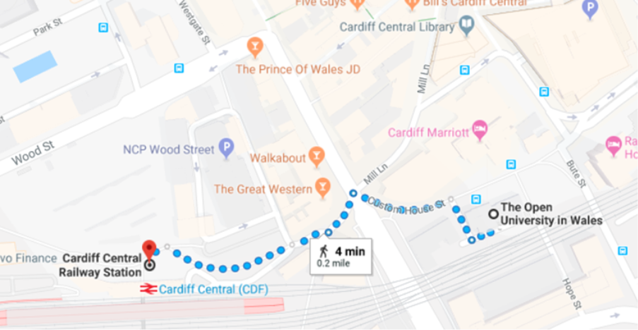

View on map
Parking
We recommend the nearby parking options available close to the St David’s Centre: St Davids Centre parking (ncp.co.uk)
Arrival
On arrival, please sign in at the main reception. A colleague will be available to show you to your meeting and working spaces.

General Facilities

Meeting Rooms
The OUiW is mostly a collaborative meeting and working space and is not generally used for teaching. There are small, private meeting pods (ideal for online meetings or interviews) on the ground floor. Main meeting rooms with facilities for hybrid meetings (for up to approx. 20) are located on the first floor accessed via a lift or the main central staircase. There are toilets available in the stairwell lobby of the first floor. A kitchen with access to hot drink facilities and a fridge is also located on the first floor.

Using your Personal Devices
You can access the wi-fi via the guest Cloud. You will need to register for an account on your first use. Alternatively, you can access Eduroam. Main meeting rooms have sockets located on the floor throughout, and also have large monitor screens for presentations, as well as devices for hybrid meetings to be hosted.

Refreshments
Light refreshments including tea, coffee and water will be available. A buffet lunch will also be provided during your visit. Please notify Wales-PGCE@open.ac.uk of any dietary requirements you may have.

