Notes on proposed QTS descriptors for meeting with Mick and Liz, 16/2/26

Rationale

As previously mentioned, we need a bespoke set of QTS descriptors as the proposed descriptors for Professional Standards do not meet the needs of the ITE sector. For example:
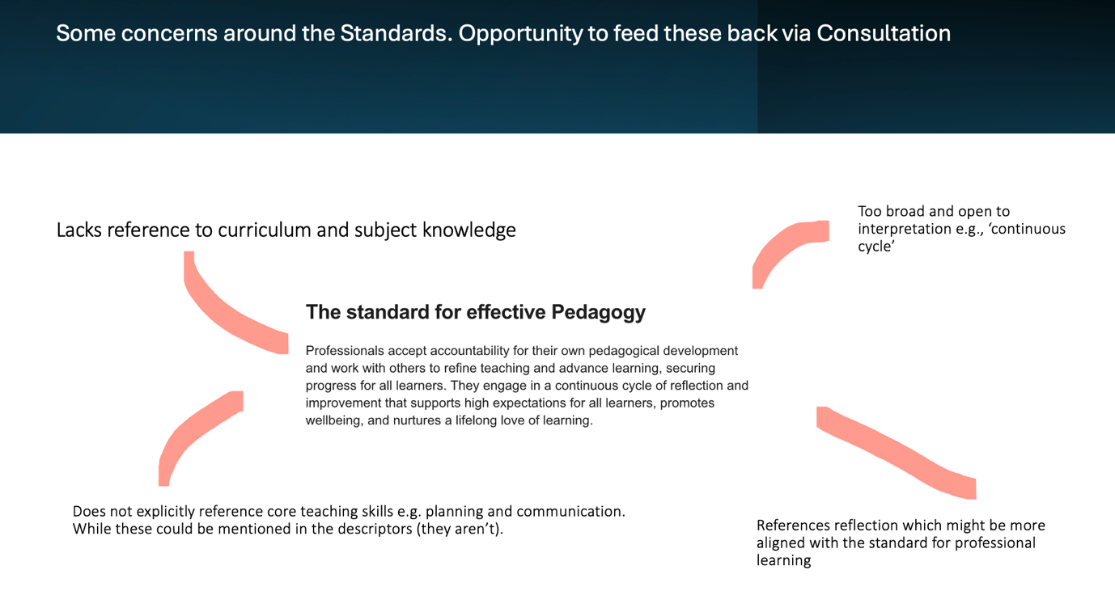

Design principles

- Concise
- Clear
- Realistic for student teachers
- Observable
- Links where possible to Professional Standards
- Retains strengths of existing QTS Standards

Sources

- Review of USCET Cymru member and Consortia comments (via Padlet and other sources)
- Existing QTS Standards for Wales – Appendix 1 maps alignment
- Proposed Professional Standards for Assistant Teachers, Teachers and Leaders – Appendix 2 maps alignment and gaps
- Research exploring QTs Standards in other countries

Format

Numbering is only for convenience, and the proposal is to develop guidance around the Standards once these descriptors have been finalised.

Professional Commitments
Student teachers demonstrate high professional standards during their programmes by…
1.1 Following their respective school and partnership policies, including safeguarding
1.2 Adhering to the EWC Code of Conduct
1.3 Demonstrating the professional commitments set out in the Professional Standards

1. Effective Pedagogy
Student teachers apply their professional knowledge to plan and teach engaging lessons. They create safe, respectful and supportive environments, meet diverse needs, assess learning well, and use resources responsibly.

To achieve QTS, student teachers should…
1.1 Apply secure subject/phase knowledge and Curriculum for Wales guidance
1.2 Plan lessons with clear learning intentions and assessment opportunities that support progression
1.3 Design learning that fosters inquiry, creativity, problem-solving, and metacognition in authentic contexts
1.4 Apply evidence-based teaching approaches to support effective learning
1.5 Create and maintain a safe, supportive, and stimulating learning environment
1.6 Communicate effectively using a range of strategies including active listening, thoughtful questioning and clear explanations
1.7 Develop learners’ literacy, numeracy, digital and Welsh language skills
1.8 Promote positive behaviour through clear expectations, consistent routines and respectful relationships
1.9 Recognise and respond effectively to learners’ diverse needs
1.10 Assess learning accurately, give helpful feedback, and involve learners in their assessment
1.11 Use resource responsibly, ethically and sustainably

2. Collaboration
Student teachers work constructively with others, particularly mentors, to strengthen teaching and support learners. They contribute positively to shared tasks and make good use of professional expertise.
To achieve QTS, student teachers should…
2.1 Seek advice and support from a range of sources, including specialists when needed
2.2 Engage in professional dialogue with mentors and others to strengthen their own teaching
2.3 Collaborate with peers on projects, assignments or group tasks for mutual benefit
2.4 Share key information with colleagues, tutors and parents/carers promptly and professionally

3. Professional Learning
Student teachers engage actively with professional dialogue, theory, and research to deepen their understanding of pedagogy. They reflect critically on practice and apply insights from learning and evidence to improve their effectiveness.
To achieve QTS, student teachers should…
3.1 Understand how small-scale enquiries can inform and shape practice
3.2 Critically reflect on teaching using evidence from multiple sources, to support professional growth
3.3 Apply insights from theory, wider reading and classroom observations to develop practice

4. Innovation
Student teachers explore new ideas to enhance learning and reflect on their impact.
To achieve QTS, student teachers should…
4.1 Take responsible risks by trying new ideas or strategies, evaluating their impact and sharing outcomes
4.2 Make judicious use of digital tools, including generative AI where relevant, to support practice

5. Leadership
Student teachers manage their workload and wellbeing, seek support when needed. They show emerging leadership in the classroom, school and wider context.
To achieve QTS, student teachers should…
5.1 Demonstrate self-leadership by managing their workload and wellbeing, seeking support when needed, and taking initiative to develop their practice
5.2 Create opportunities for learners to develop leadership skills in appropriate contexts
5.3 Show corporate responsibility by contributing towards or leading events, clubs or activities at school, community or programme level

Appendix 1– Mapping against existing QTS Standards (WG, 2024)

Legend: ✅ Covered | ◐ Partially covered / implicit | ⛔ Not yet explicit

1) Pedagogy — Refining teaching
WG element | Coverage | Note
Managing the learning environment [ | ✅ | Safe, supportive climate + behaviour routines well covered.
Assessment | ✅ | Accurate assessment + feedback + AfL included.
Differentiation | ✅ | Clear on adaptive teaching.
Recording & reporting | ⛔ | Add concise line on accurate recording/reporting of attainment/progress.
Involving partners in learning | ◐ | Present but placed under Collaboration; acceptable, but consider a short cross-reference in Pedagogy.

2) Pedagogy — Advancing learning
WG element | Coverage | Note
Four purposes for learners (CfW) | ◐ | Implicit via CfW/ambitious learning; consider naming Four Purposes explicitly.
Exploiting subject disciplines in Areas of Learning | ◐ | Could state AoLE disciplinary understanding explicitly.
Blended learning experiences | ⛔ | Add a short line on in-person/online/blended pedagogy.
Real-life, authentic contexts | ⛔ | Add authentic contexts / community links.
Progression in learning | ◐ | You imply sequencing; consider naming progression explicitly.
Cross-curricular skills/themes | ✅ | Literacy, numeracy, digital, Welsh for learners are explicit.

3) Pedagogy — Influencing learners
WG element | Coverage | Note
Challenge and expectations | ◐ | Implicit; consider explicit wording on high expectations & challenge.
Listening to learners | ✅ | Active listening explicitly included.
Learners leading the learning | ◐ | “Learner voice/contribution” is there; make learner agency/lead clearer.
Sustained effort & resilience | ⛔ | Add a short clause on developing perseverance/resilience.
Reflection on learning | ✅ | AfL/self-review present.
Learning outcomes & well-being | ◐ | Classroom well-being (envt.) and teacher well-being covered; consider pupil well-being linked to outcomes explicitly.

4) Collaboration
WG element | Coverage | Note
Seeking advice & support | ✅ | Clear.
Working with in-school colleagues | ✅ | Clear.
Supporting & developing others | ◐ | Consider adding a line about peer support/coaching at trainee level.
Enabling improvements | ◐ | Could be made explicit (e.g., contributing to department/school improvement).

5) Professional Learning
WG element | Coverage | Note
Wider reading & research outlooks | ✅ | Strong.
Professional networks & communities | ◐ | Consider naming networks/PLCs/PLP explicitly
Continuing professional learning | ✅ | Strong.
Welsh language skills (self) | ◐ | Add line on personal Welsh language development in PL.

6) Innovation
WG element | Coverage | Note
Offering expertise | ◐ | Reasonable for trainees to begin sharing developing expertise; make explicit.
Developing new techniques | ✅ | Responsible innovation + AI.
Evaluating the impact of changes | ✅ | Present.

7) Leadership
WG element | Coverage | Note
Taking responsibility for self | ✅ | Self-leadership (workload & wellbeing).
Exercising corporate responsibility | ◐ | Consider adding explicit reference to whole-school responsibility/ethos.
Leading colleagues, projects & programmes [d | ◐ | Intent is there; a touch more specificity would help.
Supporting formal leadership roles | ⛔ | Add line on supporting class/subject leaders (e.g., taking on delegated tasks).

Appendix 2: Mapping against Proposed Standards for Teaching and Leadership

Draft QTS Descriptor | Mapped Revised Professional Standards (exact descriptor titles)
1.1 Apply secure subject/phase knowledge and Curriculum for Wales guidance | Understanding the 3–19 continuum and implications for pedagogy — planning informed by prior approaches and learner development.
1.2 Plan lessons with clear intentions and assessment to support progression | Progression in learning — designing learning experiences and planning for intended outcomes.
1.3 Design learning fostering inquiry, creativity, problem-solving, metacognition | Embedding curriculum in purposeful authentic contexts — experiences that support CfW realisation.
1.4 Apply evidence-based teaching | System leadership prompt: adopting evidence-informed approaches; and Pedagogy standard: accountability for refining teaching.
1.5 Create a safe, supportive and stimulating environment | Varying teaching approaches to suit learners’ needs — inclusive, appropriate approaches that support participation.
1.6 Communicate effectively: listening, questioning, explanation | Varying teaching approaches — engaging learners and enabling them to take an active role.
1.7 Develop literacy, numeracy, digital and Welsh language skills | Professional commitments: literacy, numeracy and digital competence; Welsh language section.
1.8 Promote positive behaviour through expectations and routines | Varying approaches to suit needs — supporting engagement and participation.
1.9 Recognise and respond to diverse needs | Understanding how learners develop — addressing developmental differences and removing barriers.
1.10 Assess learning accurately, give feedback, involve learners | Progression in learning — designing and adapting experiences based on developmental needs.
1.11 Use resources responsibly, ethically and sustainably | Professional commitments: community and collective effort and ethical responsibility.

2. COLLABORATION
Draft QTS Descriptor | Mapped Revised Professional Standards
2.1 Seek advice and support from varied sources | Collaboration standard — strengthening practice by working with colleagues and partners.
2.2 Engage in dialogue with mentors/others to strengthen teaching | Collaboration standard — climate of trust, mutual support and collective thinking.
2.3 Collaborate with peers on tasks and projects | Professional Learning standard — purposeful opportunities for conversation and enquiry across learning communities.
2.4 Share information professionally with colleagues and parents/carers | Context and wider community — using contextual knowledge and engaging relevant partners.

3. PROFESSIONAL LEARNING
Draft QTS Descriptor | Mapped Revised Professional Standards
3.1 Understand how small-scale enquiries inform practice | Professional Learning standard — rigorous enquiry to foster collective growth.
3.2 Critically reflect using multiple evidence sources | Professional Learning standard — continuous improvement through reflection.
3.3 Apply insights from theory, reading, observations | Professional Learning standard — deepening knowledge and integrating new understanding into pedagogy.

4. INNOVATION
Draft QTS Descriptor | Mapped Revised Professional Standards
4.1 Take responsible risks, evaluate impact and share outcomes | Innovation standard — controlled, measured development of improved techniques; evaluation of changes.
4.2 Use digital tools, including generative AI, ethically | Innovation standard — developing improved techniques and approaches; climate for innovation.

5. LEADERSHIP
Draft QTS Descriptor | Mapped Revised Professional Standards
5.1 Demonstrate self-leadership: workload, wellbeing, initiative | Leadership standard — taking responsibility for self and displaying positive regard for others.
5.2 Create opportunities for learners to develop leadership | Pedagogy: Varying teaching approaches — enabling learners to take active roles and shape experiences.
5.3 Show corporate responsibility through contribution to school/community | Leadership standard — leading colleagues and contributing to educational ambitions; Community and collective effort commitment.

Promoting the national vision for education in Wales; supporting the Welsh language; the central importance of literacy, numeracy and digital competence; recognising the importance of community and collective effort; demonstrating professional integrity and ethical responsibility; and aiming to become the best version of their professional self.

