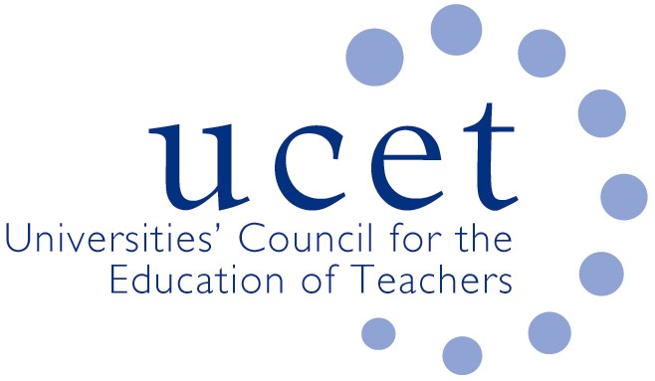

Promoting Quality in Teacher Education

Note of the UCET Research and International Forum meeting held on 7 October 2025 via Zoom

Symposium discussion

REF 2029 Education sub-panel Chair Dominic Wyse was welcomed by Linda Devlin, who chaired the meeting. Much in relation to REF 2029 had yet to be decided, and all public information can be found on the REF website. The recruitment of chairs and panel/sub-panel members had, for the first time, been an open process with individuals applying directly. The process had been robust, fair and transparent. One of the first tasks in the process will be to set the criteria by which submissions will be assessed. Any changes from REF exercise to REF exercise tended to be incremental and no great surprises for 2029 were expected. The sub-panels will develop a robust peer-review based process to consider submissions. In answer to a question, it was explained that there were no plans to change the existing census date.

Submissions to the education sub-panel are likely to be wide ranging, as ‘education’ covers a broader range than some other sub-panel subject areas. Because of this it was felt by some that teacher education research might have lower profile than other education submissions. The nature of some teacher education research also means that it is important that the focus of sub-panel judgements be on the quality of outputs and not on the methodologies used to carry out the research. It was stressed that the panel will not have any preference for any particular approaches.

The type of research outputs was discussed, and it was explained that a range of outputs (for example including toolkits and videos) will be submittable, including those submitted in conjunction with more traditional outputs such a book chapters or journal articles, and that the REF had always allowed for a range of outputs to be submitted (although the range did tend to vary from UOA to UOA).

Welcome, introductions & note of previous meeting

The note of the meeting that took place on 6 May 2025 was agreed. There were no matters arising not covered elsewhere on the meeting agenda.

Topics for discussion

A number of issues were discussed, including:

- An update on the work of the UCET Equalities Group, including a report of the previous week’s meeting which focused on the impact on students of the current discourse around immigration, the demonstrations that had taken place in some areas and the ‘othering’ and problematization of people from minority backgrounds. Other issues discussed included: the development by colleagues from Reading of an anti-racism policy for teacher education; feedback on the ITE student survey and the support it is now receiving from DfE; discussions taking place with parliamentarians; and research into supporting trans-gender ITE students in the light of recent court judgements.
- Reports on international activities, including ICET work in relation to teacher voice and lessons learnt from Covid, and the forthcoming ICET World assembly in Melbourne on 6-7 July 2026.
- An update from Amy Quickfall on the ITE Research Network, which now has 165 members and for which three online reading clubs were planned, as well as a UCET funded face-to-face writing retreat for up to 25 participants. It was suggested that the network might link to work being carried out by Jean Murray supporting the research work of colleagues on teaching and scholarship employment contracts.
- The Gatsby funded systematic review of the experience of becoming a teacher in the FE sector in England led by Andy Hobson. The research found, amongst other things, that the most positive experiences of becoming a teacher related to: relationships and support from colleagues in the workplace; relations and support provided by mentors; participating and learning from ITE experiences. Negative aspects related to: demanding workloads; pressures of performativity; perceived lack of support from colleagues; and difficult relationships. Recommendations for ITE providers and employers were noted.
- Reports from individual UCET member institutions and horizon scanning, including: the negative impact of internal ICT systems on the ability of people to engage with on-line meetings and events; the increased reluctance of universities to support research activities and conference attendance (particularly if not REF related); increased pressure on people to complete doctorates to fixed timescales; limited support for post-doctoral study; and the lack of appreciation of some senior leaders of the importance of research related activities.
- Discussions about the current policy context, including: the re-accreditation of some ITE providers for 2026/27; publication of the new Ofsted ITE framework and toolkit, where a number of issues raised by UCET during the consultation had been addressed; the publication by Ofsted of its report on Thematic Monitoring Visits (TMVs), which painted a generally positive picture of ITE provision in England; DfE plans in relation to ITE in the FE & Skills sector; and developments in Wales and Northern Ireland.
- Topics for future symposia, where it was suggested that UCET travel scholarship winners might be given the opportunity to present.

UCET issues

The following UCET issues were noted:

- The programme for the 2025 UCET conference, which will take place at the Queen’s Hotel in Leeds on 11-12 November (registration open at www.ucet/conference).
- Details of the new UCET blog, the first of which will be published immediately prior to the annual conference.
- The summer 2025 UCET newsletter.

Any other business

There was no other business.

Date of next meeting

20 January 2026.

