Secondary ITT Bursary Analysis
Mark Crowley, Nottingham Trent University
Whilst the DfE have acknowledged the bursary has a role in encouraging applicants to undertake the training year, further work is needed to investigate its effectiveness in securing Early Career Teachers in the state sector. A sizeable amount of funds are given to trainees who do not progress into their ECT period and the “wastage” could be better spent on those at the start of their teaching careers.
Without more transparent data from the DfE, the effectiveness of bursaries currently suggests a significant amount of wastage. An example analysis is given below for Chemistry ITT during 2020/21.

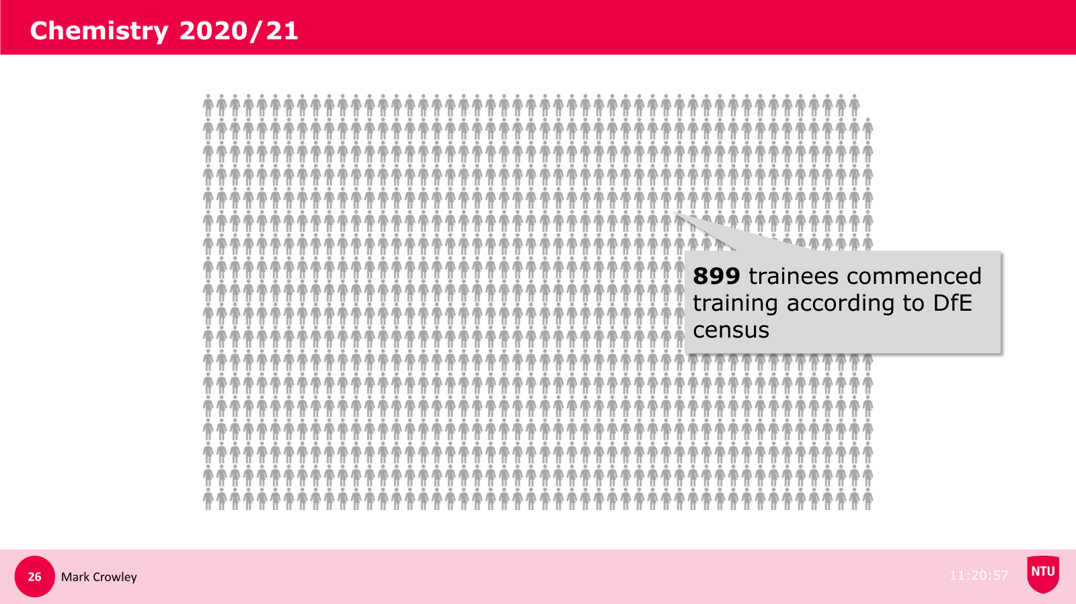
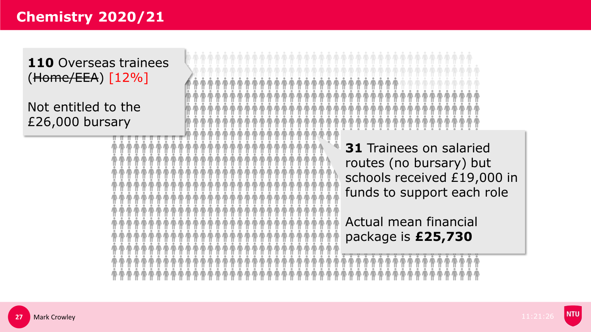

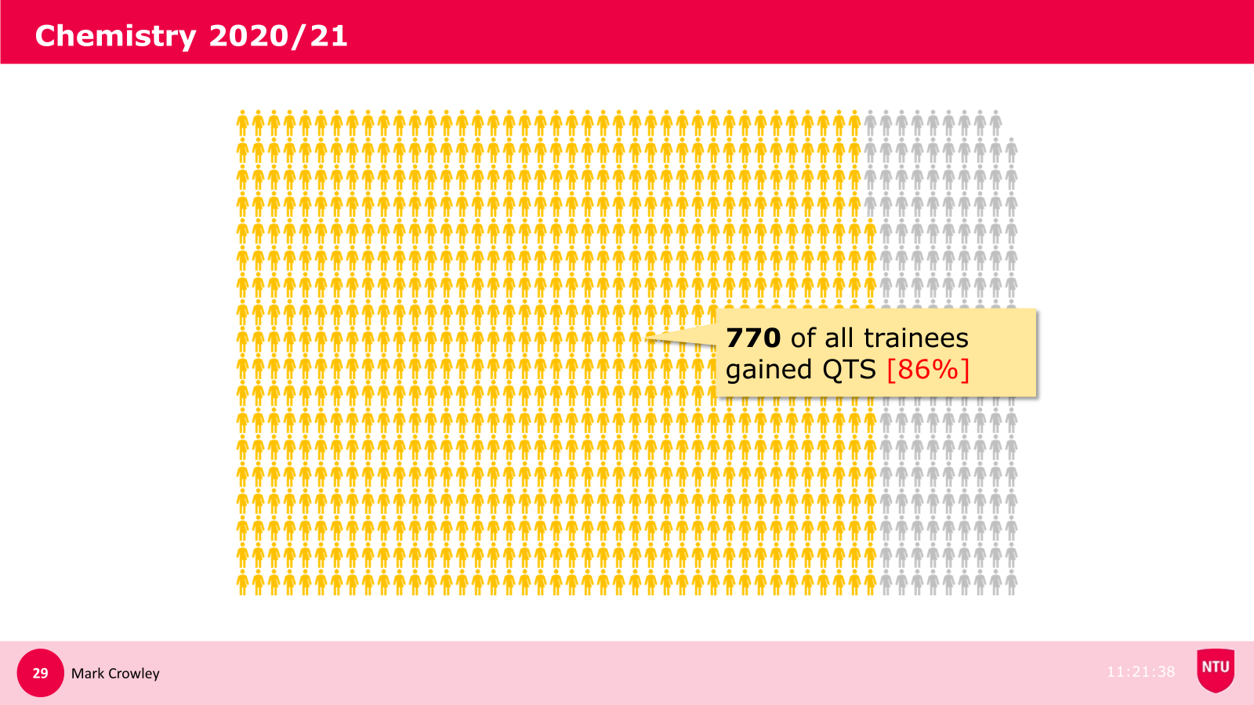
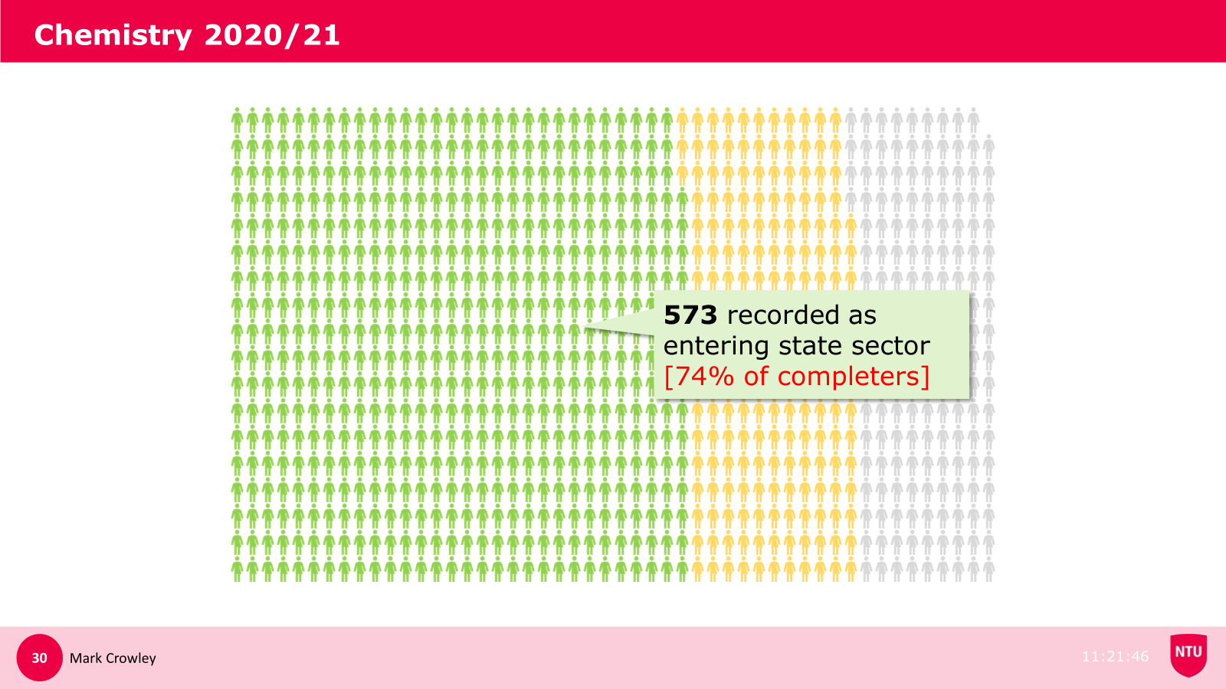
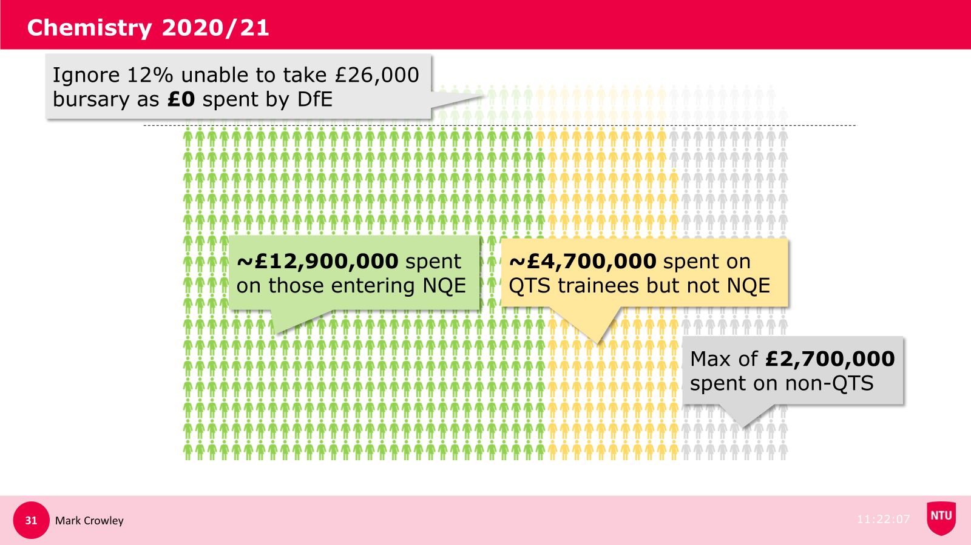

When looking at all secondary subjects, around 87,000 trainees completed their training between 2018 and 2022 in PG Secondary ITT.
Around 58,000 received a bursary at total cost of £1.1 billion but only 44,000 are recorded as entering directly in to teaching in state schools.
This suggests that approximately £250,000,000 was spent on trainees that completed their training but whom never entered state sector teaching or who have not been recorded as entering the sector yet. Over the same period 29,000 PG Secondary trainees completed their training with no bursary offered by the government with 22,000 subsequently entering teaching.
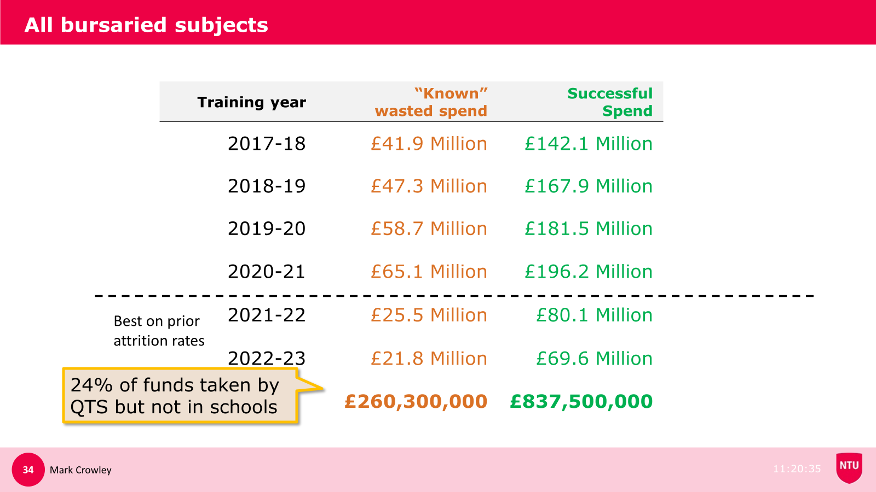
We have clear cases of bursaries being wasted on trainees not subsequently going into teaching in State Schools. For those undertaking Classics ITT, £26000 tax free bursaries were available during 2019/19. The DfE has provided the outcomes for this cohort of trainees:
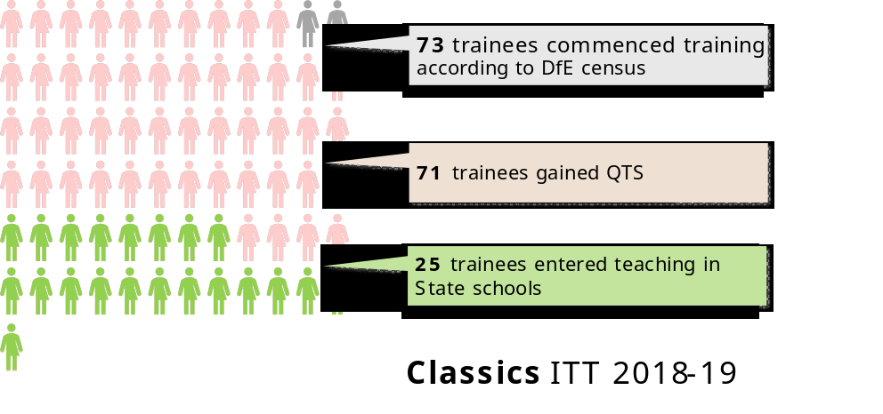
The vast majority (96%) of these trainees were UK Nationals or came from the EEA and received the standard bursary totalling at least £1.8 million for Classics. However as this only led to 25 ECTs (formerly NQTs) immediately entering the state sector, an effective cost of £72,000 per teacher can be calculated.
Understandably, there could be a risk to recruitment numbers by dropping the bursary for particular shortage subjects, but the emphasis on applicants will continue to appear misguided if those with QTS do not end up going into appropriate teaching jobs.

