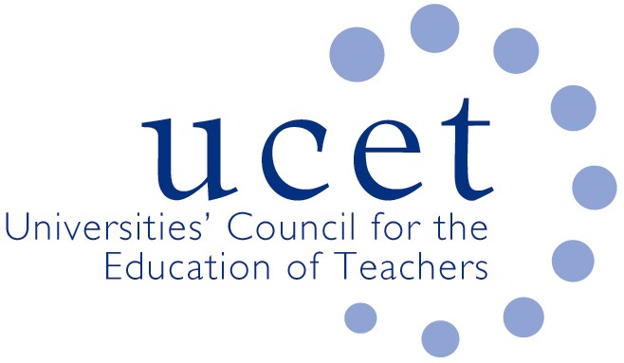
Promoting Quality in Teacher Education

ICET World Assembly and Board meeting, 12-15 June 2024, Braga, Portugal

Introduction

The 65th World Assembly of the International Council on Education for Teaching (ICET) took place at the University of Minho in the historic city of Braga in Portugal from 13-15 June, preceded by a Board meeting on 12 June at which UCET was represented by JNR, with other UK ICET Board members being Sarah Younie (the current ICET Chair); Linda La Velle and (via Zoom) Ivan Reid and Tanya Ovenden-Hope. UCET’s formal links with ICET go back to 2008 when JNR was appointed to the Board. JNR’s reports of the twelve previous World Assemblies that he attended can be found on the UCET website.

Braga is in the Northwest Portuguese district of Minho and has a population of just under 200,000. It was a provincial capital during Roman times and is host to the oldest Portuguese Archdiocese. The Roman wall is still in good condition, and the streets are full of old and attractive buildings and churches. The University, which is located on the outskirts of the city, was founded in 1973 and has some 19,000 students, 42% of whom are postgraduates.
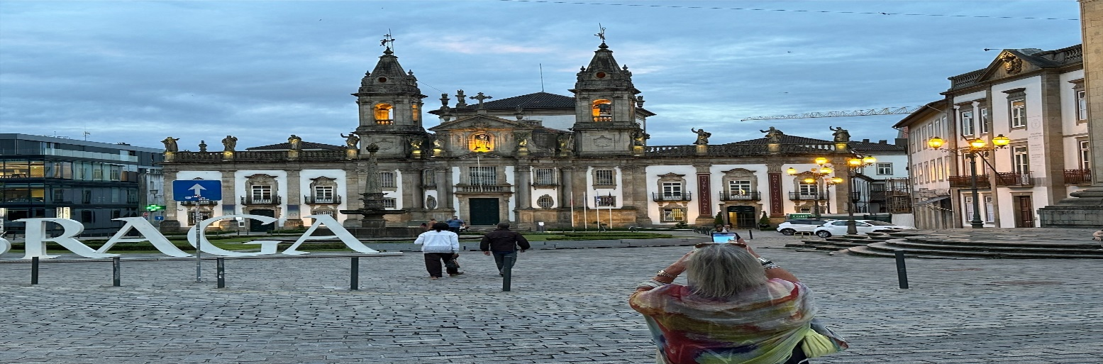
The centre of Braga

Keynotes

The opening keynote was given by Antonio Novoa from the University of Lisbon and entitled ‘Teacher Education; A third revolution’ and built on the UNESCO ‘Reinventing our Futures Together’ report. Education, he said, “must position itself ahead of the curve of change so that it can help to shape the future rather than simply react to it”. Teachers should have a transformative role in this as part of their humanistic mission. Unfortunately, however, the profession is (across the world) typified by low pay, poor moral, demoralisation and the victim of misplaced governmental policies.

There had, he argued, been two previous revolutions in teacher education: (i) the establishment of Normal schools in the mid-nineteenth century, which played a key role in the education and training of new teachers, with a strong praxis between teacher education and the actual practice of teaching. While this had its merits, it also implied a sharp distinction between schools and places of research and knowledge generation; and (ii) the replacement of Normal schools at the centre of teacher education by higher-education in the second half of the twentieth century, which had the advantage of linking teacher education to research and enhancing the professionalism of teachers. This also however caused a reaction against it with the establishment across the world of potentially harmful alternative models such as ‘Teach for America’ that were intended to address the perceived gap between what happens in school and what happens in academia.

The third revolution called for by Antonio Novoa would involve bringing together the positive attributes of the first two revolutions. This would entail: (i) the valuing of teachers’ professional knowledge (seen by him as representing a third kind of knowledge); (ii) involving teachers themselves as the leaders on ITE and teacher professional development, with a greater role than just supervising student teachers and assisting university professors; and (iii) building a new third space of a common home for universities and schools with its own rules and culture. Reference was made developments along these lines already taking place in Brazil.

The keynote was well-delivered and went down well with the audience. It was however short on specifics and, in essence, appeared to be based on a simplistic Hegelian model of synthesis emerging from conflicting world views. In terms of the presentation itself, it seemed that the model could be used to justify some of the reforms imposed on the teacher education by Governments in England and elsewhere. In response to a question about policy interventions by government, however, he said that such models should be allowed to develop free from any central interference, with HEIs and schools developing models organically in discussion with local decision-takers and authorities. In which case, one suspects that a multitude of different approaches would be developed in the absence of any agreed national frameworks, leading to inconsistency and a lack of an equity of entitlement on what pupils should be able to expect to receive from their education. Letting many flowers bloom might have its advantages, but it implies the existence of weeds as well as premium roses.

The second keynote was called ‘Enhancing the Teaching Profession through Quality Teacher Educators: addressing a need whose time has come’ and was delivered by Lin Godwin from Boston College, who identified two core issues: (i) the preparation of great teachers, the top 20% of who can be said generate 5-6 months of additional pupil learning over the course of a year; and (ii) the urgent need to educate teachers to support increasingly diverse classrooms. It is, however, difficult to address these issues because of teacher shortages. The need is so pressing that the transformation of education, rather than merely reform, is needed. Tinkering will not work. Dramatic change is needed to respond to dramatic circumstances. Is teacher education ready for this? The answer is ‘probably not’. The focus of policy makers and educators has been on teacher quality, but it should also have been on teacher-educator quality, as the former is to an extent dependent on the latter. And yet many teacher educators find themselves in their roles by pure chance, because for example the high turnover of staff (caused by low pay, morale etc.) mean that jobs are often easily available to, for example, those completing doctoral studies. Many learn how to do their jobs through trial and error, with no formal, planned and coordinated support and preparation.

Three key barriers to having a properly-educated teacher education workforce were identified. The first of these is a belief that all one needs to educate teachers is experience of being an actual teacher, leading to the replication of embedded practice and institutional conservatism. The second is a general lack of experience of preparing teachers for diverse classrooms, despite the rhetoric about prioritising issues relating to diversity and inclusion. How deep such claims made by teacher education about the centrality of diversity and inclusion is open to question (a review of research journals with a focus on teacher education showed that of 3,939 articles published, just 177 addressed issues relating to diversity and inclusion). The third barrier is using context as a reason to resist (‘that won’t work here’). Teacher education across the world, regardless of context, tends to be very similar and solutions are likely to be transferable.

Three possible directions of travel were identified: (i) treat teacher education as a legitimate profession in its own right; (ii) rather than just repeating the rhetoric, do real work in regards to diversity, and education professionals should make the effort to experience a diverse and inclusive life; and (iii) educate teachers from first-hand knowledge of diversity and by being willing to embrace new ideas. Senior HEI staff should also be educated about teacher education to stop them from only running teacher preparation as a cash-cow to subsidise other university programmes.

It was an interesting presentation, and the case for better professional development for teacher educators was compelling, although it should not of course be a top-down model imposed on the sector. The references to diversity appeared however to be shoe-horned in and the core argument could have been made without them. The use by universities of ITE as a cash-cow will come as a surprise to many in the UK where the core unit of resource has been frozen for over a decade. I am also sceptical about the extent to which there is uniformity about how teachers are educated across the globe.

Parallel sessions

There were as ever a range of parallel seminars and papers, the key ones of which I attended included: Noel Purdy from Stranmillis on teacher professionalism and morally-compassed teacher resilience; a panel discussion chaired by David Imig (former president of AACTE and good friend of UCET) on policies relating to teacher professionalism and development in Maryland, USA; Bea Noble-Rogers & Akwasi Addea-Boahene on teacher education reform in Ghana; and Christina Hanock, Alka Townend and Karen Hall from Sussex on ‘Transformative Play: Shaping the future of teacher education. 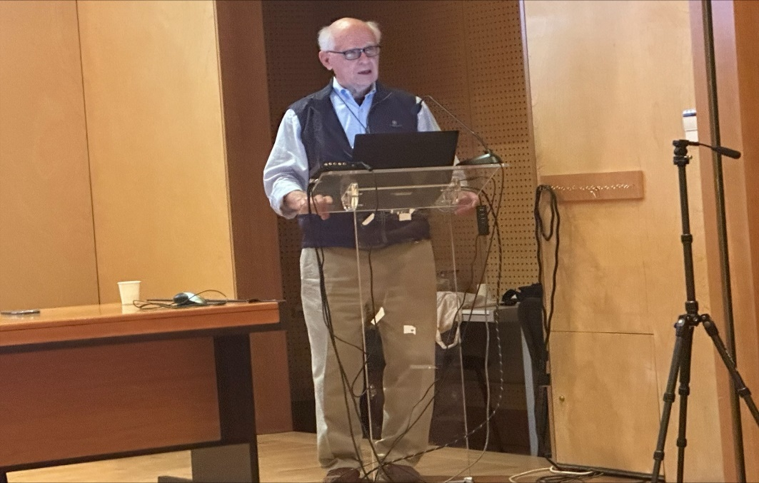
David Imig addresses the World Assembly

Cultural events

The opening ceremony was held at the Braga museum preceded by a 20 minute film about the university, (in Portuguese, with no sub-titles or translation), local wines and port and entertainment from a University guitar troop. The Gala Dinner was held at one of the conference hotels, a former palace, and included two very popular and lively musical treats, again from the university.

The gala dinner
The next face-to-face ICET World Assembly will take place in 2026 in Melbourne Australia. More information about ICET can be found at: https://icet4u.org/.

JNR, June 2024

