Teacher Professional Learning (TPL) in Northern Ireland: Consultation Booklet

Consultation on an approach to Teacher Professional Learning in Northern Ireland

“Every teacher is a learning leader, accomplished in working collaboratively with all partners in the interests of children and young people”

[Date]


Purpose

This consultation seeks views on proposals which have emerged from implementation of the Department of Education’s ‘Learning Leaders: A Strategy for Teacher Professional Learning’, specifically relating to a Teacher Professional Learning Framework (“the TPL Framework”), a Learning Leadership Lens (“the Lens”) and a draft revised set of Teacher Competences.

The Learning Leaders Strategy seeks to empower all teachers to take responsibility for their own professional learning and development. This vision is central to the elements now being consulted on.

The Learning Leaders Strategy is also central to the Department’s End-to-End Review of School Improvement, within which teacher professional learning is integral. It also aligns with the Education and Training Inspectorate’s draft Inspection Framework, within which the importance of professional learning is a priority, as one of the nine contributory areas.

The General Teaching Council for Northern Ireland (GTCNI) has responsibility for revising the Teacher Competences, incorporated as part of the Lens. The Department is consulting on the competences on GTCNI’s behalf.

Background

Teacher Professional Learning (TPL), like all professional learning, refers to the ongoing professional development within the workforce. It can take many different forms including courses, workshops, conferences, webinars, independent research, mentoring, peer learning, postgraduate and masters level studies to name a few.

As outlined in the Learning Leaders Strategy, TPL works most effectively when based on the teacher’s own understanding of their personal needs, in the context of their learners, the school and the community in which they work.

TPL and the implementation of the Learning Leaders Strategy is being considered as part of the end-to-end review of school improvement. The proposals contained within this consultation document will inform a delivery model for TPL in Northern Ireland and fulfil the first policy commitment within the Learning Leaders Strategy:

‘Teachers will have access to a coherent and career-long professional learning framework underpinned by revised teacher competences and built on established best practice and collaboration at all stages.’

Consultation

This consultation will run for xx weeks from xx to xx.

Copies in other languages and formats (including Braille, large print etc), can be made available on request. If you require the document in an alternative format, or language other than English, please contact us at LearningLeadersNI@education-ni.gov.uk or at the address below.

The best way to respond to this consultation is online using this link [DN: Link to be inserted]:

Completed hard copy responses can be sent to:

Teacher Education and Professional Learning
Department of Education
Room G11, Rathgael House
43 Balloo Road
Bangor
County Down
BT19 7PR

E-mail responses can be sent to LearningLeadersNI@education-ni.gov.uk.

The closing date for the consultation is xx and we look forward to receiving your response.

About you

Please tick the box that best describes you:

Pupil |  | Member of the Public
School Leader |  | Parent / Carer
Education Body |  | Teacher
School Governor |  | Trade Union Rep
Other
If Other, please specify:
Name (optional):
Name of School (if applicable / optional):

The Department may make responses available in summary form on its website (www.education-ni.gov.uk), although contact names and addresses would be removed.

Please note that under the Freedom of Information Act 2000, your response may be made available, on request, to the public.

If you would prefer your response to remain confidential, please tick this box.

Completing this Booklet

This consultation contains a number of statements. You are asked to indicate if you agree, disagree, or neither agree nor disagree with the statements. There are three sections and eight statements to consider. There is an opportunity at the end of each statement to provide additional comments.
SECTION A: Overarching Framework of Guiding Principles that Underpin Teacher Professional Learning

- As confirmed by the Organisation for Economic Co-operation and Development (OECD), ‘there is a growing recognition that supporting teachers’ professional learning from the beginning to the end of their career is critical to improve student outcomes….This enables them to develop the knowledge, skills and practices necessary to be effective educators, support their peers, contribute to the collective improvement of the profession and gain the trust, status and self-efficacy to carry out their work with a high degree of professionalism.’

- TPL is therefore an entitlement, a professional obligation and a personal commitment to continuous improvement, with critical self-evaluation, an essential element.

- Building on the foundations developed in initial teacher education, continued professionalism depends upon teachers routinely reflecting on their practice, individually and collaboratively and identifying opportunities for improvement throughout their careers.

- The draft Teacher Professional Learning Framework, building on the concepts in the Learning Leaders Strategy, was developed by the Universities’ Council for the Education of Teachers Northern Ireland Committee (UCETNI) on behalf of the Department.

- The framework sets out:

- a structured and informed approach to career long TPL, combining initial teacher education (ITE), early and continuous professional learning in a coherent and streamlined process;

- close collaboration between practitioners, schools and support providers as an essential element of TPL; and

- clear linkages to the school development plan, reflecting the current priorities, unique context and circumstances of each individual school.

- As outlined below, the framework is built on three key principles to guide teachers in their ongoing professional development:

- Choice – teachers have access to a programme of TPL throughout their career which balances their personal choices with the wider needs of the school. This will give educators the freedom to make decisions about their learning, including the medium through which it is delivered.

- Continuity – TPL is a continuous journey, the foundations of which are established in ITE and continues throughout their entire career.

- Collaboration – collaborative TPL enables educators to work together, sharing their knowledge, experience and relevant research. This can take place between teachers, schools, clusters, area learning communities and beyond.

- Within each of the principles, relevant examples of TPL have been included (as shown in the illustration below).

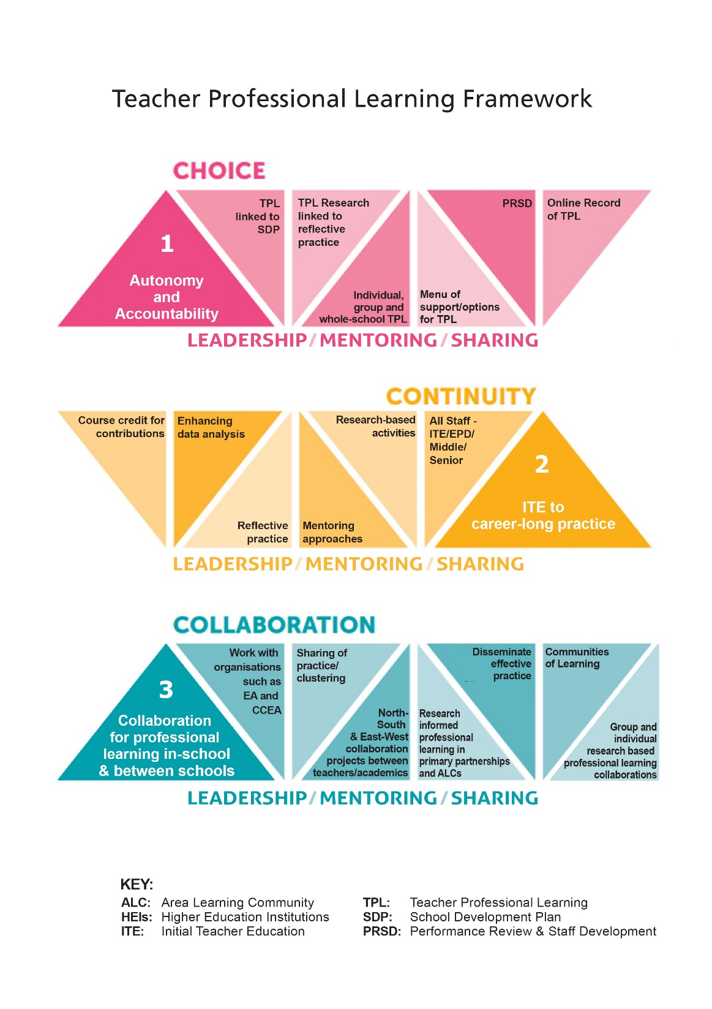

The statements below are seeking your views about the Teacher Professional Learning Framework.

1. The Teacher Professional Learning Framework streamlines and combines initial teacher education, early career teaching and continuous professional learning into a single, coherent process.

Agree |  | Neither Agree nor Disagree |  | Disagree

Additional comments (optional):

The space below is for you to add any additional comments, should you wish to provide more detail in respect of the statement above.

2. The three Key Principles of the Framework (Choice, Continuity and Collaboration) will help teachers frame/structure their professional development.

Agree |  | Neither Agree nor Disagree |  | Disagree

Additional comments (optional):

The space below is for you to add any additional comments, should you wish to provide more detail in respect of the statement above.

3. The Framework includes examples of Teacher Professional Learning.

a. Which of the following examples of TPL associated with the principle of Choice do you find helpful to have included in the framework?

TPL linked to SDP |  | TPL research linked to reflective practice |  | Individual group and whole-school TPL
Menu of support/options for TPL |  | Experiential Learning |  | Online record of TPL

b. Are there other examples of TPL associated with the principle of Choice you would find helpful to have included in the framework?

c. Which of the following examples of TPL associated with the principle of Continuity do you find helpful to have included in the framework?

Credit for contributions |  | Reflective practice |  | Research-based activities
Enhancing data analysis |  | Mentoring approaches |  | All Staff – ITE/EPD/Middle/Senior

d. Are there other examples of TPL associated with the principle of Continuity you would find helpful to have included in the framework?

e. Which of the following examples of TPL associated with the principle of Collaboration do you find helpful to have included in the framework?

Access to research |  | N/S E/W collaboration projects between teachers & academics |  | Disseminate effective practice
Sharing of practice/clustering |  | Research informed professional learning in primary partnerships & ALCs |  | Communities of Learning
Group & individual research based professional learning collaborations

f. Are there other examples of TPL associated with the principle of Collaboration you would find helpful to have included in the framework?

Additional comments (optional):

The space below is for you to add any additional comments, should you wish to provide more detail in respect of the statement above.

SECTION B: The Learning Leadership Lens

- This lens was developed following a GTCNI review of the existing 27 teacher competences - and it is therefore a revision to the existing competence framework.

- There are five dimensions to the Lens:

- Core Values (how leaders frame their work) – this has purposefully been left blank in the model to enable schools to personalise it to their own context and set of values. Suggested values however can include commitment, respect, integrity, equality and service.

- Domains of Leadership Practice to Support TPL (the fundamental purpose of what teachers do at all levels as leaders of learning) – To lead ethos, learning and improvement.

- Broad Areas of Competence (how leaders at all levels practise) - Apply Knowledge and Understanding; Work with Others; Solve Problems and Communicate Effectively. Each area contains three key competences (see Section C below), providing a total of 12 draft Competence Statements.

- The Mission of the Educator to meet the Strategic Vision for Children and Young People (why teachers practise) – these make the connection between the personal and professional mission of the teacher with the broad strategic vision for children and young people, as articulated through the Northern Ireland Curriculum: ‘to empower young people to achieve their potential and make informed and responsible decisions through their lives’; and

- The Learning Leaders Continuum (the stages through which leadership is developed) – this is based on the principle of a continuum of developing professional practice along which teachers progress in their leadership competence at different phases of their professional career and in a range of different contexts and roles.

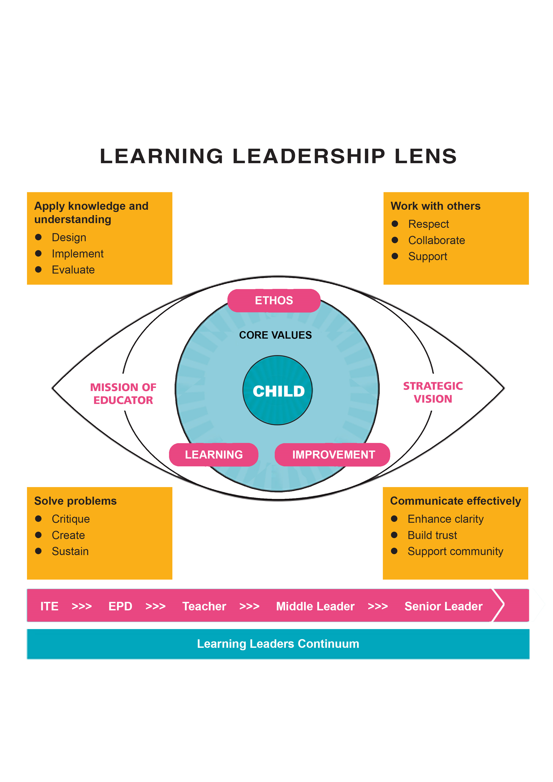
- As each teacher’s career journey is different, the concept of the leadership continuum (see foot of the Lens above) recognises that professionals develop at a pace relevant and appropriate to their needs whilst taking cognisance of both the challenges and opportunities they face in the very different contexts in which they may work at different times in their career.

- Where a teacher’s competence rests on the continuum depends upon a number of contextual factors, including the stage in their career; experience; opportunity; and the size, location, nature and context of the school in which they teach, along with specific responsibilities relevant to their role.

- For example, student teachers, early career teachers and more experienced teachers who wish to continue as classroom practitioners, for example, will continue to see themselves primarily as the leader of learning in their classrooms.

- However, once a teacher begins to actively support learning beyond their individual classroom and, perhaps in collaboration with, or providing support to, other colleagues through modelling, mentoring or coaching, they may have progressed to the stage of Middle Learning Leaders. Similarly, school principals and vice-principals must, of necessity, be regarded as Senior Learning Leaders given their particular role within the school.

Examining the Teacher’s Career Through the Lens

- The Lens signals the requirement for all teachers to focus closely and reflect carefully upon their practice and professional learning in terms of how it ought to enhance opportunities for learners, further their career development and fulfil their professional mission as an educator.

- Alongside teachers, the lens is also relevant to schools (including those who govern them); to those involved with support for the continued professional development of teachers (teacher educators and those who commission and quality assure such provision); and to employers of teachers.

Teachers

- In line with the responsibilities on teachers to commit to career-long professional learning, as outlined in the ‘Learning Leaders Strategy’, the Lens provides a way in which teachers can assure themselves that they are continuing to develop their practice in line with the interests and in response to the needs and challenges of teaching children and young people; curriculum review and development; and wider school improvement priorities.

- Learning alongside pupils, working collaboratively with other professionals and informed by current research and effective practice, they will be able to assess their growing accomplishment along the continuum of learning leadership.

- The Lens will enable teachers to:

- reflect upon and evaluate their professional effectiveness in terms of the positive impact of the outcomes of their leadership and the achievement of their learners; and

- make informed decisions about the priorities and direction of their own professional learning and growth in the best interest of learners and whole-school priorities.

Schools

- The Lens can provide a meaningful framework within which to develop school development action plans that support and require effective TPL and which subsequently guide career progress through Performance Review and Staff Development (PRSD).

Teacher Educators

- For teacher educators working in ITE, the Lens must support the design of quality research and evidence-informed programmes which promote self-reflection, professional enquiry and professional autonomy.

- The Lens may also be used to develop appropriate tools for the evaluation and assessment of learner outcomes and competence through an agreed framework.

- Fundamentally, the Lens will be used by teacher educators/providers to support teachers at all levels to develop their competence and capacity as Learning Leaders.

The statements below are seeking your views about the Learning Leadership Lens.

4. Is it helpful to explain visually the key aspects of teacher education and professional learning through a ‘Learning Leadership Lens’?

Agree |  | Neither Agree nor Disagree |  | Disagree

Additional comments (optional):

The space below is for you to add any additional comments, should you wish to provide more detail in respect of the statement above.

5. The Five Dimensions of the Learning Leadership Lens (the Core Values, the Domains of Practice to support TPL, the Areas of Competence, the Personal, Professional Mission of Educators to meet the Strategic Vision for Children and Young People, and the Learning Leaders Continuum) will be helpful in influencing and guiding the professional development of teachers at various career stages.

Agree |  | Neither Agree nor Disagree |  | Disagree

Additional comments (optional):

The space below is for you to add any additional comments, should you wish to provide more detail in respect of the statement above.

6. The Learning Leaders Continuum accommodates the diverse career paths of teachers and promotes professional growth at their own pace, taking into account whole-school and individual needs and challenges.

Agree |  | Neither Agree nor Disagree |  | Disagree

Additional comments (optional):

The space below is for you to add any additional comments, should you wish to provide more detail in respect of the statement above.

7a The core values dimension of the lens has been left blank to allow schools to reflect their own context and agreed values. Do you agree with this approach?

Agree |  | Neither Agree nor Disagree |  | Disagree

b. Should the core values dimension of the lens include suggested values, for example commitment, respect, integrity, equality and service?

Agree |  | Neither Agree nor Disagree |  | Disagree

Additional comments (optional):

The space below is for you to add any additional comments, should you wish to provide more detail in respect of the statement above.

8. The three Domains of Practice to support TPL (leading ethos, leading learning and leading improvement) accurately reflect what is required to be a learning leader working at all levels in education.

Agree |  | Neither Agree nor Disagree |  | Disagree

Additional comments (optional):

The space below is for you to add any additional comments, should you wish to provide more detail in respect of the statement above.

SECTION C: Draft Revised Teacher Competences
- As noted above, the General Teaching Council for Northern Ireland (GTCNI) has responsibility for revising the Teacher Competences. A draft revised set is outlined in the table below which the Department is consulting on, on GTCNI’s behalf.

- Each Area of Competence contains three key competences, combining to form a total of 12 draft revised teacher competences or indicators.

- Each draft revised competence is then followed by a description of the characteristics expected of a teacher in demonstrating the draft revised competence. Depending on the particular context of the school, they may be varied and enhanced in how they are evidenced by teachers.

Area of Competence | Indicators (how I demonstrate competence)
Applying knowledge and understanding | Design | Plan and prepare high quality learning experiences that continuously improving outcomes for all, informed by pedagogy and TPL (including the latest academic research).
Applying knowledge and understanding | Implement | Further my own TPL through implementing plans effectively to enhance the learning experience and improve outcomes for all, including those who may experience barriers to their learning.
Applying knowledge and understanding | Evaluate | Use first-hand evidence to inform decisions for future planning in the best interest of all learners.
Working Effectively with Others | Respect | Create a safe, strong and trusting culture of mutual respect based on the principles of equality and inclusion to promote the care and welfare of all.
Working Effectively with Others | Collaborate | Build collegial relationships within and beyond my school to create better learning experiences and outcomes for all learners.
Working Effectively with Others | Support | Support and challenge pupils to reach their potential in partnership with colleagues, parents and carers.
Being Solution Focused | Critique | Identify and analyse challenges to optimise learning experiences and outcomes for all, both as an individual teacher and with colleagues, and use this knowledge to inform interventions.
Being Solution Focused | Create | Work flexibly, creatively and supportively with others to devise solutions to problems and build capacity for further development.
Being Solution Focused | Sustain | Reflect critically on the effectiveness of actions to build capacity to bring about and sustain improvement.
Communicating Effectively | Enhance Clarity | Use appropriately a variety of communication methods, including digital, to enhance understanding and promote a sense of inclusion.
Communicating Effectively | Build Trust | Communicate in a variety of ways, in a professional and mutually respectful manner, to foster a successful learning community.
Communicating Effectively | Support Community | Be optimistic, respectful and resilient in order to build positive working relationships and consensus.

The statements below are seeking your views about the draft revised set of Teacher Competences.

9. The consolidation of the original 27 teacher competences into the draft revised 12, in four groups, provides a clear and manageable basis for demonstrating teacher practice.

Agree |  | Neither Agree nor Disagree |  | Disagree

Additional comments (optional):

The space below is for you to add any additional comments, should you wish to provide more detail in respect of the statement above.

10. The draft revised set of teacher competences summarise the key aspects of effective practice.

Agree |  | Neither Agree nor Disagree |  | Disagree

Additional comments (optional):

The space below is for you to add any additional comments, should you wish to provide more detail in respect of the statement above.

ANNEX A: FREEDOM OF INFORMATION ACT 2000 – CONFIDENTIALITY OF CONSULTATIONS

The Department will publish a summary of responses following completion of the consultation process. Your response, and all other responses to the consultation, may be disclosed on request. The Department can only refuse to disclose information in exceptional circumstances. Before you submit your response, please read the paragraphs below on the confidentiality of consultations and they will give you guidance on the legal position about any information given by you in response to this consultation.

The Freedom of Information Act gives the public a right of access to any information held by a public authority, namely, the Department in this case. This right of access to information includes information provided in response to a consultation. The Department cannot automatically consider as confidential information supplied to it in response to a consultation. However, it does have the responsibility to decide whether any information provided by you in response to this consultation, including information about your identity, should be made public or be treated as confidential.

This means that information provided by you in response to the consultation is unlikely to be treated as confidential, except in very particular circumstances. The Lord Chancellor’s Code of Practice on the Freedom of Information Act provides that:

- The Department should only accept information from third parties in confidence if it is necessary to obtain that information in connection with the exercise of any of the Department’s functions and it would not otherwise be provided;

- The Department should not agree to hold information received from third parties “in confidence” which is not confidential in nature; and

- Acceptance by the Department of confidentiality provisions must be for good reasons, capable of being justified to the Information Commissioner.

For further information about confidentiality of responses please contact the Information Commissioner’s Office (or see website at: http://www.informationcommissioner.gov.uk/).

TPL Study: Continuing Professional Learning (Strand II) - OECD 2020
Teaching: The Reflective Profession - The General Teaching Council for Northern Ireland (gtcni.org.uk)

