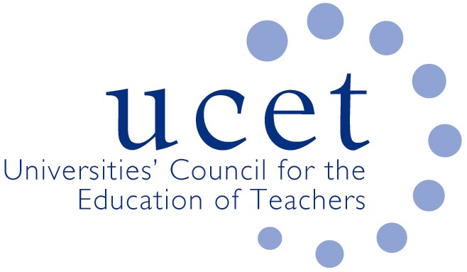

Promoting Quality in Teacher Education

Note of the UCET Research and International Forum meeting held on 7 May2024 4 via Zoom

Welcome & introductions

Colleagues were welcomed to the final meeting of the academic year.

Symposia discussions

The morning discussions were led by Vini Lander, Chair of the UCET Equalities group. Following the launch of the Anti-racism Framework for ITE/T and the very successful Anti-racism in ITE/T conference in March 2022 it became clear that teacher educators from all parts of the country were working largely in isolation to promote anti-racism and racial justice in ITE/T. There was a clear need to develop some kind of network of teacher educators committed to racial justice who could collectively strengthen this work. The presentation examined the rationale, structure and purpose of the Anti-racist Teacher Education Network (ARTEN) launched in January 2024 and its potential to transform ITE/T practice with respect to racial justice. Details of ARTEN, including how to become a member of the network, can be found at https://www.leedsbeckett.ac.uk/research/centre-for-race-education-and-decoloniality/anti-racist-teacher-education-network/

A report was also given on the recent meeting of the Equalities group, with highlights including: the ITE students survey, which colleagues were encouraged to pass onto their student teachers; work with the OU on the development of an on-line resource to support people from under-represented groups apply for ITE; the development of an animation tool to help colleagues implement the Anti-Racism Framework for ITE; trans issues in regard teacher education; and discussions on equalities issues with shadow ministers. Further information about the work of the Equalities Group can be found at: https://www.ucet.ac.uk/equalities-group.

REF issues

The following issues were discussed in relation to the 2029 REF exercise:

- The small proportion of teacher education research submitted in the two previous REF exercises (circa 6% of total education outputs).
- The impact of institutional issues (staffing changes, pressures of ITE reforms, limited funding etc.) on the volume of education research being carried out in education departments and the number of staff involved in research (although examples were also given of universities investing some money in developing research expertise).
- The implications of staffing contracts, including the definition of 'significant responsibilities for research’ in contracts (which was felt unlikely to change significantly) and the balance between the number of staff on teaching only contracts and those with research responsibilities. These could include: a reduction in research active staff actually involved in teacher education; the use of ‘teaching only’ contracts actually releasing time for research-active staff to carry out research; the percentage of research active staff submitted to the REF and the impact this could have on environment statements.
- The workload of those appointed to REF sub-panels and the importance of universities giving staff time to undertake REF related work.
- The importance of maintaining and supporting the education research community, including the ongoing need for face to face meetings and events.
- The development of links between BERA and UCET.

ITT/ECF update

A report was given of the publication in January of the new combined ITT/ECF, which would not have any impact on ITE programmes until September 2025. Changes requested by UCET and others for more explicit references to be made to EDI and climate change issues had not been taken in board. Changes that had been made related to: SEND; oracy; research literacy; the needs of younger pupils; and the importance of progression and transition from the CCF into the ECF. UCET’s response to the publication had been to call for a more inclusive and sector-wide approach to identify what should be expected of ITE and EPD, drawing on the work of the UCET IBTE group.

Journal coverage

The limited coverage of teacher education issues in education journals continued to be a cause for concern, and it was suggested that journals might be encouraged to publish ITE focused special editions. Further analysis of journal coverage might also be usefully carried out.

International issues

The following international issues were noted:

- The 2024 World Assembly of the International Council on Education for Teaching in Braga on 13-15 June: https://www.icet4u.org/world_assembly_2024.php.
- 2024 UCET Gordon Kirk Travel Scholarship winners.
- DfE guidance on visa applications for schools.
- The withdrawal by DfE of International Relocation Payments for ITE students.

UCET issues

The following UCET issues were noted:

- The publication of a UCET briefing paper on the contribution that universities make to teacher education and teacher supply, intended for use by UCET nationally and (amended as necessary) by providers at a local level in the run-up to this year’s General Election. A glossy edition including institutional case studies was also in preparation.
- A planned graphic version of the UCET IBTE report.
- The Easter 2024 newsletter.
- The 2024 UCET conference that will take place at the Queen’s hotel in Leeds on 12-13 November. The theme of the conference will be: ’A space on which to create and celebrate inquiry rich teacher education’, with all plenary sessions relating to this theme. Keynotes already agreed included Christine Counsell, Aimee Quickfall, Adam Vasco and Jospeh Mintz, with plenary sessions to also include a presentation by the UCET Climate Change sub-group and a panel discussion on the sharing of research expertise with schools. The evening tribute act will be Dolly Parton.

Any other business
It was reported that UCET had submitted evidence to Ofsted’s ‘big-listen’ consultation, and a meeting with HMCI to discuss the response had been arranged.

Date of next meeting

8 October 2024, via zoom

