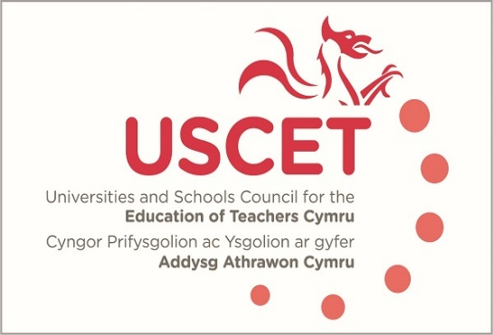

17 October 2023

Kevin Palmer
Head of Initial Teacher Education
Welsh Government
Cathays Park
Cardiff CF10 3NQ

Dear Kevin,

ITE partnerships across Wales are deeply committed to supporting new entrants to the profession to become high-quality practitioners, and collectively, to enhance our approaches to the continuous improvement of ITE provision. Over recent years, we have worked in cooperation with both Estyn and EWC to support the realisation of the vision of ITE set out in accreditation criteria and the new inspection framework. It is within that collegiate spirit that we have previously raised concerns on behalf of our members pertaining to the regulatory framework for ITE and which we reaffirmed in recent discussions on 9 October. In response, Estyn and EWC agreed to continue to explore mitigating measures.

These measures will be warmly welcomed in the short term, but we remain concerned about the inherent challenges of working within multiple regulatory frameworks and the risks that this may continue to pose to ITE provision. Furthermore, we believe this may also be a missed opportunity for us to collectively achieve long-lasting and transformative system-level change within a self-improving system.

Issues raised by members about the current regulatory system include:

- The complexity, duplication and workload associated with multiple regulatory frameworks, including those of the QAA and other HEI requirements. This may pose a risk to the coherency and efficacy of Partnership quality assurance and enhancement processes in addressing all aspects of each framework.
- The impact on the workload and wellbeing of Partnership staff following an intensive and condensed timeline of regulatory activity following the pandemic. The need to be responsive continues with new monitoring and re-accreditation processes and further review of inspection arrangements.
- Providing the necessary capacity and resource to effectively meet the robust requirements of both accreditation and inspection processes alongside the full remit of Partnership working (including recruitment, developing curriculum, teaching, assessment, strengthening partnership working, research, addressing national strategic priorities such as BAME recruitment and retention and Welsh in ITE). This must also be achieved in an increasingly challenging fiscal environment and during a period of recovery from the ongoing impact of Covid on education.

Partnerships believe that swift and resolute collective action is needed to safeguard the ongoing sustainability of ITE provision, to mitigate the risks outlined, and above all, to secure our ambitions for our national mission together.

We look forward to further opportunity to discuss with colleagues in Estyn and the EWC how we might identify greater synergy between the requirements of accreditation and inspection and to consider solutions to some of the issues which have been shared with us by colleagues. Points for discussion which would address the examples shared with us are outlined below:
- The selection of regulatory staff with relevant expertise and understanding of the context of ITE (and its position within HEIs).
- The nature of the regulatory relationship and how visits can be designed robustly but with collegiality and regard for the impact on staff wellbeing (as activities are likely to be perceived as high-stakes).
- A clear outline of both inspection and accreditation processes, including the length and duration of activity, with mutually agreed roles and responsibilities agreed in advance. Where possible, shared data collection templates may be expeditious.
- The capacity and resource issues inherent in the need to release school-based partnership staff to attend multiple regulatory visits, alongside wider partnership commitments.
- Clarity around the purpose of and processes for data sharing between organisations and exploration of university QA processes as a further means to collect quality and compliance data.
- Deploy most effectively the expertise, capacity and resource of all parties (EWC, Estyn and Partnerships) and ensure good stewardship of public finances by avoiding duplication and ensuring clarity of purpose and process to meet key statutory requirements (rather than full legislative scope).

Partnerships continue to participate widely in the range of opportunities available to us to support the continuous improvement of ITE – from the annual EWC conference to opportunities as peer-inspectors. We enter into forthcoming discussions with a positive approach to finding solutions which offer immediate relief to pressures across the sector now, and work towards a truly synergistic and transformative approach for the future. Yet, we must also reiterate the strength of feeling from members on these issues and the risks posed by the current arrangements.

We look forward to taking these issues forward with colleagues and to achieve tangible solutions as soon as possible.



James Noble-Rogers
Executive Director
UCET

