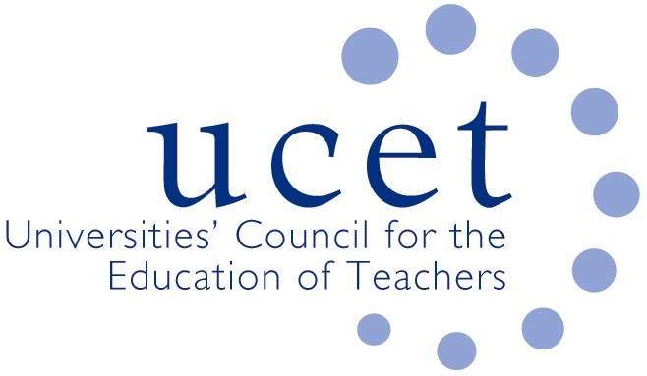
A Registered Charity (No 275082)

9-11 Endsleigh Gardens, London WC1H 0EH

T: 020 7621 6836
info@ucet.ac.uk

Promoting Quality in Teacher Education

Minutes of the meeting of the Northern Ireland Higher Education Liaison Group meeting held at 12 noon on Tuesday 10 January 2023 at Queen’s University, University Road, Belfast, BT7 1NN

Attendance

David Barr (Ulster)
Kyle Crutchley (DE)
Tricia Eaton (Stranmillis)
Ian Gallagher (GTCNI)
Martin Hagan (St. Mary’s)
Emma Holmes (Education Authority)
Angela Kane (DE)
Esther Martin (CCEA)
Kevin Mattinson (UCET, via Teams)
Daniel Muijs (Queen’s)
James Nelson (Queen’s, and Chair of meeting)
James Noble-Rogers (UCET, via Teams)

Apologies

Jonathan Heggarty (Stranmillis)
Roisin McPhilemy (Open University in Ireland)

No representatives of the Department for the Economy were present.

Welcome & introductions

Colleagues were welcomed to the second meeting of the academic year, with a particular welcome to those attending for the first time.

Minutes and matters arising

The minutes of the meeting held on 3 October 2022 were agreed, other than CCEA curriculum work related to the refreshing of the design principles of the new curriculum, not the curriculum itself.

There were no matters arising not already included on the agenda.

Matters arising from the morning UCETNI meeting

Applications to ITE programmes for 2023/24 were down on previous years, partly because of bursaries available in England and competition in some subject areas from other employers. It is hoped that applications might pick up later in the year. Recruitment processes are also being constrained because intake targets for ITE providers have yet to be confirmed.

Placements sub-group

An update was provided on discussions that had taken place at the December meeting of the UCETNI placements sub-group, where there had been support for the principle of coordinating support for mentors and teacher-tutors. DE colleagues agreed to consider the scope for an annual face-to-face event to celebrate and build upon the work of ITE partnerships. Links should also be developed between HEIs and EA regarding support for mentors. It was agreed that a meeting would be arranged, with HEI and EA representatives: Patricia Eaton (Stranmillis) and Emma Holmes (EA).

Teacher competences

Concerns expressed at previous meetings about the gradual introduction by ITE providers of the new teacher competences were noted by DE. These included: the potential for confusion of two sets of competences in operation at the same time: the risk of further disjuncture between ITE and CPD provided in schools; and the possibility that the competences might change as a result of forthcoming consultative and legislative processes. UCETNI members were keen to support the introduction of the new competences as best they could, but this would require an integrated system-wide approach rather than piecemeal change. DE agreed to consider the matter further and return with alternative proposals.

It was suggested that the Learning Leaders’ strategy itself might be relaunched in the light of developments, including the introduction of new and relevant professional development opportunities, that have taken place since publication in 2016. It was agreed that this should be an agenda item for discussion at the next meeting.

ITE allocations for 2023/24

Concern was again expressed about the lateness of the announcement of ITE allocations for 2023/24 and the impact this could have on planning, budgeting and levels of recruitment. DE reported that it has been in discussions with the Department for the Economy and is awaiting a response. It was likely that, in the absence of ministers, existing allocations would remain in place.

Reports from partner organisations

The following reports were received:

- DE: The ITE partnership handbook had been amended and comments are invited by 18 January. It was hoped that a new version would be available in time for the March meeting of the ITE working group and would be consulted on with school leaders. It was hoped that a final version would be published before the next academic year. The Learning Leaders Communications Group had met and key messages, for referral to the Oversight Group, have been discussed. The consultation on the future of the GTCNI has not attracted as many responses as originally hoped and this might make it more difficult to quickly develop the planned legislation to replace GTCNI. Consideration was being given to consulting, through a survey to be distributed via UCETNI members in January, postgraduate and final year undergraduate ITE students. It was suggested as an alternative that any survey be delayed until ITE students had received their scheduled briefings about the GTCNI, or even seek views as part of those briefings. DE agreed to consider these suggestions.
- GTCNI: The introduction of GTCNI’s new registration system in April 2023 will streamline the processes for GTCNI registrations, although scope for teachers to register at different times of the year will remain. It was being made clear in presentations to newly qualified and qualifying teachers that responsibility for registering, and paying associated fees, rests with them. HEI colleagues who had helped to introduce the new procedures, which appeared to be working well, were thanked. The scope to synergise systems for the recording of CPD activities and the use of on-line development portfolios between different bodies such as GTCNI and the EA was discussed. GTCNI had noted and was monitoring the increase in the number of requests on how to register with GTCNI from African countries.
- EA: Face-to-face EPD events for new teachers in their first three years of teaching have re-started, alongside on-line webinars. These have been well attended. On-line resources to support induction have been made available, and support provided in respect of on-line coaching and mentoring. A teacher-tutor panel has been established to discuss support provided in schools by teacher-tutors. The importance of synergy between the support provided to teacher tutors by ITE providers and the EA was acknowledged.
- CCEA: Updates were provided in regards to Fair Start including: raising awareness of the refreshment of the principles of the design of the new curriculum; 14-19 projects; the development of curriculum-related resources; the RSE project; webinars for teachers on issues such as SEND and ‘sensitive’ issues such as consent and period dignity; learning through play guidance; CPR resources developed in partnership with the EA and the NI Ambulance Service; and the RE Advisory Group, which has been reinstated following the judicial review outcome which found the Core Syllabus for RE and Collective Worship were in breach of European Human Rights articles. DE agreed to report back on expectations for ITE providers in regards to CPR issues. CCEA agreed to consider the scope for UCETNI representatives to attend appropriate webinars.

Any other business

None.

Date of next meeting

12 May 2023 (Senate Building, Queen’s).

