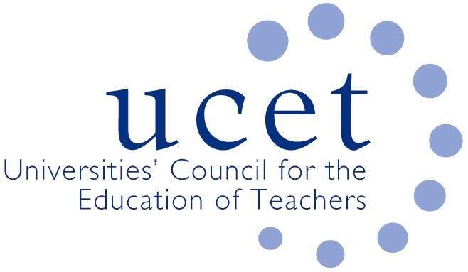
A Registered Charity (No 275082)

9-11 Endsleigh Gardens, London WC1H 0EH

T: 020 7621 6836
info@ucet.ac.uk

Promoting Quality in Teacher Education

Note of the meeting of the UCET Post 16 forum held on-line at 1pm on 3 February 2023

Welcome, introductions and minutes of the previous meeting.

Colleagues were welcomed to the second meeting of the 2022/23 academic year, especially to those attending for the first time. The note of the meeting held on 21 October was agreed. On matters arising none of the appeals against non-accreditation following round 2 of the QTS market review exercise had been successful; and UCET would be holding a series of workshops to support members who had been accredited through stage 2 of the process, and was also facilitating discussions between accredited and non-accredited providers about the possible development of new ITE partnerships.

Discussion

A range of issues were discussed, including:

- An update from JNR on non-Post 16 related issues, including: the new UCET CPD paper (‘golden-thread or gilded cage’); a review of UCET’s strategy, governance, ways of working & organizational structure; and developments in Wales and Northern Ireland.
- Feedback from that morning’s symposium which had been led by colleagues from OfSTED and DfE. Key points included: as OfSTED entered the third year of its current inspection cycle, no FES provision had yet been graded as ‘outstanding’. Issues arising from inspections included curriculum planning & sequencing; mentoring; and quality assurance. Providers might it was suggested pay attention to subject knowledge and how that is reflected in mentoring and the sequencing of curricula and co-ordination between what happens at ITE provider level and in partner colleges. The timing of inspections would were possible take account of the impact of industrial action. It was re-confirmed that the CCF does not apply to FES provision. Reference was also made to paragraph 38 of the OfSTED handbook, which allowed a degree of autonomy for colleges on how curricula for particular subjects was sequenced. It was agreed that the topic for the net morning symposium would be alternative forms of assessment and subject knowledge in the context of the new diploma, with contributors to include Sarah Telfer, Dan Williams and Lynn Senior.
- Updates from the ETF including:
  - The new professional diploma in teaching, which would replace the DET from September 2024, had been well received by the sector, although it was acknowledged that partner colleges and other organisations needed to be made more aware about its possible implications (e.g. in regards mentoring, teaching hours, on-line lessons etc.) for them. AOC, FAB etc. might it was suggested have a role in this. Although welcomed in principle, the requirement for 20 hours remote teaching might prove challenging and some mitigation (such as simulated lessons) might be required. The new qualification had already been mapped against the new occupational standards and so did not need mapping additionally against the post-qualification professional standards, although student teachers should nonetheless be made aware of what these were.
  - Guidance on the DET had been updated in the light of, amongst other things, the new minimum core and a video about the minimum core changes was available on the ETF website.
  - Materials currently hosted on the FE advice website would be migrated across to the ETF website.
  - A new group of awarding body providers, intended to give awarding bodies similar support to that given to HEIs through UCET Post-16, was being established.
  - A report on subject-specific video resources from ETF would be given at the next meeting.
- DfE updates including:
  - New funding regulations, which would make the new Diploma in Teaching (DIT) the only teaching qualification for the sector attracting public funding would come into effect from August 2024. It was intended to produce a list of ITE qualifications that meet the new requirements to guide potential student teachers and inform decisions about loan eligibility made by the Student Loans Company (SLC). This would be as concise as possible, and would make it clear which qualifications were, and which were not, eligible for loan support. It was agreed that members of UCET Post 16 forum would be invited to discuss the list, and it was acknowledged that a transition period might be required to allow for university validation timescales. The list would be included in a publication containing a range of key information likely to be of interest to those interested in teaching in the FE and skills sector.
  - It was confirmed that bursary support for pre-service programmes in some (as yet unspecified) subjects would be available for 2024 and a handbook setting out the precise details would be published soon.
  - Discussions were taking place, in a joined up way, across DfE about the implications for teacher education of Prime Minister’s recent announcement about the need for young people to study mathematics up until the age of 18.
- Subject teach-meets, where twilight meetings attended by a total of 12 organisations (inc. 10 HEIs) had supported trainees in the development of their subject and pedagogic subject knowledge. Thanks were given to all those, especially Sarah Boodt, for the work they had done on this. A total of 19 vocational and non-vocational subjects had been covered so far, and volunteers were invited to lead on others. The meets were primarily intended to support student teachers, but were also a potential resource for ITE tutors and for mentors. DfE agreed to consider what it might do to facilitate the further development of the teach-meets.
- Current levels of recruitment, where a mixed picture was reported, with come institutions experiencing a fall in applications compared to the previous year and others an increase, but with most reporting steady state. Recruitment to pre-service programs was however suffering because of the financial climate and people not being in a position to give up work in order to train. A significant increase was reported in overseas applications, particularly from Nigeria, although these rarely if ever translated into actual recruits. The increase in such applications, which also applied to QTS programmes, might be a result of DfE messaging about policy changes relating to overseas teaching qualifications, although the availability of on-line interviews might also be a factor. There were also concerns about an increasing number of domestic applicants not having any clear understanding about the FE and skills sector, and possibly only applying in case they were unable to secure a place on a secondary QTS course. The DfE Apply service was, as intended, geared towards applicants for QTS programmes, although discussions abut the scope to make it appropriate for e FE and skills sector might take place.

Items for information

The UCET December newsletter was noted.

Any other business

None.

Date of next meeting

19 May 2023, via zoom

