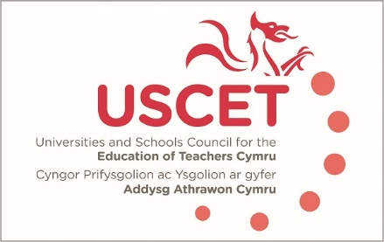

Agenda for the meeting of the University and Schools Council for the Education of Teachers (USCET) to be held at the Radisson Blu Hotel, Bute Terrace, Cardiff, CF10 2FL at 10am on Thursday 18 May 2023

- Welcome & introductions
- Minutes and matters arising (enc.):
- Reports from ITE providers
- Reports from working groups
- Matters to raise with Estyn, WG and EWC:
  - Response to USCET letter on Estyn/EWC regulatory functions
  - Accreditation criteria
  - GCSE equivalency
  - Other issues
- USCET issues:
  - Review of UCET strategy, organisational structures and ways of working (enc.)
  - Chair and Vice Chair of USCET
  - UCET Easter newsletter (enc.)
  - 2023 UCET conference
(11.30am WG, Estyn, EWC & other colleagues join meeting)
- Estyn & EWC regulatory functions
- Accreditation update
- Reports from:
  - Welsh government
  - Estyn
  - EWC
- Any other business
- Date of next meeting: tbc

