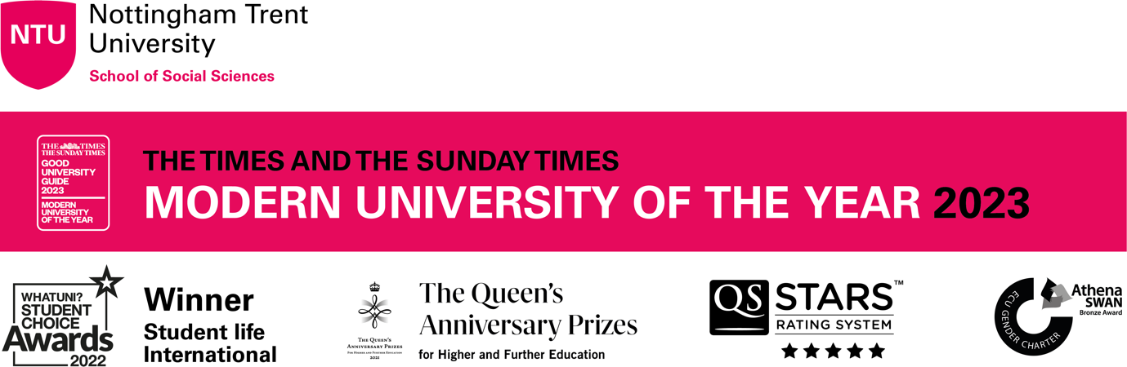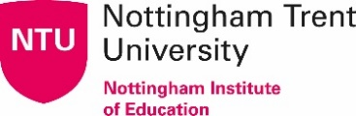
Dr Chris Rolph
Director
Nottingham Institute of Education
T: 0115 848 8961
E: chris.rolph@ntu.ac.uk

Dear James,

I would like to apply for the 2023 Gordon Kirk travel scholarship. As you know, I am Director of NTU’s Nottingham Institute of Education and have been in this role for 4 years. For the last 5 or 6 years I have been an active member of UCET’s CPD forum. I am seeking a travel scholarship to support a small comparative research study looking at teacher education in Kenya, compared with that in the UK (specifically England).

Over the last 12 months we have been developing a partnership with colleagues at Strathmore University in Nairobi. Three colleagues from Strathmore are contributing to an edited book which I am currently writing for Emerald, and we are looking at potential (online) student collaborations between the two universities. Like NTU, Strathmore has a commitment to marginalised communities, including refugees, and has a number of research projects that are rooted in the local community. Strathmore is also engaged in teacher development (through its Centre for Education and Development) and runs an MSc in Educational Management. Strathmore is a member of the AFELT umbrella organisation which seeks to support the development of academic staff in East African HEIs.

The curriculum for schools in Kenya has been undergoing radical change over recent years, very deliberately moving from the reactive post-colonial “curriculum of self-reliance” (Gichuru et al. 2021) towards an informed competency based curriculum with an ambition to develop “engaged, empowered and ethical citizens” (UNESCO 2017). This has not been without its difficulties (Akala 2021), including that of retraining teachers (Muasya and Waweru 2019), but it offers the opportunity to integrate indigenous knowledge into the curriculum (Lumonya 2020) and to “africanise” or move further away from colonial models of education (Ruth & Ramadas 2019). The competency based curriculum is a direct contrast to the English National Curriculum which has become increasingly focused on content; there has been a corresponding divergence between assessment expectations with those in Kenya allegedly more “authentic”. The competency based curriculum purports to put the learner and their needs at the centre of the education system generating lifelong learners and at the same time meeting local economic needs (Amutabi 2019). Clearly, a wholescale change in national curriculum presents challenges to the established teaching workforce, both in terms of practice and philosophy (Sifuna and Obonyo 2019), and this is one of many issues that have recently been explored at Strathmore University.

As a former headteacher and curriculum designer I have a deep interest in the underlying philosophy of curriculum design, and its ability to encourage a thirst for knowledge as well as support meaningful assessment mechanisms and provide a basis from which to meet society’s needs. In particular, I am interested in the way that national policy supports such development, and the responses of practitioners in policy enactment—this is explored in my recent book. I would like to undertake a short study visit to Strathmore University to investigate the impact that the competency based curriculum has had on serving teachers and their CPD. I would be particularly interested in whether training to teach a competency based curriculum necessarily demands a competency-based training programme, comparing this with England’s know that/know how to statements in the Core Content Framework, and contrasting with the rigid content of the Early Career Framework. I would anticipate doing this by interviewing some members of the academic team at Strathmore, and also gathering the views of a number of their students/trainees if I can visit during term time. I anticipate being able to visit in summer/autumn 2023, depending on the convenience of Kenyan colleagues.

I would expect to write up my findings in the form of a journal article, but could also speak at a UCET conference or one of the UCET forum meetings. Finance permitting, I might be able to present a paper at the World Education Leadership Symposium, which is held annually in Switzerland and where I have spoken in the past. I would of course acknowledge the support given by UCET were I to be awarded a scholarship. I believe the findings might be of interest to UCET members, and they may have the potential to inform commentary on UK policy.

C Rolph
March 2023

Estimated costs (based on March 2023 prices)

Travel to Nairobi  - Airport/station parking 4 days  - Petrol/train fare to airport  - Return air fare to Nairobi  - Nairobi taxis | £90  £100  £1000  £50
Accommodation in Nairobi  - 4 nights hotel | £600
Subsistence  - 4 days @ £30 | £120
Total | £1960

Statement of Support
I have discussed this application with Dr Magdalene Dimba (Dean, School of Humanities and Social Sciences) and Dr Alfred Kitawi (Director, Centre for Research in Education) as well as their colleague in the Business School, Dr William Murithi, whose email of support is below:

From: William Murithi <murithiwilliam@gmail.com>
Sent: 27 February 2023 13:14
To: Rolph, Chris <chris.rolph@ntu.ac.uk>
Cc: akitawi@strathmore.edu; MDimba@strathmore.edu
Subject: Re: Potential funding
Hello Chris,
I trust you are well.
This is a great opportunity and I would suggest that you apply. It will offer an opportunity to conduct the research as stated and one to lay the foundation for the collaborations. You will get a chance to meet the team at Strathmore and maybe give a talk on the competence-based ITE curriculum. I do not want to put the cart before the horse but I'm sure Dr Dimba and Dr Kitawi will be delighted to host you at Strathmore University HSS.
Keep us posted on this and when likely your travel would be.

NTU policy uses worldwide subsistence rates

