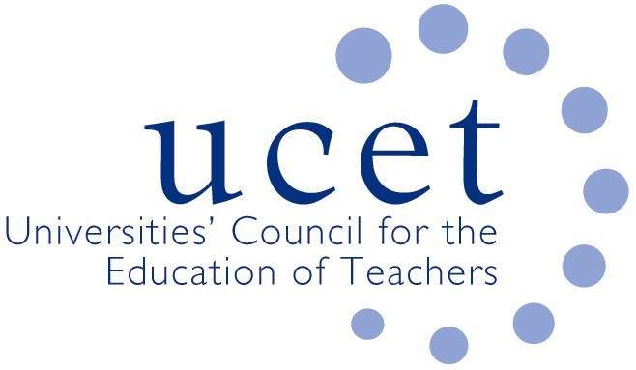

Promoting Quality in Teacher Education

Note of the UCET Research and International Forum meeting held on 17 January 2023 via Zoom

Welcome & introductions

Colleagues were welcomed to the 2nd meeting of the academic year. The notes of the meeting held on 11 October 2022 were agreed. There were no matters arising not included elsewhere on the agenda.

Discussions

A range of issues were discussed, including:

- An update from JNR on non-R&I related issues, including: the issuing of updated UCET/NASBTT guidance on DBS and child-protection related issues; feedback from the November 2022 UCET conference; and developments in Northern Ireland and Wales.
- Feedback from that morning’s symposia, a recording of which would be circulated. Key points included: the taking forward of the UCET Intellectual Base of Teacher Education (IBTE) work, including the drafting of further briefing on each of the main themes, and for which volunteers to contribute were requested; a planned analysis of the journey that had led to the current teacher education policy context; and an opportunity to contribute on teacher education policy and content to the BERA blog and other BERA publications. A suggestion for the next morning symposium included updates in relation to the aforementioned work. Other ideas were also invited.
- An update on the work of the UCET Equalities sub-group. The December meeting had covered: a report from colleagues in Wales on embedding anti-racism in teacher education curricula and cross sector collaboration on anti-racism in the context of the Welsh Governments anti-racism strategy and its intention to become an anti-racist country by 2030; updates on ongoing Equalities Group projects in relation to the survey of recruitment to ITE (to which all UCET members were encouraged to contribute, and would take place every three years and might be extended to cover the wider school workforce and the ITE workforce); the development of an online course for people from under-represented groups who might be interested in applying for ITE and which it was hoped would be hosted from 2024 on the OU’s Create platform; the need for greater coverage of equalities issues at the UCET conference; and the production of ITE materials for those seeking sanctuary. The new Anti-racism framework for ITE (https://www.ucet.ac.uk/14635/anti-racism-itet-framework) developed by the equalities sub-group which had been funded by the NEU and Newcastle University and which, amongst other things, addressed the de-racialisation of ITE and the absence of any race-related issues in either the ECF or the CCF, and which would be the subject of a conference at Leeds Becket University on 29 March - https://www.leedsbeckett.ac.uk/blogs/carnegie-education/2022/11/anti-racism-framework - and which would also be the subject of a future UCET event.
- An update on the ITE Market Review in England, including: the unsuccessful appeals by ITE providers against non-accreditation; the support given by UCET to non-accredited providers; forthcoming UCET workshops on curriculum design, mentoring, ITAP and partnership to support UCET members through Stage 2 of the accreditation process; and the publication in December by DfE on guidance on the development of new ITE partnerships, and the identification by UCET of a number of issues that had to be addressed (e.g. the scope for lead delivery partners to contextualize ITE curricula, regulatory and accountability issues surrounding partnerships; and the scope for lead partners to retain pre-existing brand identities and continue to have a role in the recruitment of student teachers).
- The recent UCET paper on CPD, (‘golden Thread or Gilded Cage’) which amongst other things identified important areas of teacher development (including those relating to inequalities) not covered by the ECF and NPQs, and about which DfE had invited UCET to discuss the following week.
- International issues, including the forthcoming invitation by UCET for applications for 2023 travel scholarships, and an update on the work of ICET, whose next World Assembly would take place in Melbourne in January 2024, with an international on-line symposium taking place in September 2023.
- The forthcoming review by UCET of its strategy, ways of working, governance and organizational structure. The December 2022 UCET newsletter was also noted.

Any other business

The following issues were raised:

- Concern about the lack of ESRC funding for research projects relating to teacher education following the recent bidding exercise, which meant that there would not have been any large-scale and independently funded research into teacher education for some 20 years.
- The 50th anniversary of the Journal for Teacher Education (JET) in 2024, which would include a special issue (for which contributions and guest editors were invited) on international teacher education policy.

Date of next meeting

9 May 2023 via Zoom

