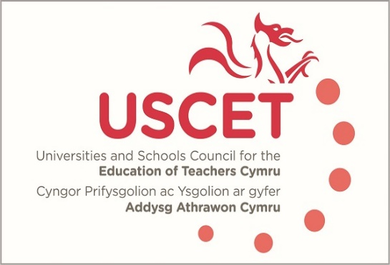

26 January 2023

Max White
Head of Initial Teacher Education
Welsh Government
Cathays Park
Cardiff CF10 3NQ

Dear Max

The purpose of this letter is to provide comments, on behalf of USCET, on the recent paper outlining a proposed joint approach to the inspection and monitoring of ITE programmes by Estyn and the EWC, and to request an urgent strategic meeting of senior colleagues from Welsh Government, USCET, Estyn and the EWC to discuss options for the commissioning of an independent review into how regulatory frameworks might be streamlined.

The paper very helpfully allows for a comparison to be made between the regulatory functions carried out by Estyn and EWC, and we welcome the commitment given in it to reducing regulatory burdens and to co-construction. The paper also, however, confirms that there is significant overlap and duplication which places an unacceptable burden on ITE providers at a time where over-zealous accountability and performativity norms are becoming less common in other parts of the education sector. The preparation involved in the run up to both Estyn inspections and EWC visits represents, for several weeks, a full-time role for some ITE staff and takes them away from important work focussed on the needs of student teachers and schools. Timescales for the submission of information are often unrealistic and take little or no account of university timetables such as those relating to programme validation. The same information is often requested by each organisation, and meetings frequently cover the same ground and involve the same HEI and school staff.

The duplicate regulatory requirements also have significant implications for partner schools at a time when the other pressures they face are at an all-time high. Expecting schools to engage with Estyn inspections and EWC monitoring visits to the extent required is increasingly untenable and could, we fear, push many out of partnership. Attendance by school colleagues at Estyn and EWC meetings is already declining, and this itself risks undermining the joint accountability for ITE that underpins the new ITE structures introduced just a few years ago.

A number of colleagues have reported that they find the professional dialogue they have with EWC helpful, and we believe the EWC colleagues feel the same. We do not however think that these need to take place as part of formal monitoring visits, with the pressures on ITE providers which this necessarily brings with it. The EWC’s role is to check compliance of programmes against the ITE criteria. We do not see why this cannot be done through a desk-based exercise.

We support wholeheartedly the principle of ITE being subject to robust and effective regulatory and Quality Assurance. But the current approach, which seems to confuse what Estyn and the EWC are permitted to do under their agreed remits with what they are required to do, places unnecessary burdens on ITE providers and their partner schools, is wasteful of resources and is, because it diverts attention from the core responsibilities of ITE providers and schools, potentially counter-productive.

To resolve this issue, we would suggest that an independent review, to report within a few months, investigates what a robust, proportionate and cost-effective regulatory system might look like. This would be led by a respected professional with no direct links to either the ITE sector, Estyn or EWC. USCET and the ITE sector would of course collaborate full with such a review.

Yours sincerely,
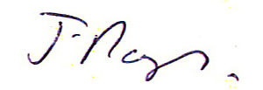
James Noble-Rogers, Executive Director

