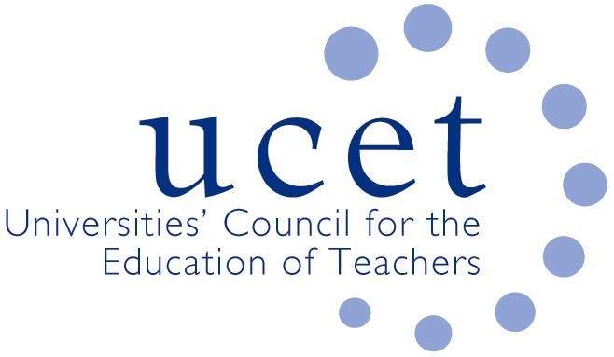
A Registered Charity (No 275082)

9-11 Endsleigh Gardens, London WC1H 0EH

T: 020 7621 6836
info@ucet.ac.uk

Promoting Quality in Teacher Education

Note of the meeting of the UCET Management Forum held on-line at 1pm on Tuesday 29 November 2022

Welcome, introductions and minutes of the previous meeting

Colleagues were welcomed to the first meeting of the academic year. The note of the meeting held on 21 June 2022 was agreed. On matters arising, placement issues had improved to an extent because of smaller cohorts, although staff sickness in schools, the lack of suitably qualified school staff in some subject areas and ECF pressures were causing difficulties in some instances. The situation was expected to worsen because of future ECF demands on schools, the new ITE quality requirements and a possible increase in student numbers linked to the economic recession.

Discussion

A range of issues was discussed, including:

- An update from JNR on issues not included on the agenda, including: feedback from the 1-2 November UCET conference and developments in Northern Ireland & Wales.
- Recruitment to ITE, including feedback from that morning’s symposium which had been informed by an excellent presentation on applications and recruitment from Mark Crowley. Key issues noted and discussed included: the expectation that DfE would fail to meet its secondary intake target for 2022/23 by more than 30%; the significant reduction in the number of people undertaking SKE programmes; and the replacement by DfE of its Teacher Supply Model with a Teacher Workforce Model (details of which had not been made publicly available). Applications for 2023/24 were reported by several forum members to be higher than at the same stage last year, although these did not always translate into actual recruits and there were some concerns about the quality of applicants. Any apparent increase in acceptances might be a temporary result of the changes to the date references were collected through the Apply system (references themselves were noted as being increasingly short on detail). Anger was reported amongst current year English students about the introduction of a £15,000 bursary next year, with some opting to defer as a result. Suggestions from DfE that bursaries might be set for a three-year period were welcomed. The cost-of-living crisis was acting as a brake on both recruitment and retention. An increase in the number of international applicants – for example from Nigeria – was noted, although schools were sometimes reluctant to accept recruits from other countries. Strategies for maximizing recruitment at institutional and regional level were shared. It was agreed that DfE would be asked to share details of Explore Teaching Advisors placed in HEIs and to encourage them to work in partnership with staff in HEI education departments.
- The DFE review of the ITE Market. The results of round 2 accreditations had been announced in September, with some 83% of HEI applicants being successful, and 13 being unsuccessful. UCET had provided support for non-accredited providers in respect of their appeals. Meetings had also taken place to discuss options for legal challenge should any of the appeals not be upheld. Guidance in relation to Stage 2 of the accreditation process had been published, and UCET would be holding a series of workshops to discuss and share approaches in relation to, for example, the submission of curriculum materials; mentoring; ITAP and partnerships. DfE advice on partnerships was expected soon, and UCET would help to facilitate partnerships between accredited and non-accredited providers where possible and appropriate. A statement on the future of School Direct was expected to be included in the partnership guidance, and UCET would support members maintaining relationships with SD lead schools (e.g., as future lead delivery partners) and had made suggestions to DfE. DfE had also been asked by UCET not to be overly prescriptive about the demarcation of responsibilities between organisations involved in ITE partnerships, and to warn providers against predatory activities that might undermine existing partnerships, by for example insisting on exclusive relationships with schools. It would also be asked to keep to its commitment that it had no preferred model of partnership, in terms of either size or type of provider.
- DBS and KCSIE developments, including: despite some initial lack of clarity by the DFE, it seemed that in many or most cases visiting ITE tutors would not need to be DBS checked (although providers might nonetheless arrange for such checks to facilitate access); schools, while they should not expect to have sight of DBS forms, were within their rights to request them from students; on-line interviewing of students was still allowed, as long as providers had a clear and written rationale for doing so; and at least one member of recruitment panels should have had safer recruitment training (e.g. that provided by NSPCC). On considering whether to accept applications with criminal records, suggestions included: agreeing within partnerships which kinds of offences need not be a bar to recruitment; convening a panel (to include a school leader) to consider cases on an individual basis; and seeking advice on a case-by-case basis from local authority safer recruitment teams. Securing certificates of good conduct from home countries in respect of overseas students was noted to be problematic, and colleagues were reminded about the importance of having documented processes in place for checking the qualifications, identity and history of such applicants. A statement about the on-line presence and activities of student teachers was welcomed by the group. New guidance on child protection issues would be issued by UCET soon. In the meantime, colleagues were encouraged to send UCET anonymised examples of individual DBS cases and how they were resolved.
- Post-compulsory ITE issues, including details of the new Diploma in Teaching (FE & Skills), which would become the only teaching qualification for the sector eligible for public funding.
- The recent publication of the CPD forum paper on the ECF and NPQs, ‘Golden Thread or Gilded Cage), which was to be discussed with DfE in the new year, and which MF colleagues were encouraged to share.
- Inspection issues, where it was confirmed that ITE apprenticeships would be covered by ITE inspections and not additionally by provider-level apprenticeship inspections, although information collected by the latter could potentially trigger the former, and ITE apprenticeships were still subject to EFSA audit procedures.
- Topics for future symposia, where suggestions included: the assessment of student teachers; working with teaching school hubs and new ITE providers; and building links between ITE and the ECF.
Items for information

The following items were noted:

- The summer UCET newsletter
- The report of the 2022 World assembly of the International Council on Education for Teaching held at Bath Spa University.

Any other business

JNR reported that discussions had taken place with DfE and the OFS about the implications for ITE of industrial action in schools.

Next meeting

Tuesday 14 March 2023 via Zoom.

‘We take safeguarding very seriously and work with our beginning teachers to support them to understand their online presence and what is/is not appropriate in the context of a professional teacher. This includes tasks which take place in the induction phase of the course. Where there are incidents or issues that have happened in a student’s life, which are publicly available online, we explore these with the student and agree an appropriate way forward. On very rare occasions this may result in a partnership decision to recommend that the student does not continue on their teacher training programme.’

