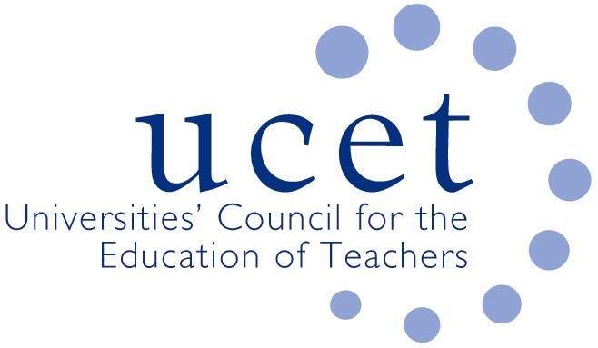
A Registered Charity (No 275082)

9-11 Endsleigh Gardens, London WC1H 0EH

T: 020 7621 6836
info@ucet.ac.uk

Promoting Quality in Teacher Education

Note of the meeting of the UCET ITE secondary forum held on-line at 1pm on Tuesday 22 November 2022

Welcome, introductions and minutes of the previous meeting

Colleagues were welcomed to the first meeting of the academic year. The note of the meeting held on 14 June 2022 was agreed. On matters arising, issues surrounding school placements had generally eased largely because of lower recruitment, although there were variations by subject, and increased pressures on schools from the ECF, new ITE requirements and anticipated upturns in recruitment would probably lead a worsening situation in the future.

Discussion

A range of issues were discussed, including:
- An update from JNR on non-secondary related issues, including: feedback from the 1-2 November UCET conference; the finalisation of a new teaching qualification for the FE and skills sector, the forthcoming publication of a new UCET CPD paper (‘golden thread or gilded cage’); and developments in Wales and Northern Ireland.
- The DFE review of the ITE Market. The results of round 2 accreditations had been announced in September, with some 83% of HEI applicants being successful, and 13 being unsuccessful. UCET had provided support for non-accredited providers in respect of their appeals, the results of which would be announced the following week. Meetings had also taken place to discuss options for legal challenge should any of the appeals not be upheld. Guidance in relation to Stage 2 of the accreditation process had been published the previous day, and UCET would be holding a series of workshops to discuss and share approaches in relation to, for example, the submission of curriculum materials; mentoring; ITAP and partnerships, topics that had also been discussed at that morning’s symposium. A DfE led group on how to ensure teacher sufficiency in areas of under-provision resulting from accreditation outcomes had met soon after the round 2 results had been announced but appeared to have subsequently gone into abeyance.
- DBS and KCSIE developments, including: despite some initial lack of clarity by DFE, it seemed that in many or most cases visiting ITE tutors would not need to be DBS checked when visiting schools (although providers might nonetheless arrange for such checks to facilitate access); schools, while they should not expect to have sight of DBS forms, were within their rights to request them from students; on-line interviewing of students was still allowed, as long as providers had a clear and written rationale for doing so; and at least one member of recruitment panels should have had safer recruitment training (e.g. that provided by NSPCC). On considering whether to accept applications with criminal records, suggestions included: agreeing within partnerships which kinds of offences need not be a bar to recruitment; convening a panel (to include a school leader) to consider cases on an individual basis; and seeking advice on a case-by-case basis from local authority safer recruitment teams. New guidance on child protection issues would be issued by UCET soon.
- Recruitment to ITE, where an analysis by Mark Crowley suggested that DfE would meet just 66% of its secondary recruitment target for 2022/23, with the HE sector and HEI-led School Direct programmes recruiting the largest share. Teach First was likely to miss its target, and salaried routes accounted for only 1,500 trainees in total. Feedback on recruitment for 2023/24 from forum members was mixed and to an extent subject-specific, although several reported an upturn, although this was likely in part to be because of the economic recession. The change in the Apply system in respect of the timing of reference requests might have skewed current application and acceptance rates. The changes in reference dates was thought to penalise ‘marginal’ applicants because relevant information was not available and was also increasing the amount of time that needed to be spent on interviews.
- SKE, where take up had fallen in most subjects and was impacted by changing levels and coverage of ITE bursaries. Better coordination between the two was felt to be required. Most SKE programmes were of 8 weeks duration, which was often not sufficient for prospective students with only A’ Level qualifications in the subjects concerned.
- Suggestions for the next morning symposia included: developing early career researchers in ITE; and pastoral issues and the impact of the cost-of-living crisis.
Items for information

The following items were noted:

- The summer UCET newsletter
- The report of the 2022 World assembly of the International Council on Education for Teaching (ICET) held at Bath Spa University.

Any other business

None.

Date of next meeting

7 March 2023, via zoom.

