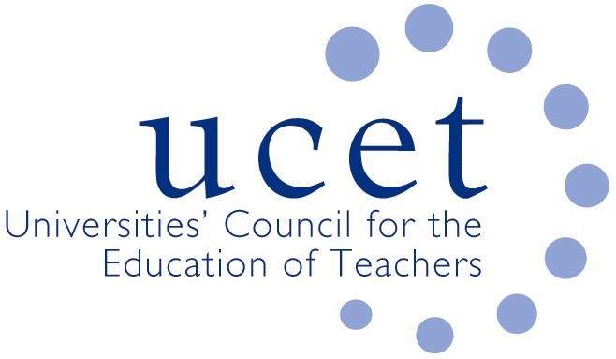
A Registered Charity (No 275082)

9-11 Endsleigh Gardens, London WC1H 0EH

T: 020 7621 6836
info@ucet.ac.uk

Promoting Quality in Teacher Education

ITE primary and early years forum: note of the meeting held via zoom at 1pm on Tuesday 15 November 2022

Colleagues were welcomed to the first meeting of the academic year, particularly to Des Hewitt who was attending for the first time since his recent illness. The note of the meeting held on 7 June was approved. On matters arising, it was confirmed that Aimee Quickfall had been appointed as Vice Chair of the forum to serve for up to three years from 2022/23.

A number of issues were discussed, including:
- An update from JNR on non-primary related issues, including: feedback from the recent UCET conference; the forthcoming publication of a new UCET CPD position paper, 'Golden thread or gilded cage'; the finalisation of a new teaching qualification for the FE and skills sector; and developments in Northern Ireland and Wales.
- Feedback from that morning's symposium on OFSTED inspection experiences which had been led by Julian Brown and Sarah Cave from Northampton. Key issues reported included: providers should highlight key issues they would like during the initial OFSTED meeting, and be ready to justify any assertions made during the inspection itself; inspectors might like to request sight of student assignments and use the content of assignments as evidence, despite not necessarily being aware of HE marking protocols; there had been a focus during inspections of compliance issues, including those relating to KCSIE; it was important for staff to take time out from the inspection process and celebrate its conclusion; provider staff should have a good understanding of the OFSTED inspection framework and the ITE requirements; and OFSTED had asked questions about procedures for the appointment of HEI staff, despite this not appearing to be covered in the ITE requirements or the OFSTED framework.
- It was agreed that the topic for the next morning symposium would be on ITAP (with Michelle Pearson as one volunteer speaker), and the following symposium would be about the future of School Direct and the new apprenticeship programme.
- The review of the ITE Market, and the results of round 2 of the accreditation process, which had resulted in 83% of HEIs being approved for accreditation and 13 being unsuccessful. The results of appeals against non-accreditation were expected to be announced within the next couple of weeks, although the timetable had kept slipping. The collective support given to all providers throughout the accreditation process was noted and welcomed. Guidance on Stage 2 of the accreditation process, and about the possible development of new partnerships (which could be a route for non-accredited providers to continue to engage in ITE pending a new accreditation round in 2025/26), was expected to be published soon. The work of a new UCET group to identify ways in which the values of the sector and the principles set out in the UCET IBTE report could continue to be reflected in ITE from 2024/25 was noted.
- DBS and KCSIE developments, including: despite some initial lack of clarity by DFE, it seemed that in many or most cases visiting ITE tutors would not need to be DBS checked when visiting schools (although providers might nonetheless arrange for such checks to facilitate access); schools, while they should not expect to have eight of DBS forms, were within their rights to request them from students; on-line interviewing of students was still allowed, as long as providers had a clear and written rationale for doing so; and at least one member of recruitment panels should have had safer recruitment training. On considering whether to accept applications with criminal records, suggestions included: agreeing within partnerships which kinds of offences need not be a bar to recruitment; convening a panel (to include a school leader) to consider cases on an individual basis; and seeking advice on a case by case basis from local authority safer recruitment teams.
- Recruitment to ITE programmes for 2023/24, where several colleagues reported upturns in recruitment compared to last year, particularly to postgraduate programmes. This might, it was suggested, reflect the anticipated economic recession, and possibly changes in regards the time at which references were requested through the new apply service. An increase in international applications, for example from Nigeria, we're noted although this did not always translate into actual recruits. Recruitment to secondary was improving, possibly in part because of increases in bursaries (with the attendant risk that those in receipt of high bursaries might not actually go into school once qualified).
- Early years issues, including: continued problems with recruitment, reflecting poor salaries, conditions of service and status; the implications for EYITT of the Market Review; the issuing by DFE of contracts to EYITT providers; staffing difficulties; the publication of an OFSTED research report; and the introduction of an early years NPQ, which was not always understood by people in the sector. It was agreed that JNR would ask DFE for information about any plans in regards EYITT qualifications.
Items for information

The group noted:
- The summer UCET newsletter
- The report of the ICET world assembly held in June at Bath Spa university.
Any other business

The group discussed requirements in relation to the induction year and the ECF of teachers qualifying prior to the introduction of the ECF but who had not yet held a teaching position.

Date of next meeting

28 February 2023 via zoom.

