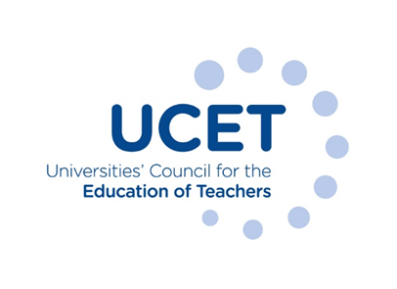

Note of the meeting of the UCET CPD forum held online at 1pm on Tuesday 8 November 2022
Welcome, introductions and minutes of the previous meeting
Colleagues were welcomed to the first meeting of the academic year, with a particular welcome given to those attending for the first time. The note of the meeting held on 31 May 2022 was agreed. There were no matters arising not already included on the agenda.
Discussion
A range of issues were discussed, including:
- An update from JNR on non-CPD related issues, including feedback from the previous week’s UCET conference; the new teaching qualification for the FE and skills sector for 2023/24 onwards; the election of new UCET officers; DBS checking for ITE students; and developments in Northern Ireland and Wales.
- Feedback from that morning’s symposium on CPD offers and opportunities extending beyond national NPQ and ECF frameworks. Examples of the content and organisation of such CPD included: non accredited taster programmes for teachers, leading to a ‘Certificate of Participation; CPD on leading improvement & change, and other programmes addressing aspects of leadership not fully addressed by the NPQ; the joint funding of programmes by schools and teachers, with bulk discounts sometimes offered; provision involving a mixture of full and part time students from the UK and overseas; programmes on the development of research skills and helping teachers to critique research; the continued demand for master’s CPD; the possible increase in recruitment to HE programmes should public funding for NPQs come to an end; the use of APL and APCL to encourage recruitment; the holding of CPD conferences; stand-alone PGCerts for those for who a full master’s might not be practicable or affordable; the desirability of CPD that attracts external accreditation (e.g. that for SENCOs); and giving teachers completing the ECF and NPQs the opportunity to build on their learning and attract HE credits, with the potential to progress to full master’s. it was agreed, following discussion, that a sub-group of the CPD forum should be established to investigate the scope to develop and publish case-studies and other forms of evidence from schools about the value of CPD provided by universities. The work of the sub-group might also form the basis of discussions at the next morning symposium.
- The implications for CPD of the Market Review of ITE provision, which (pending the outcome of appeals) might lead to the de-accreditation of 13 HEI QTS providers. The introduction of new quality requirements relating to mentor training and intensive practice might also have an impact, as might the development of wholly new partnerships, which could involve partner schools joining up with national providers at the expense of existing HEs and SCITTs. Discussions might it, was suggested, usefully take place about the pooling of CPD expertise amongst universities and other providers.
- The imminent publication of the new CPD position paper, whose new title would be: ‘Golden Thread or Gilded Cage?’ and would be published as both a stand-alone document and in abridged form, drawn from the existing Executive Summary. Following discussions in break-out rooms, suggestions for dissemination included: local school networks; the Chartered College, with the abridged version forming the basis for an article in the Impact journal; BERA; IPDA; TEAN; subject associations; teacher unions; head-teacher organisations; government and other statutory agencies; social media; the Education Select Committee; TES & Schools Week; ECF and NPQ providers; teaching school hubs; EEF; NASBTT; school governor associations; and the Confederation of school trusts.
- A report on the APPG on teacher development, where the production of case studies (including those aimed at prospective teachers) and think-pieces had been discussed at the most recent meeting.
- Updates from individual institutions where the growth in the international market was noted.

Items for information
The following items were noted for information:
- The summer UCET newsletter.
- A report on the 2022 World Assembly of the International Council on Education for Teaching which had been held at Bath Spa University.
Any other business
None.
Date of next meeting
21 February 2023, via Zoom.

