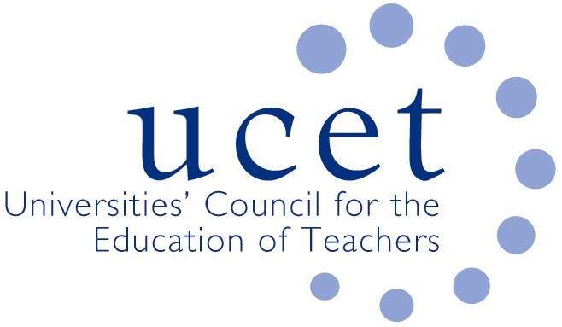
A Registered Charity (No 275082)

9-11 Endsleigh Gardens, London WC1H 0EH

T: 020 7621 6836
info@ucet.ac.uk

Promoting Quality in Teacher Education

Note of the meeting of the UCET Post 16 forum held on-line at 1pm on 21 October 2022

Welcome, introductions and minutes of the previous meeting

Colleagues were welcomed to the first meeting of the 2022/23 academic year, with a particular welcome to those attending for the first time. The note of the meeting held on 20 May 2022 was agreed. There were no matters arising not already included elsewhere on the agenda.

Discussion

A range of issues were discussed, including:

- An update from JNR on non-Post 16 related issues, including: iQTS roll out; the drafting of a new UCET CPD paper; recruitment to QTS programmes; and developments in Wales and Northern Ireland.
- Feedback from that morning’s symposium on the new Diploma in Teaching (FE & Skills) which would be the only publicly fundable teaching qualification for the sector from 2024/25. The new DIT qualification was designed to reflect the breadth of the FE & skills sector, take account from lessons learnt from Covid and elsewhere since the DET had been introduced and address issues raised by OfSTED and employers. A number of issues had been raised during the discussion, some of which were answered while others would be taken away for further consideration. It was agreed that the next morning symposium would be led by colleagues from DfE and from the OfSTED FE policy unit.
- QTS/QTLS parity. A number of instances had been reported of DET qualifications being identified as a route, once QTLS had subsequently been secured, for people to teach in the schools sectors, including the primary schools. While it was agreed that FE & skills teaching qualifications should not be used as a backdoor route into teaching, QTS/QTLS parity was considered to be important and there were legitimate reasons why QTLS holders should sometimes be employed on the same basis as those with QTS in schools.
- Level 3 qualification requirements for QTLS. A number of prospective teachers had it was reported lost employment opportunities because they did not hold a relevant level 3 qualification and so could not be considered for QTLS. This related, in particular, to teachers in SEND schools not being able to achieve QTLS, and therefore maintain their employment, because they did not hold a Level 3 SEND qualification. ETF colleagues reported that in regards ITE students recruited from October, a level 2 qualification combined with relevant experience (e.g., as demonstrated by reports from mentors) would be acceptable. The issue of those on programmes currently who might want to subsequently move towards QTLS would be considered. A number of acceptable Level 3 SEND qualifications had been included on the ETF website. The different requirements for ITE bursary support and QTLS were noted, although DfE colleagues felt that the two were not directly comparable.
- The implications for the sustainability of FE ITE of the outcome of QTS Market Review accreditations, which might lead to circa 20% of QTS providers losing their accreditation. UCET was in the process of supporting relevant members through the appeals process and would continue to offer support in terms of Stage 2, and for providers who might want to either develop new partnerships or diversify away from QTS.
- Changes to the DET minimum core for 2022/23 onwards, which now covered EDI and ESD. The minimum core was, ETF explained, a guide for ITE providers and indicated the areas which ITE students should cover during their training, and in the context of their status as students. The expectations set out in the minimum core did not represent expectations applicable to all staff in the FE sector, and it was agreed that the wording of the documentation would be reviewed.
- Updates from ETF, including creation of video resources for teachers, ITE providers and students, including those with a subject specific focus. The Talent to Teach programme, which provided placement opportunities in colleges for undergraduates, would not continue into the next year, although it was hoped it might be reestablished in future years.
- Financial incentives and bursaries for ITE students, where the deadline for accessing bursary funding would close on 31 October. The funding manual was being updated, and colleagues were reminded to provide information on provider contact details, trainee characteristics etc. as part of the forthcoming data collection exercise, the response to which was mandatory. Take-up of bursaries was reported to be lower than on previous years, reflecting general downturns in recruitment. It was confirmed that level 2 qualifications in functional skills was not, because of the breadth of the qualification, acceptable in terms of bursary eligibility.
- Other DfE updates included: the forthcoming publication of a document on expectations in terms of improvement for the quality of ITE, in the context of the broad range of providers in the current market; discussions were taking place with SLC colleagues about the production of clearer guidance on eligibility for student loans, which might have implications for the nomenclature of the new Diploma qualification; the broadening of OfSTED’s remit to include the inspection of non-HEI ITE provision; the embedding of Education for Sustainable Development in the new Diploma and in the DET minimum core; action being taken to prevent the sale of DET exemplification/answers on eBay, under ‘essay-mill’ legislation; and bringing the FE sector into the scope of the Teacher Regulation Agency.
- ITE recruitment, where most (although not all) colleagues reported a downturn in recruitment to pre-service programmes, and some reported a reasonable number of early applications received for programmes beginning in 2023.

Items for information

The following items were noted:

- The UCET summer newsletter.
- Details of the 1-2 November UCET conference which would take place in Stratford upon Avon on 1-2 November (www.ucet/conference).

Any other business

None.

Date of next meeting

3 February 2023

