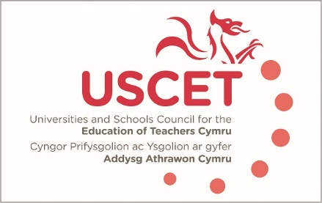

Agenda for the meeting of the University and Schools Council for the Education of Teachers (USCET) to be held on-line at 10.00am on Thursday 26 January 2023

- Welcome & introductions
- Minutes and matters arising (enc.):
  - Global Education Community
  - Tackling educational inequality
- Rob Wilks, Policy Manager for BSL: input into ITE.
- Reports from ITE providers
- USCET response to accreditation consultation (enc.)
- EWC/Estyn regulatory functions paper (enc.)
  - UCET issues:
  - UCET governance & committee/forum structures (JNR)Review of UCET strategy, organisational structures and ways of working (JNR, enc.)
  - UCET December newsletter (enc.)
(11.30am WG, Estyn, EWC & other colleagues join meeting)
- Estyn & EWC regulatory functions
- Accreditation update
- Reports from:
  - Welsh government (inc. UCAS update and GCSE equivalency)
  - Estyn
  - EWC
- Any other business
- Date of next meeting: 18 May 2023

