**Report of the 2022 World Assembly of the International Council on Education for Teaching, held at Bath Spa University on 21-23 June 2022**

This was the first ICET World Assembly since Johannesburg in 2019, and the first in the UK since Glasgow in 2011. It was, as is traditional, preceded by an all-day meeting of the ICET Board on Monday 20 June in the delightful old building at Bath Spa University. This was James O’Meara’s last meeting as President after 10 years of outstanding service. The new President, and former ICET Chair, will be Carol Hordatt Gentles from the University of the West Indies in Jamaica, whom we wish well. The current Chair of ICET is Linda la Velle, who with her colleagues, had organised the World Assembly and did a tremendous job: particular credit being due to Christina Preston of MirandaNet, who secured valuable sponsorship from Zoom, The Wisdom Partnership, Inspiration and the Improvising School. At the board meeting, reports were received on ICET’s work with UNESCO, research activities, financial issues, the election of new ICET officers (Sarah Younie as Vice Chair, and Deb Eldridge as Treasurer) and a preliminary decision to hold the World Assembly face to face every two years, with a virtual event taking place in the intervening years.



*The ICET Board convenes*

I missed the first day of the conference proper because of a clash with the UCET Management Forum, and was disappointed to miss what I understand to have been excellent keynotes from **Sarah Younie** on ‘*Reimagining Education for teachers: time for transformation’*, and **Andy Hobson** on ‘*Onside co-mentoring for teacher -education: breaking down the last vestiges of hierarchy’,* as well as a number of outstanding paper sessions and workshops around the theme of technology in teacher education. I was however able to attend that evening’s opening reception which was held at the Bath Royal Scientific and Literary Institution, which included welcome speeches, food and drink and a presentation on MirandaNet, a professional development research-based resource for teachers relating to ICT and the World Wide Web.

The second day began with a keynote address from ICET Board member, and UCET Executive Committee member, **Tanya Ovenden Hope** based on her ground-breaking research with **Rowena Passy** on *‘Why are Educationally Isolated schools challenged by teacher supply?’*. The recruitment of student teachers in England, and the retention of existing teachers, is a serious problem and, based on feedback from delegates, other countries are experiencing similar challenges. The pandemic had for a short time masked the problems and encouraged a sense of complacency by government and the situation is now worse than it was before, with significant demographic pressures looming. Isolated (in terms of geography and access to financial, physical and cultural capital) schools face additional challenges, both in terms of teacher recruitment, but also because there are not healthy levels of churn as serving teachers are, due to a lack of alternative employment opportunities, reluctant to leave, thus reducing the scope for schools to bring in new staff with fresh ideas and approaches. Such schools also find it difficult to apply for external project related funding, either because they lack the bid-writing expertise that larger groups of school have, or because government agencies might favour applications which produce greater ‘bangs per-buck’ in terms of outcomes than is possible in areas with relatively small populations. The problems are, in short: lack of access to a high-quality workforce; lack of CPD opportunities for serving teachers; limited access to external interventions; geographical isolation; cultural isolation; and socio-economic deprivation.

The keynote was followed by a report on ICET’s work as joint **thematic leaders with VSO** as part of the UNESCO Teacher Task Force, which raises awareness, expands knowledge and supports countries to meet UNESCO targets in relation to, for example, a fully qualified teacher workforce through knowledge production, advocacy and the utilisation of national and regional policy levers. Conference attendees were invited to input into the work of the thematic group in advance of a high-level UNESCO summit scheduled to take place the following week.

The second and final keynote of the day was from **Akwasi Addae-Boahene** on: *Reforming the Teacher Education system in Ghana: the path to systemic impact’*, ably assisted by **Bea Noble-Rogers** who has worked on the project in partnership with Akwasi and others since its inception in 2015 with funding from DfID. The project began when it was becoming increasingly clear that ITE for pre-tertiary education needed reform. High ambitions were set for an ITE system that would equip new teachers with critical thinking, enquiry, technological expertise, problem solving and communication skills, and would make teaching an attractive career option. The intention was to educate a cadre of teachers who would do much more than simply equip pupils to pass exams. Central to this work was the development of new and widely accepted teacher standards, an ITE curriculum and the introduction of a new four-year BEd, as well as a change in the culture and management of teacher education and the ending of a near monopoly by just one institution.

These reforms were, unlike in some countries, developed from the bottom up and agreed, following a ‘big-conversation’, with all relevant stakeholders, including the teacher unions, whose unanimous commitment and support were instrumental in securing the agreement and buy in of the Education Minister and, following a change of Government, the agreement of the new minister and, the entire new cabinet. International experts subsequently described the reforms as being *‘genuinely world class’*. And early metrics point towards significant success. The work of TTEL has recently evolved into being less of a one-off project and is now recognised as an NGO, and as such, has secured funding of $16 million dollars from Mastercard, and additional funding from Jacobs, to support the reform of secondary education. Key to the project’s success, according to Akwasi, was stakeholder support, co-construction and political backing. A bottom-up rather than a top-down approach.

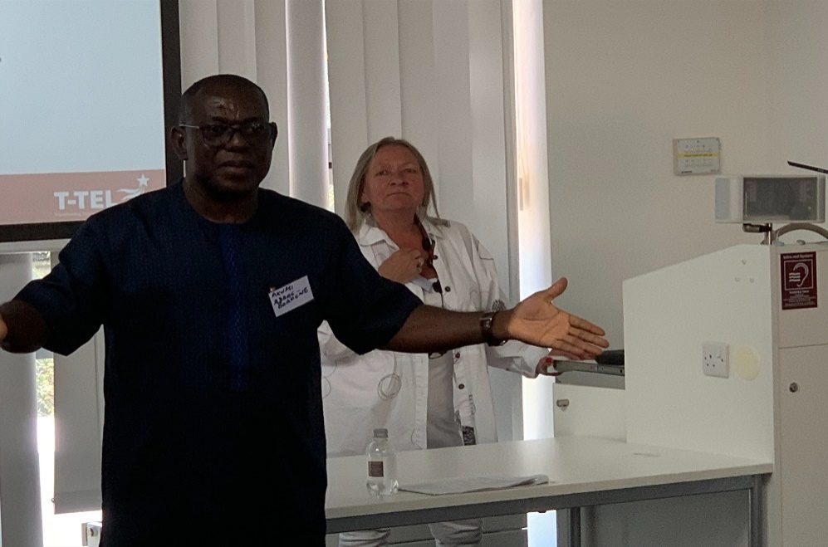

*Akwasi Addae-Boahene and BNR at the ICET conference*

UCET Vice Chair **Trevor Mutton** delivered an excellent keynote on the Thursday morning on *‘What is the future of initial teacher education’,* changed from the more pessimistic earlier title *‘Is there a future for teacher education?’*, drawing on a range of international research framing the analysis with a number of questions posed by Carol Bachi in her ‘*What is the problem represented to be?*’ model, including reference to the focus by policy makers on value-added and economic measures of teacher education effectiveness . He went on to identify how these measures and assumptions were reflected in the myriad of teacher education policy documents that have been published in England, from the 2011 ‘Importance of Teaching White Paper’, the 2012 Teacher Standards, the Carter report, the ECF, the CCF and, most recently, the ITT Market Review. After noting that the easiest response to such things might simply be to go along with the flow and salvage what one can, he suggested that teacher educators should instead focus on what does actually make a good teacher (and by implication the kind of teachers that ITE should develop). Although teachers require both craft knowledge and technical knowledge, neither alone is sufficient; a model of the teacher as a full professional requires also the capacity for critical reflection. As a model of the characteristics that all teachers should have, the work of the UCET Intellectual Base of Teacher Education Group was referenced. This prompted a very positive response from those in the audience.

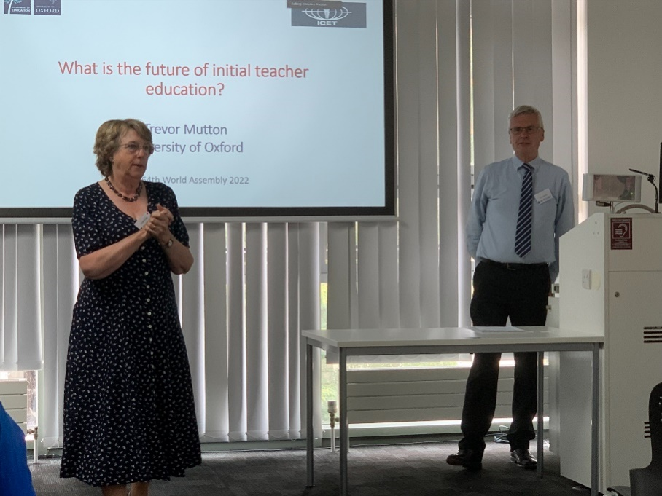

*ICET Chair Linda la Velle introduces Trevor Mutton*

The final keynote of the conference was on ‘*Reclaiming creativity and transforming teacher education in crisis time’* from **Larissa McLean-Davies** from Melbourne, who spoke about the scope that times of crisis (Covid, climate change, the need for inclusion) can act as a spur to act creatively and to think outside existing paradigms, collectively to mobilise knowledge and understanding and crucially, to bring together people from different disciplines to meet changing needs and contexts. Much of teacher education has in the past been geared towards controlling rather than encouraging creativity, for example through the imposition of restrictive teacher standards and the assumption that knowledge is fixed and not open to critique. A project at Melbourne, which took account of the knowledge and understanding of indigenous people (e.g., in respect of having a holistic and joined-up understanding of place, and so of climate issues) has been re-imagining the teacher education curriculum to encourage a critical approach, the development of new partnerships, the bringing together of theory and practice and the breakdown of subject, disciplinary, philosophical and cultural boundaries. This approach contrasts with a 2022 report by the Australian government which would, if implemented, do nothing to address the new crisis-driven priorities or foster shared responsibility and the creation of new knowledge. Key challenges were, she said: the need to consider teacher education with reference to the whole of a teacher’s career; decolonising ITE; not only teaching what one already knows; the potential role of teacher educators as epistemic agents and brokers, and the need to speak back to – and recreate – teacher standards.

As well as the keynotes, the conference included a range of excellent workshops and symposia, including from **Rachel Lofthouse, Deb Outhwaite, Linda la Velle,** and one including myself and colleagues from Israel, Canada, Jamaica and Portugal speaking about teacher education policy reforms in their respective countries. It was clear that there were a number of common themes to top-down driven ITE policy reforms although, based on audience reaction, if a prize had been awarded for the least well-thought through, disruptive and downright daft reforms, it would have gone to England.

A much-loved tradition of the World Assembly is the **gala dinner**, which was held at the Apex Hotel at the end of the penultimate day. This involved much dancing and jollity, all helped along by a very good band that included a familiar looking saxophonist by the name of Nick Sorensen, formerly of Bath Spa University, now of *The Improvising School*.



*Closing ceremony*

JNR

UCET

June 2022