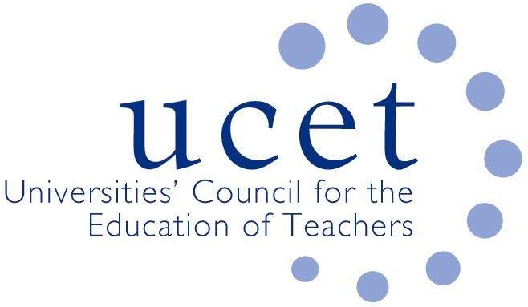
A Registered Charity (No 275082)

9-11 Endsleigh Gardens, London WC1H 0EH

T: 020 7621 6836
info@ucet.ac.uk

Promoting Quality in Teacher Education

Note of the meeting of the UCET ITE secondary forum held on-line at 1pm on Tuesday 14 June 2022

Welcome, introductions and minutes of the previous meeting

Colleagues were welcomed to the final meeting of the academic year, which was being chaired by Bryony Black. The note of the meeting held on 8 March 2022 was agreed. On matters arising, Tracy Wallis was thanked for Chairing the 8 March meeting in the absence of the forum chair and vice chair.

Discussion

A range of issues was discussed, including:

- An update from JNR on non-secondary related issues, including: latest developments on the drafting of a new teaching qualification for the FE and skills sector, the drafting of a new UCET CPD paper on the ECF and NPQs; and developments in Wales and Northern Ireland.
- The DFE review of the ITE Market. The results of round 1 accreditations had been announced on 16 May, with just 27% of providers being successful, although a significant number were thought to have missed out by just one or two points. Concerns had been expressed to the minister and others about the fitness for purpose of the process, and the misleading, incomprehensible and contradictory nature of the feedback that had been given. The deadline for round 2 applications was 27 June. UCET’s policy was to support member institutions in whatever course of action they chose to take. For those choosing to apply or reapply in round 2, workshops addressing each of the main subject areas would be held. In response to a question, it was confirmed that providers were not required to submit formal expressions of interest to apply or reapply in round 2. The Stage 2 process for those that had been successful in round 1 would begin with a conference in June that all providers would be expected to attend, followed by the submission of curriculum materials to approved DfE ‘experts’. References to the possibility of the withdrawal of accreditation during round 2 had, at UCET’s request, been removed.
- Recruitment to ITE in 2022, where mixed reports were given although applications were generally struggling, and changes in bursaries were having an impact with, for example, not suitably qualified people applying for particular bursary subjects. School Direct was not recruiting well, and some schools were requesting that those students they had recruited be transferred to core provision because of viability issues. There had been a significant increase in the number of international applicants, not all of whom were appropriately qualified. The quality of UK applicants was also reported to be mixed. PE, for which recruitment caps had been removed, was also recruiting poorly.
- The availability of placements had generally improved since the previous meeting, although concerns were expressed about future availability in case MATTs and others chose, partly because of the Market Review, to only work with one provider. Mentor capacity because of the ECF continued to be an issue, with a particular impact on initial ITE placements. General pressures on schools, including those relating to Covid, were in some cases reducing placement capacity and schools’ ability to engage with ITE more generally. ITE students having to self-isolate were now classified as ‘absent’ as opportunities to engage with schools remotely no longer existed.
- Retention and employment. Students were experiencing increased financial difficulties, for example because of increased travel costs, and those without bursaries often had to secure part-time work, which reduced the time they had to address issues in relation to, for example, subject knowledge. Schools were also increasingly finding it difficult to provide additional help to students requiring extra support and were more likely to advise them to withdraw or ask the ITE provider to find them an alternative placement. More students were requesting deferrals or withdrawing from programs completely. Many students and mentors were experiencing anxiety issues, which impacted on retention. The impact of Covid related forced isolation had also affected the behavior, resilience, socialisation and professionalism of some student teachers. Employment rates were generally reported as acceptable, although ECTs were more likely than before the pandemic to take a year or two out on completion of their ITE.
- DBS and keeping Children Safe in Education (KCSIE), where colleagues were reminded of their responsibility to have regard to KCSIE when recruiting to programs and of making ITE students aware of safeguarding procedures and regulations.
- SKE issues, including the need for geography and general science SKEs. A number of providers had closed their SKE provision. Some MATTs had, on the other hand, established their own programs.
- It was agreed that the next morning symposium would be on mentoring, ITE curricula and assessment, with volunteer speakers to be invited.

Items for information

The following items were noted:

- The Easter UCET newsletter
- The 1-2 November UCET conference, which would be held in Stratford upon Avon, with keynote speakers including: Tim Brighouse & Mick waters; Gayle Gorman; Dame Alison Peacock; Stefanie Sullivan; and James Williams.

Any other business

None

Future meetings

The next meeting would take place on Tuesday 22 November via Zoom.

