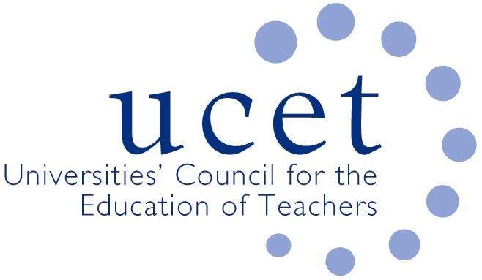

A Registered Charity (No 275082)

*9-11 Endsleigh Gardens, London WC1H 0EH*

*T: 020 7621 6836*

*info@ucet.ac.uk*

*Promoting Quality in Teacher Education*

**Note of the meeting of the UCET Post 16 forum held on-line at 1pm on 20 May 2022**

Welcome, introductions and minutes of the previous meeting

Colleagues were welcomed to the final meeting of the 2021/22 academic year. The note of the meeting held on 4 February 2022 was agreed. On matters arising, it was reported that the results of round 1 of the ITE Market Review for QTS accreditation had been announced on 16 July. Concern had been expressed about the efficacy of the process, which had seen fewer than 40% of applications being successful, although it was understood that a significant proportion had only missed out by 1-2 marks. The quality of the feedback was reported to be poor and often inconsistent. There were concerns about the potential impact on teacher supply and on the indirect impact on the viability of PCET provision. UCET’s focus had been on supporting members through stage 2 of the process and expressing serious concerns about the process.

Discussion

A range of issues were discussed, including:

* An update from JNR on non-Post 16 related issues, including iQTS pilots and developments in Wales and Northern Ireland.
* Feedback from the morning symposium on how FE teacher educators use modelling to teach values to student teachers which had been led by Heather Booth-Martin. Suggestions for future symposia included: feedback from OfSTED inspections, including mentoring and the delivery of subject specific ITE.
* Covid related issues, where although placement difficulties were reported to have eased, there were issues around student teachers being expected to stand in for absent teaching staff. Covid mitigations in respect of the DET had, it was reported, been extended until the end of the academic year.
* The development of the new Professional Diploma in Teaching (FE and Skills), which had been expected to be delivered from September 2023 but might now be delayed until 2024/25. A framework for the qualification had been developed by a working group (which included significant UCET representation) and shared with DfE, OfQUAL and others, and discussion was ongoing about the extent to which DfE wanted the Diploma to be a genuinely sector-owned qualification. Changes compared to the DET were likely to include: 75 of the 120 credits to relate to the new ‘core’; it would reflect the new Occupational Standards that underpin the new apprenticeship qualification; the inclusion of ESD and professional practice components; the scope to allow for credit transfer; and a recognition that only so much ground can be covered in ITE, with further post-qualification early professional development required. Issus still being discussed included: the research base to underpin the qualification; assessment issues; and the articulation of the role of mentors.
* The new professional standards for teachers in the sector and their implications for ITE programmes, where it was confirmed that the new standards should apply to all those commencing training in September 2022 (pending the introduction of the new Diploma), with ITE providers given discretion about whether to use the new or existing standards for continuing students. Views were mixed on the extent to which programmes and programme materials would have to be amended in the light of the new standards, and it was felt that the introduction of the new Diploma should have been more closely aligned with the introduction of the new, post-qualification, professional standards. A comparison between the existing and the new standards, with the differences highlighted, could be found on the ETF website. Post 16 forum members were encouraged to write to the ETF if they were unsure about how to reflect the new standards and had any questions in regards, for example, how to assess student teachers.
* Other ETF updates, including: the new DET minimum core that could be found on the ETF website and would apply from 2022/23; the Talent to Teach programme, giving some 365 undergraduates (and some unemployed graduates) experience in the FE sector and for which an invitation to tender would be issued soon; the development of level 3/4 qualifications to provide a route into teaching for those not yet in a position to embark on level 5 programmes; and plans (subject to funding) to provide support for teacher educators in the sector.
* Training for mentees, linked to ECF’s work on mentor training, with a workshop to be held on 29 June. Post 16 forum members were invited to suggest student teachers who might want to participate.
* Recruitment to ITE programmes in 2022/23, which was generally at 2021/22 levels or slightly below. The profile of applicants had reportedly changed for some providers, and examples were given of ‘bursary tourism’.
* Inspection issues, where OfSTED were reportedly focusing on (amongst other things): subject-focused training; mentoring (including mentor training, and mentor’s understanding of the inter-relationship between the ITE curriculum, the stage which student teachers were at and their own activities). Reports were given of OfSTED not taking due account of the continuing impact of Covid, and pursuing lines of enquiry resulting from, for example, single and unrepresentative comments from individual student teachers.

Items for information

The following items were noted:

* The UCET Easter newsletter.
* Details of the 1-2 November UCET conference which would take place in Stratford upon Avon on 1-2 November (www.ucet/conference).

Any other business

None.

Date of next meeting

21 October 2022.