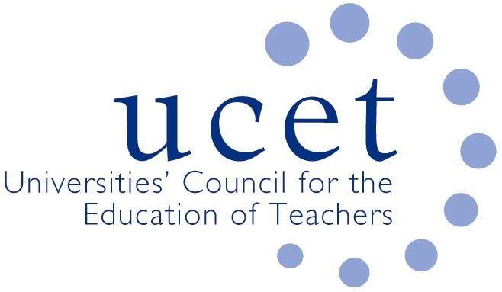
A Registered Charity (No 275082)

9-11 Endsleigh Gardens, London WC1H 0EH

T: 020 7621 6836
info@ucet.ac.uk

Promoting Quality in Teacher Education

UCET NIHELG

12.00pm, Monday 3 October 2022, Old Common Room, Lanyon Building, Queen’s University, University Road, Belfast, BT7 1NN

Agenda
- Welcome & introductions
- Minutes & matters arising (enc.)
- Matters arising from morning UCETNI meeting
- ITE allocations 2022/23
- Lessons learnt from Covid 19 (enc.)
- TPL research project
- UCETNI Partnership sub-group
- Teacher Education Partnership Handbook (enc.)
- Reports from partner organisations:
  - DE
  - Department for the Economy
  - GTCNI
  - EA
  - CCEA
- Date of next meeting: 10 January 2023

