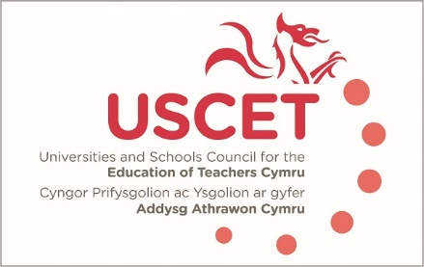

Agenda for the meeting of the University and Schools Council for the Education of Teachers (USCET) to be held on-line at 10.00am on Thursday 19 May 2022

- Welcome & introductions
- Minutes and matters arising (enc.):
  - Talk Pedagogy
  - World Education Summit
  - Global Education Community
- Reports from ITE providers
- Estyn & EWC regulatory functions (enc.)
- Tackling Educational Inequality (enc.)
(11.30am WG, Estyn & EWC colleagues join meeting)
- Estyn & EWC regulatory functions
- Reports from:
  - Welsh government (inc. BME bursaries and GCSE equivalency)
  - Estyn
  - EWC
- Items for information:
  - ITE Market Review in England
  - Easter UCET newsletter (enc.)
- Any other business
- Date of next meeting: tbc

