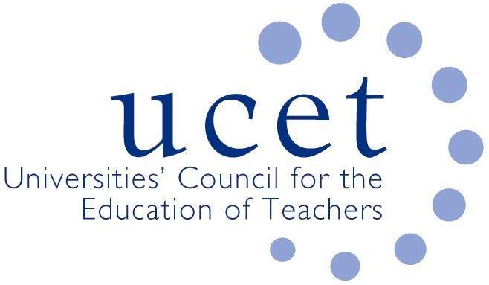
A Registered Charity (No 275082)

Promoting Quality in Teacher Education

Minutes of the meeting of the UCET Northern Ireland Committee held at 10am on Tuesday 11 January 2022 via Zoom

Attendance:

David Barr (UU); Patricia Eaton (Stranmillis); Max Fincher (UCET); Johnathan Heggarty (Stranmillis); Jackie Moses (UCET); James Noble-Rogers (UCET); Martin Hagan (St. Mary’s); James Nelson (Queens, & Chair of meeting).

Apologies:

Roisin McPhilemy (OU).

Welcome & introductions

All were welcomed and apologies noted.

Minutes of the previous meeting & Matter Arising

The minutes of the meeting held on 5 October 2021 were agreed. There were no matters arising not included elsewhere on the agenda.

Updates from member institutions (including Covid 19 and placement issues)

The following updates were received:

- Ulster: Face to face delivery for students was continuing, with a mixture of face to face and virtual for school visits. Some HE staff were not always comfortable visiting schools, for example where pupils were not wearing face masks, and some subject leaders in schools were as a result helping to support lesson observations. Assessments had not been affected as much takes place through the use of on-line portfolios. External examiners were working remotely.
- St. Mary’s: Only final year students were currently participating in face to face learning activities on campus, although others may return when final year students go into school. Placements and tutor visits were continuing.
- Stranmillis: Teaching on ITE programmes will begin across the board later in January, with the intention that as much as possible will be face to face. Examinations are largely being carried out on-line. Students are being kept fully up to speed with developments through regular messaging. PGCE students are in school and face to face visits will begin the following week. On-line examination boards are planned for the summer.
- Queens: All students will be on placement until the end of the month. The number of students with Covid has noticeably increased. Face to face school visits are continuing as far as possible, although these have been limited to at most one per tutor per-day, with lateral flow tests taken prior to each visit. Hoping to return fully to face to face teaching as soon as possible.

Feedback from 17 December Working Group

The key issues raised were:

- Representation from the Council for Curriculum Assessment and Examinations (CCEA) on the Northern Ireland Higher Education Liaison Group (NIHELG), where it was agreed that CCEA should be invited to join in respect of their curriculum and teacher development responsibilities.
- The collection by UCETNI of information on the availability and capacity of school placements and the coordination of ITE delivery more generally, where it was agreed that a sub-group be established.

Teacher Professional Learning (TPL) proposals

The TPL paper was broadly welcomed by the group, particularly the emphasis on teachers themselves having ownership and leadership of their professional learning and the avoidance of any ‘one size fits all’ approach. The paper would be issued to stakeholder groups for consultation as part of a re-launch of the Learning Leaders strategy. Key objectives were to ensure greater synergy between the professional learning teachers experience through all stages in their careers, the use of e-learning portfolios and other aspects of professional learning that had not always worked well in the past. Success would, to an extent, be dependent on funding. Some questions remained about where lead responsibility for aspects of the proposals would rest, particularly in the light of recent developments in respect of GTCNI.

The Department for Education was in the process of developing proposals for the provision of funding, to be allocated through UCETNI, for a researcher to facilitate and draw from workshops of key stakeholder groups (early career teachers, principals, ITE providers etc.) on priorities for TPL. It was agreed to support the proposals, subject to further details and discussion.

Teacher Workforce Planning: correspondence with ministers

The letter on workforce planning sent to the minister on behalf of UCETNI, and the minister’s response, was noted. The minister’s agreement that workforce planning issues needed to be addressed was welcomed, although care would have to be taken of the impact any changes to workforce planning might have on the sustainability of ITE programmes generally.

UCET issues

An update of the review of the ITT Market in England was received. The UCET December newsletter was noted.

Arrangements for NIHELG

It was agreed that the following issues would, in addition to those already covered on the agenda or through matters arising, would be raised:

- A summary of feedback from the feedback from institutions.
- The placements sub-group.
- The minister’s recent announcement on the deployment within schools of student teachers to address supply issues.
- TPL and the proposed research project.
- Workforce planning.

Any other business

None.

Date of next meeting

3 May 2022 (format to be decided).

