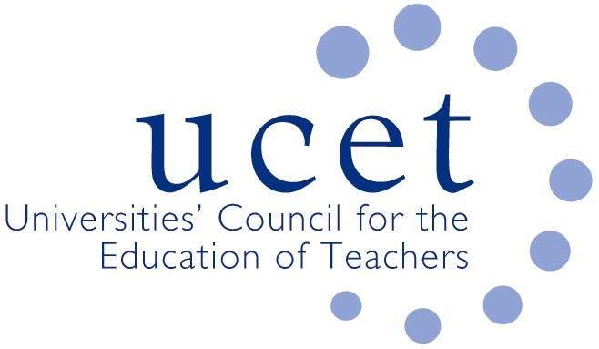
A Registered Charity (No 275082)

9-11 Endsleigh Gardens, London WC1H 0EH

T: 020 7621 6836
info@ucet.ac.uk

Promoting Quality in Teacher Education

Agenda for the on-line meeting of the UCET ITE secondary forum to take place at 1pm on Tuesday 8 March 2022. There will also be a morning symposium beginning at 10.30am on: mentoring, ambitious curricula and student teacher assessment with contributions from, amongst others, Steve Connolly and Gareth Bates. Please click on the following link to register for the event: https://www.ucet.ac.uk/xxxxxx

- Welcome & introductions
- Minutes of the previous meeting
- Matters arising
- UCET updates
- ITE Market Review:
  - Feedback from forum members on applications for accreditation
  - Support for round 2 applications for accreditation
  - Other Market Review updates and issues
- Current ITE issues:
  - Recruitment to programmes for 2022/23
  - Placement issues
  - Covid 19 issues
  - Current ITE requirements
- Inspection issues:
  - Feedback from recent inspections
  - Other inspection issues
- SKE
- Items for information:
  - UCET December newsletter
- Topics for future symposia
- Any other business
- Date of next meeting: 14 June 2022 (format to be agreed)
Supporting papers

- Note of 23 November 2021 meeting
- ITE Market Review FAQs
- UCET correspondence with ministers
- Latest ITE criteria for 2021/22
- FAQ on current ITE requirements
- UCET ITE inspection guidance
- Results of UCET survey on Covid and other pressures
- UCET December newsletter

