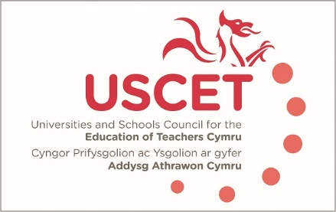

Agenda for the meeting of the University and Schools Council for the Education of Teachers (USCET) to be held on-line at 10.00am on Thursday 27 January 2022

- Welcome & introductions
- Minutes and matters arising (enc.)
- Reports from ITE providers and summary of responses to USCET survey (to follow)
- Reports from working groups
- Estyn & EWC regulatory functions (enc.)
(11:30 am WG, Estyn & EWC colleagues join meeting)
- Estyn & EWC regulatory functions
- Talk Pedagogy (Mark Ford, WG)
- Equivalency testing
- Reports from:
  - Welsh government
  - Estyn
  - EWC
- Items for information:
  - ITE Market Review in England (enc.)
  - December UCET newsletter (enc.)
- Any other business
- Date of next meeting: 19 May 2022

