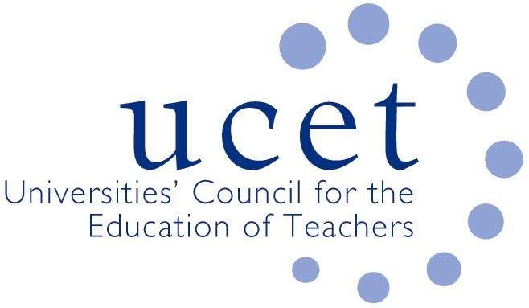

Promoting Quality in Teacher Education

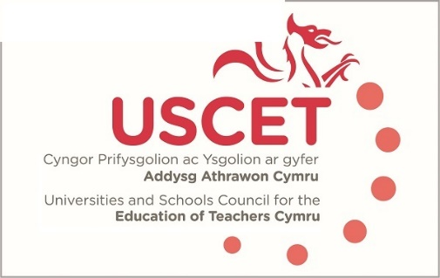

Notes from the meeting of the University and Schools Council for the Education of Teachers (USCET) held on-line at 10.00am on Thursday 21 October 2021

- Welcome & introductions

Lisa Taylor (Chair)
Tracey Eastment
Hannah Barry
Mandy Essen
Tamasine Croston until 11am
Melanie Smith
Sarah Stewart
Sharne Watkins
Helen Lewis
Hazel Wordsworth joined meeting at 12 noon
James Noble Rogers
Jackie Moses

Apologies
Lisa Bowen
Elaine Sharpling
Jonathan Davies

Lisa welcomed everyone and said how challenging the start to the year has been.

- Minutes and matters arising

No actions arising from last meeting and minutes confirmed

- Reports from ITE providers

Helen Lewis – recruited well for year and programme underway, students now on placement. Two challenges, firstly difficult to place students, main reason is the NQT project. James NR – same situation in England (2 reasons given, COVID and ECF) other reason is new primary programme and forward planning difficult as no history to work from and systems for allocations don’t line up.

Sarah Stewart also found placements a challenge in light of COVID recovery, schools evaluating work with ITE and are focusing largely on one provider, as OU is not a mainstream provider they are finding it hard.

Sharne Williams – Agree there is an issue here. Recruitment been buoyant, Estyn visit is imminent, starting in December.

Other concerns expressed included
- schools having to send pupils home due to COVID and the impact this could have upon student teachers being able to complete the statutory 120 school experience days in 2021-22.

Welsh Govt would like providers to get back to the 120 days requirement in school, but this is problematic and is counter to some advice form the local authorities, for example, some are insisting that students stay at home when showing signs of COVID and they are not expected to work. – this could amount to 5-10 days as average.

Mandy Essen – It is likely that the NQT programme will run again next year as generally felt it was a good idea. Need to go back to Welsh Govt to discuss/review this. There is a need to discuss with HEI’s and the regional consortium to ensure that this is managed appropriately and meets the needs of all involved. There seems to be a lot of fallout from the placement scheme which has led to a number of unintended consequences.

Acknowledged that this is a difficult time, schools are struggling with capacity concerns and are exhausted, supple teacher issues not helping so schools are reluctant and may not able to do the additional work that they would normally embrace.

Mandy Essen – looking at some of the standards that students have particular difficulties in evidencing and seeing how this could be better supported. Also looking at setting up triads to share good and effective practice.

Lisa Taylor – USW did over recruit but have managed to place all students. Some DBS applications have been delayed so some late placements. Their new PGCE is starting next Sept so starting recruiting to that and appreciate the difficulty mentioned earlier concerning recruiting without firm numbers.

To note - PGCE applications on the UCAS site appears in the UG area, it may be necessary to direct students. Providers should also be aware that you can only upload 1 reference, so admissions teams need to be know if they are requesting 2 references.

Sub Group Updates

PCET – joined by Steve Bell from Estyn and Helen Scaife from Welsh Govt.
Estyn report on PCET provision and the report is now published, number of themes coming out around strategic direction, Welsh language, networks, QTS pathways and conversion. The report also includes a number of recommendations and Melanie Smith can share report if people would like to contact her directly. https://www.estyn.gov.wales/thematic-report/initial-teacher-education-post-compulsory-education-and-training-sectors

PCET placement still an issue and there may be a need to review this the number of hours required to help ease this
QTLS will only apply at level 7 but sector also covers level 5 & 6 so is problematic/complex.

Meeting felt it would be useful to have an update from WG re BAME applications targets that are being suggested. JNR – this has been tried before and isn’t that simple and could have negative effect on overall recruitment numbers. The issue is wider than just ITE. Might be better to set targets as extra places rather than part of the allocation.

A question was raised as to whether incentivisation was the right approach to improving recruitment. Felt that need to look much more broadly at this as it is more complex than being currently presented.

USCET Partnership & Strategy Paper

Decided to shelve this for today’s meeting as want to spend time looking at the monitoring process from EWC

Equivalency Tests

No update at the minute as Welsh Government are still looking at this. The issue around the B grade requirement is still prevalent but this may change due to Welsh Government’s focus on widening participation, specifically in the BAME sector.

Estyn/EWC Briefing Paper

There appears to be a lot of overlap between the role of Estyn & EWC. For example, EWC are present at the final feedback from Estyn and there is a sharing of documentation. It had previously been agreed that they would work collaboratively and complimentary but providers not seeing this at the minute. Concern that this could result in constant visits which could have a huge impact on institutions especially in terms of cost and resource; may even lead to some VCs deciding that ITE is too costly.

It was agreed that there is a need to look at what the legislation requires each of them to do and what it allows them to do (subtle but important difference) work roles could then be rationalized and this would lead to a reduced workload and less overlap.

The Chair suggested putting together a paper to challenge this. It was also suggested that we ask Estyn and EWC to put together paper to outline what their distinct roles and remits are and if these were laid side by side it may highlight where the overlap and issues are.

An email has been sent to WG outlining the concerns of the sector and asked for this to be looked at as a priority. For this afternoon’s meeting it would be good to ask for clarification and request they both look at documentation to address overlap and thereby reduce burden on providers.

USCET meetings from January 2021
(12 noon WG, Estyn & EWC colleagues join meeting)

Joining the meeting at 12 noon

- Welsh Government – Lisa Drury-Lawson, Max White
- Estyn – Sarah Lewis
- EWC - Bethan Stacey

Reports from:
  - Welsh Government
      - Ministry announcing launch of BAME plan (tomorrow morning), first phase focusing on what we can do now. Reliant on numerous other areas of education sector for its successful outcome. Going to be a challenge but in process of commissioning support from BAME community to work with providers to deliver on this. Also setting up a working group with cross representation to establish how the sector will take it forward.
      - Development of Welsh Medium Strategy – Ministry very keen, updates to follow but again it will need provider cooperation and collaboration to be successful.
      - Finalising arrangement to incentives schemes, these have just been signed off by the Minister but not in position to share details yet, will do so as soon as they can but confirm that there is a focus on where we need to address shortage areas.
      - Working on allocations for next year’s recruitment – hopefully will be able to complete soon and get ministerial approvals. WG looking to keep steady state in terms of numbers. Will shortly need to look at putting more emphasis on secondary subjects, 30% Welsh medium recruitment already in requirements, looking at additional 5% for BAME recruitment from next round.
      - Looking at revised system for criteria for new accreditation process – from 2024, probably not major changes but ensuring that certain areas are strengthened.
Questions/ Observations
Number of partnerships raised concerns about placements – and unintended consequences of placement programme for NQTs. May have to look at 120 days school experience as this has had knock on effect. Also, ongoing impact of COVID and the lack of supply teachers is creating ongoing challenges in this area.
Some LAs are insisting that if students are at home self-isolating they can’t work and can’t engage with school, the result is 5-10 days missing placement time. It would be good to keep these conversations going in monthly catch ups
Response from Welsh Government
There is a need to keep this on the agenda, we may need to keep some of amended criteria in place which could be adjusted at local level. The 120 days can be a mixture of methods although preference would be for it to be in school. We will continue these conversations in the partnership meetings. It feels a bit disingenuous if schools are using NQTs as excuse for not taking student, NQTs should be seen as an additional resource, there is obviously a need to discuss further. WG are aware of the teacher supply issues. They have been around for a number of years but exacerbated by COVID, it does though, need further thought/discussion. WG felt that the response of LAs to self-isolating students appears odd and they were not sure they understood the rationale for it, some clarification is needed (it was explained that this was not just LA response but that it was also coming from the Unions, who state that if off ill they shouldn’t be working), it is however inconsistent across sector, there is a need to have conversations with relevant authorities and make sure message is consistent.
Chair raised questions of allocations and acknowledged the difficulty here but stressed if they could be given as early as possible as new programmes are disadvantaged in terms of recruitment as they are unsure of their target numbers until late. It was also acknowledged that it was good to hear that the Welsh Medium and BAME allocations are a ‘working towards’ target rather than a set allocation. As the later may have a negative impact on recruitment.
Chair also raised a serious concern from partnerships in relation to the work of Estyn and EWC. In reviewing recent documentation, it appears that there is a lot of overlap in terms of roles, it was asked if there could be a paper that clarifies this, so everyone is clear. WG wouldn’t commit to producing a paper but did acknowledge and understand the concern but stated that there is still work ongoing to look at this and streamline the processes, WG are working with both Estyn and EWC on this and the next meeting is mid-November.
EWC’s response was that they wholly agree that message needs to be better and more consistent and stressed that conversations are ongoing with a view to resolving some of the issues and improve the messaging. They stressed a desire to give reassurance on this matter.

  - Estyn Updates
      - Recent publication on Initial Teacher Education in Post Comp Education & Training (check website link above)
      - There has been further training of additional & peer inspectors, and this has been positively received and proven to be a useful way to share information around system.
      - The 12 November event will focus on ‘The Curriculum for Wales and Additional Learning Needs’
      - New guidance on inspection is now published and on website. Thanks to input from sector. This is still draft as need to be tried out. Estyn have been working closely with EWC in looking at how the processes will work across both organizations over next few years. They acknowledged that there is still some work that needs to be done especially in addressing any overlap and ensuring that the burden on partnerships is kept to a minimum. Estyn have removed their programme of annual monitoring, they are also reviewing the link inspector programme and looking to replace that with opportunities for partnerships to feed into Estyn’s thematic work.
      - Inspection cycle begins this year, undertaking one pilot inspection (Cardiff partnership), may result in some small changes but hard to know until tested.
      - Are working on a paper to clarify roles within the new system and ensure minimum overlap and establishing single process.

  - EWC Updates
      - The document that has been circulated is committed to developing a single process whereby accreditation, monitoring and inspection work together. EWC are working closely with Estyn to ensure that two areas complement each other but state that there is still some work to be done. Discussions are ongoing with Estyn and they would both appreciate any feedback on the document. The Chair explained that USCET has discussed this and will provide feedback on behalf of the sector.
      - The EWC annual event – There was one last March and there is an intention to hold another event before the end of financial year. They would like providers to present one aspect of their provision, covering how it is working, any development and any areas of good/innovative practice. The event will held virtually, EWC will meet with partnerships and discuss this further. The exact format is yet to be finalized.
      - Andrew Pickford has been appointed as ITE manager and will be joining EWC from 16th November

To Note
- UCET Conference online 2 & 3 November 2021

Date of next meeting

27 January 2022 - online

