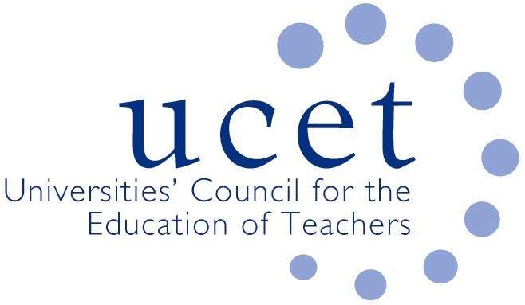
A Registered Charity (No 275082)

9-11 Endsleigh Gardens, London WC1H 0EH

T: 020 7621 6836
info@ucet.ac.uk

Promoting Quality in Teacher Education

Agenda for the meeting of the UCET Research and International Forum,
1pm, Tuesday 18 January 2022, Via Zoom

There will be a morning symposium beginning at 10.30am. The topic will be ’research integrity and the ITE Market Review’
To register for the symposium please click on the following link:
https://www.ucet.ac.uk/13260/research-and-international-forum

- Welcome & introductions
- Minutes & matters arising
- UCET updates
- ITE Market Review and feedback from morning symposia:
- Topics for future symposia
- International issues:
  - BERA Research Intelligence special edition on international perspectives on the curriculum
  - UCET travel scholarships
  - iQTS
- Equalities issues:
  - BERJ issue on refugee education
  - Feedback from 14 December Equalities Sub Group meeting
- Items for information: December newsletter
- AOB
- Date of next meeting: Monday 23 May 2022
Background papers
- Minutes of the previous meeting
- DfE Market Review:
  - DfE consultation report
  - DfE FAQs
  - UCET letter to Robin Walker
- Link to BERA Research Intelligence special edition
- Link to BERJ issue on refugee education
- UCET December newsletter

