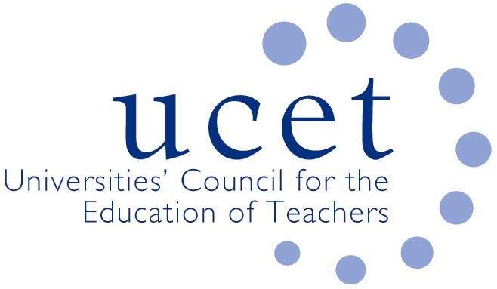
A Registered Charity (No 275082)

Promoting Quality in Teacher Education

Minutes of the meeting of the UCET Northern Ireland Committee held at 10am on Tuesday 5 October 2021 via Zoom

Attendance:

David Barr (UU); Johnathan Heggarty (Stranmillis); James Noble-Rogers (UCET); Martin Hagan (St. Mary’s); Roisin McPhilemy (OU, Chair); James Nelson (Queens).

Apologies:

Jackie Moses (UCET).

Welcome & introductions

All were welcomed and apologies noted. A special welcome was given to Johnathan Heggarty who was attending his first meeting.

Minutes of the previous meeting & Matter Arising

The minutes of the meeting held on 4 May were agreed. On matters arising, it was reported that a reinstatement of HE funding for ScOTENs had been secured.

Updates from member institutions (including Covid 19 and placement issues)

The following updates were received:

- Queen’s: ITE places for the current year had all been filled by June, although there had been a concerning number of withdrawals and deferments during the summer, particularly in post-primary maths. A blended approach to programme delivery, with some provision taking place face to face and some on line, was continuing (graduation ceremonies had been on-line, and ‘non-travel Tuesdays had been introduced for both staff and students). Placements were broadly on-track. A number of unqualified but experienced teachers from the Republic had applied for programmes because of new requirements in the south relating to teaching qualifications.
- St. Mary’s: Challenges from the previous academic year had, partly because of the collegiate and consistent approach taken across the sector, largely been met. The blended approach being adopted for the current year (which might itself need to be more carefully defined) might however bring its own challenges. Large lectures and sessions involving 75 or more students will take place on-line. Students would be placed in school after Christmas, although some visits to schools might take place before then. Issues were arising in cases where staff had to shield or self-isolate.
- Stranmillis: Lectures, seminars and workshops were continuing, with those involving 100 or more people taking place on-line. More than 90% of students had been vaccinated. Concerns existed about recruitment to STEM subjects (both ITE and pre-ITE) and the difficulty of meeting the supply needs of schools and colleges. A collaborative approach by the sector, ED and schools was needed to address this.
- Open University: Recruitment to the BA(Hons) in Education Studies (primary) generally was healthy, in part because of the OU’s experience of providing on-line courses. Resource banks allowed ITE (not relevant to the NI context) and CPD students to view classroom practice. It was hoped to return to some face to face provision in the 2022/23 academic year.
- Ulster University: A hybrid approach remained in place, with a mixture of on-line provision (especially for larger groups) and face to face. Placements for primary students had begun, and post-primary students would begin to go into school from November. Virtual observations of students on placement would take place where needed, for example if HEI staff had to self-isolate or shield. Contingency plans were in place should Covid infections increase. Students were being encouraged by the university and some partner schools to vaccinate. Protocols on social distancing etc. were on the whole being observed.

Feedback from the ITE working group

Feedback from the 16 September ITE working group included: The Department for Communities recommendation on compulsory SEND modules for ITE and DE’s response about ITE being just the first phase of teacher professional development, and that any significant additions to ITE curricula would have to be offset by reductions elsewhere; Fair Start and the response by some HEIs to requests from DE for information; the suggestion by DE that work be started on digital e-portfolios on teachers professional development (about which they had been referred to the EWC in Wales about its Professional Learning Passport); and the scope to deliver more part-time and distance learning ITE, which could it was noted only be realistically achieved by increasing ITE allocations. During the discussion, the assumption by some ETI inspectors that ITE could cover everything that teachers need to know about SEND ITE was questioned. Clarification was also required about the number and coverage of government sub-groups with ITE representation and who these representatives were.

UCETNI priorities for 2021/22

Priorities for UCETNI discussion and actions included: coordinating responses from across the sector to relevant reviews & initiatives and sharing information and approaches; pressing DE and GTCNI on the roll-out of the new teacher competencies framework; the involvement of the ITE sector in the Review of Education; recruitment to ITE and workforce planning for schools and colleges; and the implications for some ITE providers of the government’s review of NDPBs.

It was agreed that, rather than hold its own event to showcase the sector, UCETNI would be better placed to contribute to those organised others, although the value of giving staff from the ITE sector the scope to meet collectively should not be overlooked.

UCETNI meetings for 2021

It was agreed that, subject to room availability at the OU, the next two UCETNI meetings would take place face to face.

Arrangements for NIHELG meeting

Arrangements for the afternoon meeting were discussed and agreed.

UCET issues

A brief report on the review of the ITE Market in England was provided. Registration for the annual UCET conference, which would take place on-line 2-3 November and was free of charge to colleagues from members of UCETNI institutions, was open at: www.ucet/conference. The UCET summer newsletter was noted for information.

Any other business

None.

Date of next meeting

11 January 2022 at 10am (to be followed by NIHELG)

Membership of the shared education sub-group was subsequently confirmed as: James Nelson (Queen’s); Aideen Hunter (Ulster); Martin Hagan (St. Mary’s); and Lisa Mackenzie (Stranmillis).

