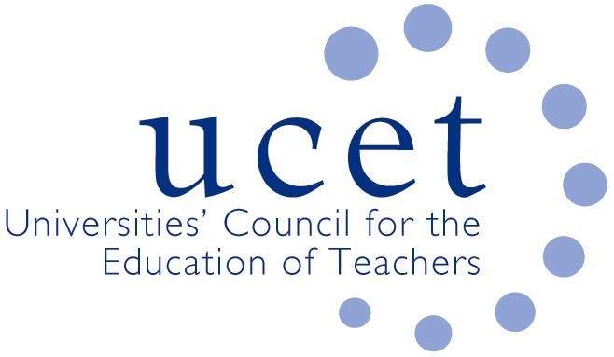
A Registered Charity (No 275082)

Promoting Quality in Teacher Education

Minutes of the meeting of the UCET Northern Ireland Committee held at 12pm on Tuesday 5 October 2021 via Zoom

Attendance:

David Barr (UU); Johnathan Heggarty (Stranmillis); Kyle Crutchley (DE); Averill Morrow (EA); James Noble-Rogers (UCET); Martin Hagan (St. Mary’s); Roisin McPhilemy (OU, Chair); James Nelson (Queens).

Apologies:

Mark Barr (ETI), John Kennedy (ETI), Jackie Moses (UCET).

Welcome & introductions

All were welcomed and apologies noted.

Minutes of the previous meeting & Matter Arising

The minutes of the meeting held on 4 May were agreed. There were no matters arising not included elsewhere on the agenda.

Matters arising from morning UCETNI meeting

The issues discussed included:

- The importance of DE and others taking a strategic and planned approach to workforce planning in the context of increasing reports of a shortage of teachers in some areas, particularly STEM subjects and design & technology. The lack of data on the subject specialisms of teachers, and of the age-profile of the profession was a case for concern. More data was needed on the proportion of teachers remaining in the profession immediately after qualifying (figures from participation in EPD1 and EPD2 programmes suggested that there might be significant wastage). DE colleagues confirmed that data from the Teacher Vacancy Survey carried out each September did feed into calculations of ITE allocations, although this was not subject specific. UCETNI might, it was suggested by some UCET colleagues present, write to the minister about the issue.
- The cross-recognition of teaching qualifications awarded in other countries and jurisdictions, and the issue of unqualified but experienced teachers from the ROI seeking NI teaching qualifications because of new rules in the South. It was agreed that further clarification on the first issue should be sought from the GTCNI, and DE agreed to report back on the second matter.
- The importance of maintaining and increasing momentum in relation to the development of new teacher competencies, to which all ITE programmes would in due course have to align and would have implications for CPD. Meetings of the Learning Leaders working groups and oversight group were being reconvened, and a consultation document on the roll-out and revitalizing of the Learning Leaders strategy was being prepared. The competency framework itself, which formed part of the Learning Leaders strategy, was near completion and work on each would be taken forward in parallel.
- The membership and coverage of various sub-groups covering: SEND; Fair Start; Irish Medium; and Shared Education. It was agreed that DE would supply a list of relevant sub-groups and of the ITE representatives. UCETNI collectively might it was suggested also have representation where appropriate. The recent communication to some ITE providers from the Department of Justice about implementation the recommendations contained in the report of Sir John Gillen’s Review of the law and procedures in serious sexual offences in Northern Ireland was raised. DE agreed to find out more about the possible implications for teacher education.
- The potential role for ITE providers to contribute to the development and implementation of the Skills Strategy.

Updates from partner organisations

The following updates were received:

- Department of Education: DE had approved in a letter dated 16 July the reinstatement of funding for ScOTENs in 2021/22 to support the teacher exchange programme and the annual conference. Following a meeting of the ITE Working Group on 16 September, DE had written to school principals with information about the timing of school placements by each of the HEIs. The letter had already yielded positive results.
- Education Authority: Almost all support for early career teachers had been moved on-line, something which had led to an increase in participation and allowed for a greater range of issues to be covered (e.g. support in relation to the NI curriculum for teachers qualifying in England); the development of coaching conversation skills for tutor-teachers linked to the Leaning Leaders strategy; the coordination of on-line teacher professional learning for ECTs working as occasional supply teachers through a new ‘host school’ pilot; the sharing of concerns expressed earlier during the meeting about the shortage of teachers in some subjects (e.g. D&T) and an apparent over-reliance on teachers trained in England; the Education Technology Programme which was replacing C2K and would provide some 20,400 laptops to teachers from September; and the development of a new EA Digital Learning Service.

Any other business

None.

Date of next meeting

11 January 2022 at 12pm

