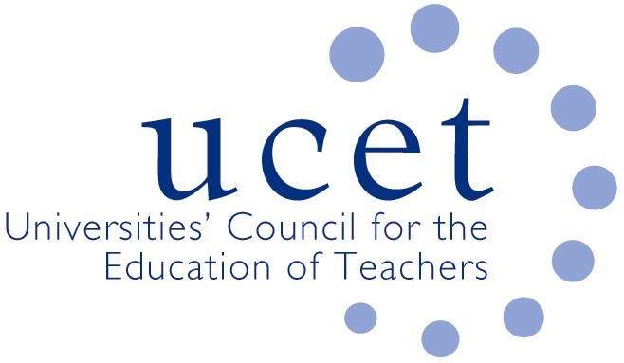
A Registered Charity (No 275082)

9-11 Endsleigh Gardens, London WC1H 0EH

T: 020 7621 6836
info@ucet.ac.uk

Promoting Quality in Teacher Education

5 July 2021

Rt. Hon Gavin Williamson MP
Secretary of State for Education
Sanctuary Buildings
Great Smith Street
London SW1P 3BT

Dear Secretary of State,

ITE Market Review

We are writing to express our concern about the implications of some of the recommendations outlined in the consultation on the ITE Market Review published earlier today. We have made a number of these points during earlier discussions, but they do not seem to be reflected in the published proposals.

There are parts of the Market Review report which we are pleased to support and we look forward to working with DfE on their implementation. For example, we agree that: ITE programmes should be informed by the most up to date and robust research; that there should as far as possible be consistency between ITE curricula and the experience of student teachers in school; and that mentors should have a key role in the delivery of ITE programmes and should be both properly trained and adequately resourced. We also acknowledge that government, or another regulatory authority, has both a right and responsibility to hold ITE providers to account and to ensure a measure of consistency, although not uniformity, in the way that new teachers are trained and educated.

We do however have a number of concerns about: the resource implications of what is being proposed; the planned timescales; the impact on teacher supply; the implications for established ITE partnerships; and the status of the teaching profession. We also do not understand why the Review Group’s suggestions on the content and structure of ITE programmes could not be achieved through changes to the existing ITE criteria without going through the turmoil and risks that a wholesale restructuring of the ITE market would entail.

The proposals in the consultation document are not costed. And yet there will be significant resource implications. For example, increasing the amount of time student teachers spend in school will clearly place an extra burden on partner schools. It will also make it more difficult to ensure consistency and equity, something which the review group itself recognises as being important. The proposal to ensure student teachers receive minimum levels of mentor support, and that lead mentors have an entitlement to proper training (both things that we welcome in principle), will also cost money. The increase in the length of postgraduate ITE programmes to 38 weeks will have cost implications for providers, despite the fact that ITE is already underfunded when compared to programmes for other professionals. Proposals relating to undergraduate programmes will also cost money. The cost to central government of an intensive accreditation process should also have been set out in the report.

The planned timescales, especially if ITE providers have to go through an unnecessary accreditation procedure, are unreasonable. It can easily take 9 months for programmes offered by universities to be designed, consulted upon and go through revalidation processes. Programme details must, under CMA regulation, be published before students apply for courses. Further information about this has been shared with your officials. It must be taken properly into account before any plans are finalised.

There are potentially huge implications for teacher supply at a time when it is clear that the boost to ITE recruitment resulting from the pandemic is coming to an end. The current organisational structure has been extremely effective in supplying this country’s schools with a large number and diverse range of new teachers each year. This should not be put at risk. One of the key factors in determining an applicant’s choice of ITE provider is location. If SCITT and HEI providers are forced out of the market (e.g. because of expectations in terms of scale) some potentially excellent teachers will be lost. The uncertainty associated with accreditation and reaccreditation procedures, added to increased prescription over how resources within partnerships are allocated, could lead senior staff within universities to conclude that it would be in their interests to divert their attention to more secure and sustainable areas of activity. The pipeline that exists between some non-ITE undergraduate cohorts and PGCE programmes at the same institution will be broken. It cannot be assumed that existing providers will be content to act as junior delivery partners.

The increased involvement of schools in ITE, something which we have long championed, is one of education’s success stories in recent years. Schools are often involved in ITE partnerships because of the relationships they have developed with their partner providers over a number of years. There is no guarantee that they will be willing to partner with other, potentially remote, organisations, especially if this leads to a loss of flexibility and ownership and increased prescription about what they do and how they do it. The withdrawal of schools from partnership will lead to fewer placement opportunities for student teachers. That in turn will act as a further constraint on recruitment.

It is in our view essential that ITE programmes are research informed and that new teachers are equipped to be able to interpret, apply, critique and contextualise relevant research. This is, at least in part, acknowledged in the consultation proposals. However, the proposals also imply that some research is incontestable and set in stone. We do not agree with this. There are always alternative approaches and new teachers should be aware of these. The status of teaching as a profession depends in part in it being an intellectual endeavour. Breakthroughs in education have often resulted from a questioning approach. The continued involvement of some research intensive universities in teacher education might be at risk if they are expected to slavishly follow and accept current and potentially time-limited orthodoxies. The withdrawal of such institutions would do huge damage to the prestige of the profession.

Yours sincerely,

James Noble Rogers

CC: Nick Gibb

xxxxxxJames

