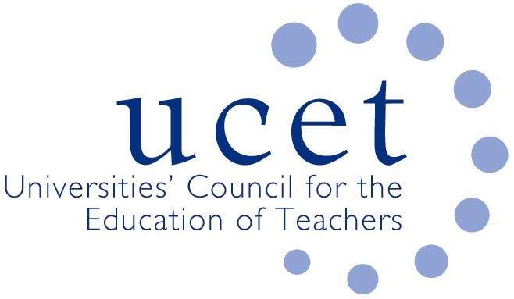
A Registered Charity (No 275082)

9-11 Endsleigh Gardens, London WC1H 0EH

T: 020 7621 6836
info@ucet.ac.uk

Promoting Quality in Teacher Education

Note of the meeting of the UCET CPD forum held on-line at 1.00 pm on Friday 11 June 2021

Welcome, introductions and minutes of the previous meeting

Colleagues were welcomed to the meeting. The note of the meeting held on 26 February 2021 was agreed. On matters arising:
- Colleagues were encouraged to complete the questionnaire on the contribution of teacher education to HEIs. Time for this would be made available after the formal meeting had concluded.
- UCET meetings for the rest of the calendar year, including the annual conference (registration open at: www.ucet/conference), would take place on-line.
Discussion

A range of issues was discussed, including:

- An update from JNR on non-CPD related issues, including OfSTED inspections of ITE (where a focus had been on the alignment between ITE curricula and student teacher’s experience on placement, CCF implementation and the assessment of students); UCET’s response to the iQTS consultation; and developments in Northern Ireland and Wales.
- A brief report of that morning’s symposium on coaching and mentoring led by: Jenny Carpenter; Alison Fox & colleagues; Rachel Lofthouse; and Lizana Oberholzer. The areas covered included: advanced mentoring programmes and feedback from participants; mentor and leadership programmes; mentoring and coaching in leadership; the development of peer mentoring; and the comparison of mentors and mentees at the beginning and end of mentoring programmes. There was discussion about the different roles given to mentors, including those based on gender and the assumptions this implied; and the links between gender and preference for Instructional Coaching. Potential mentor burn-out resulting from CCF and ECF expectations was also raised. It was agreed that the topic for the next morning symposium would be the contribution to HEIs of teacher education, including an analysis of the results of the survey referenced above.
- The implications for CPD of government policies in relation to: the ITE Market Review; the Institute of Teaching; Teaching School Hubs and the ECF. The following issues were made following a presentation from JNR and subsequent group discussions:
  - Many Teaching School Hubs continued to value the support given to them by HEIs and would continue to work in partnership, although this varied from hub to hub and region to region. TSHs were often unclear about their roles and responsibilities, particularly in regard ITE, and would need advice and support (although HEIs were not always in a position to give advice in respect of some recent reforms).
  - Some schools were reluctant to work with new TSHs because of the relationships they had developed with earlier teaching schools and other partners.
  - Increased prescription over the content and structure of ITE and CPD programmes could damage the autonomy of both HEIs and teachers, prevent the contextualisation of programmes and undermine the academic standing and professionalism of teaching. This was particularly the case when HEIs were acting as delivery partners for the ECF and NPQs and, potentially, ITE.
  - Demographic changes might reduce the demand for new teachers in the near future, potentially giving DfE more flexibility in the imposition of ITE reforms.
- Proposed quality assurance procedures for CPD programmes, which were felt to acknowledge the importance of criticality and contextualisation to a greater extent than government.
- National Professional Qualifications, including the new specialist NPQs in Leading Teacher Development, Leading Teaching and Leading Behaviour and Culture
- The Early Career Framework, including: discussion of the UCET Effective CPD paper at the APPG, the IPDA conference and Collective Ed; and UCET’s critical response to the recent DfE webinar for UCET and NASBTT members.
Items for information

The Easter UCET newsletter was noted for information.

Any other business

None.

Date of next meeting

Tuesday 9 November 2021, via Zoom.

