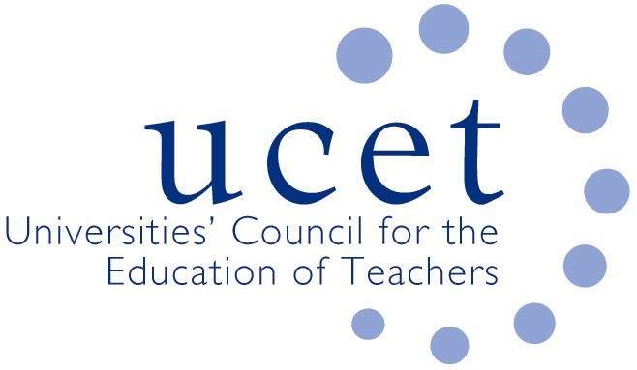

Promoting Quality in Teacher Education

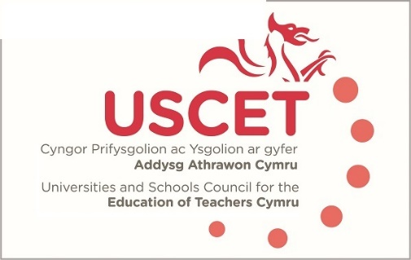

Agenda for the meeting of the University and Schools Council for the Education of Teachers (USCET) to be held on-line at 10.00am on Thursday 21 October 2021

- Welcome & introductions
- Minutes and matters arising
- Reports from ITE providers
  - ITE recruitment
  - Placements
  - Other
- USCET partnership & strategy paper
- Equivalency tests
- Estyn/EWC briefing paper
- USCET meetings from January 2021
(12 noon WG, Estyn & EWC colleagues join meeting)
- Relationship between Estyn & EWC regulatory functions
- Equivalency testing
- Reports from:
  - Welsh government
  - Estyn
  - EWC
- Items for information:
  - ITE Market Review in England
  - IQTS
  - 2-3 November UCET conference
  - Summer UCET newsletter
- Any other business
- Date of next meeting: 27 January 2022

