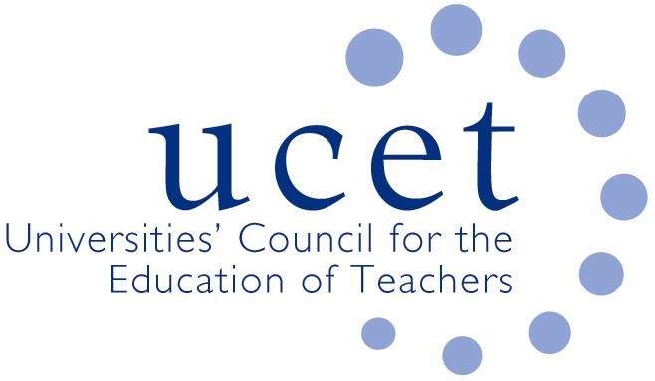
A Registered Charity (No 275082)

Promoting Quality in Teacher Education

Minutes of the meeting of the UCET Northern Ireland Higher Education Liaison Group held at 12 noon on Tuesday 4 May 2021 via Zoom

Attendance:

David Barr (UU); Mark Barr (ETI); Alison Chambers (DE); Kyle Crutchley (DE); Gerry Devlin (GTCNI); Anne Heaslett (Stranmillis); James Noble-Rogers (UCET); Max Fincher (UCET); Martin Hagan (St. Mary’s); Roisin R.McPhilemy (OU, Chair); James Nelson (Queens); Shirley Sweeney (DE); John Unsworth (EA);

Apologies:

Alan Boyd (DE) & Jackie Moses (UCET).

Minutes of the previous meeting

The minutes of the meeting held on 12 January 2021 were agreed. On matters arising, Alan Boyd had discussed the Independent Review of Education with his DE colleague, Peter Hutchinson. It had been confirmed that the Review was scheduled to be completed within 18 months, although there was scope to increase this by 6 months if necessary. ITE will be one of the areas covered. The deadline for applications to be part of the review team closed in March. Interviews would take place and announcements would be made in July. UCETNI would be one of the stakeholder organisations consulted as part of the review.

Matters arising from morning UCETNI meeting

There was agreement that the productive working relationship that had developed between teacher education institutions, UCET, DE and other organisations through the Covid 19 working group and elsewhere should be maintained and developed further. DE confirmed that the working group would continue to meet, albeit possibly less frequently, and could discuss the full range of issues related to ITE. It was suggested that NIHELG might inform some of the issues to be discussed by the Working Group.

UCETNI suggested that it could contribute to any events that DE and others were planning, possibly in relation to Learning Leaders. It was confirmed in response that DE was looking to reconvene the Learning Leaders Communications and Engagement sub-group and that a conference, to which UCET and others such as the Education Authority might contribute, might form part of a communications strategy. Timing might however be an issue, as anytime in 2021 could be too early, while spring 2022 might be affected by election timetables and Purdah.

Covid 19 contingency plans and reports from member institutions

Member institutions reported that programmes were progressing well and placements for students had been secured. Many valuable lessons had been learnt in respect of blended learning, remote observations and partnership working and would be carried forward. Students had received appropriate placement experiences and relationships with schools were good. Campus based sessions were in some instances being front loaded, and breaks were being added prior to placements to support student well-being. Attendance at meetings had been improved, and travel costs reduced, because of on-line meetings.

Support for NQTs

The Education Authority had changed the way in which it provided support to early career teachers, with activities now taking place on-line. This had allowed for stronger and larger networks of new teachers to be established. It was agreed that the EA would provide a more detailed input at the next meeting.

Review of Irish Medium Education

Shirley Sweeney spoke about the development of policy in regards Irish Medium Education. While the quality of existing provision was good, concerns persisted about the shortage of Irish Medium teachers, especially in post-primary. Consideration might be given to developing immersive specialist programmes and to recruiting student teachers directly onto such courses rather than offering enhancement programmes to those already recruited to mainstream courses. These might initially be for postgraduates but programmes for undergraduates might also be an option at some stage. The content of ITE would be reviewed, with less emphasis on enhancement and more on immersion. The advice of the sector on this, and on issues such as timescales and costs, would be welcomed. It was felt that the development of Irish Medium ITE programmes delivered in parallel to existing provision might be too great a step. Consideration of the pedagogical approaches used and the use of immersion as part of existing programmes might however be an option.

During the discussion, reference was made to: the existing ITE programme accreditation criteria and inspection frameworks; the challenges this would present for post-primary undergraduate programmes; university procedures for re-validating programmes; and the potentially high costs involved.

It was agreed that DE would contact UCETNI and ITE providers for advice and further discussions.

Reports from partner organisations

The following reports were received:

- Department of Education: ITE institutions had been notified of their unchanged (totaling 580 places) 2021/22 ITE allocations on 23 March; although an invitation from Peter Weir to his ministerial colleague in the Department for the Economy had not led to an agreement for a reinstatement of DFE funding for SCoTENs, DE officials were looking at options for it to resume funding and it was hoped that an announcement would be made soon; the generic responses to questions about ITE from Assembly members discussed at the last meeting was being used and had proved helpful; changes had been agreed to the Post-Primary Maths and Science programmes at Stranmillis subject to a formal review, which may include a wider review of ITE provision. This is unlikely to take place before 2022/23 at the earliest.
- Education & Training Inspectorate: A Managing Inspector to replace John Anderson had yet to be appointed. In the meantime, responsibilities would be shared between Mark Barr (ITE) and John McUsker (Learning Leaders); a review into how ETI operates, drawing on the lessons learnt from Covid 19 and involving stakeholder organisations such as UCETNI, would take place soon.
- GTCNI: Registration events for HEIs had taken place successfully, and HEIs were asked to remind students about the processes for registering with GTCNI.
- Education Authority: Support for early career teachers was being reviewed and further developed. HEIs were asked to encourage student teachers to make use of these.

Any other business

It was confirmed that school placements taking place outside Northern Ireland could count towards requirements in respect of the number of days students spend in school.

NIHELG members thanked Anne Heaslett for her contribution to the work of the group and to teacher education, and wished her well for the future.

Date of next meeting

5 October 2021

