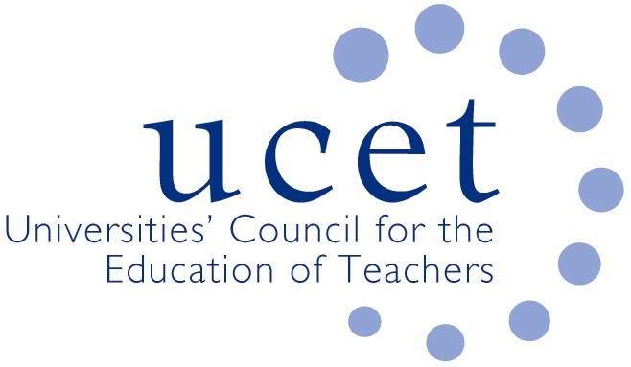
A Registered Charity (No 275082)

9-11 Endsleigh Gardens, London WC1H 0EH

T: 020 7621 6836
info@ucet.ac.uk

Promoting Quality in Teacher Education

Agenda for the meeting of the UCET Research and International Forum,
1pm, Tuesday 12 October, Via Zoom

There will be a morning symposium beginning at 10.30am. The topic will be the ’ ITE Market Review, including the engagement of ITE colleagues in research, and how to respond collectively to support education research in the new environment’. Speakers will include James Noble-Rogers and Gillian Peiser (LJMU)
To register for the symposium please click on the following link: https://www.ucet.ac.uk/13234/research-and-international-forum

- Welcome & introductions
- Minutes & matters arising
- UCET updates
- ITE Market Review and feedback from morning symposia:
- Topics for future symposia
- International issues:
  - iQTS consultation
  - DfE updates for international ITE students
  - Reports on international activities from forum members
- Horizon scanning and institutional feedback
- BERA systematic scoping review
- Equalities issues: update report from equalities sub-group
- Format of R&I forum meetings from January 2022
- Items for information:
  - UCET summer newsletter
  - 2-3 November UCET conference programmer
- AOB
- Date of next meeting: 18 January 2022
Background papers
- Minutes of the previous meeting
- DfE Market Review:
  - UCET response
  - UCET press notice
  - UCET correspondence with ministers
  - Summary of responses issued
- iQTS
  - DfE consultation report
  - Expert Group membership
- DfE updates for international students
- BERA systematic scoping review
- UCET Summer newsletter
- 2-3 November UCET conference programme

