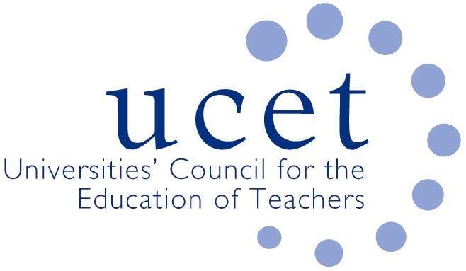
A Registered Charity (No 275082)

9-11 Endsleigh Gardens, London WC1H 0EH

T: 020 7621 6836
info@ucet.ac.uk

Promoting Quality in Teacher Education

Note of the meeting of the UCET CPD forum held on-line at 1.00 pm on Friday 26 February 2021

Welcome, introductions and minutes of the previous meeting

Colleagues were welcomed to the meeting. The note of the meeting held on 10 November 2020 was agreed. On matters arising:
- Feedback was given on tenders for ECF and NPQ roll-out, where it appeared that no HEIs had been successful in bids to be ECF lead providers. A number of colleagues were thinking of attending market review events for ECF deliver partners, although the financial sustainability of such work was open to question.
- The Institutional Pressures working group had decided to refocus its activities to concentrate on evidencing the value added through HEI involvement in teacher education. An update would be provided at the next CPD forum, with the possibility to devoting the first morning symposium of 2021/22 to its findings.
Discussion

A range of issues was discussed, including:

- An update from JNR on non-CPD related issues, including ITE placements; QTS assessments in the context of Covid; ITE course extension funding; and developments in Northern Ireland and Wales.
- A brief report of that morning’s symposium on international CPD opportunities and sustainability, which had been led by Rachel Lofthouse, Tracey France and Paul Vare. It was agreed that the topic for the next symposium would be on coaching and mentoring, with potential volunteers including: Rachel Lofthouse; Alison Fox; Jo Skelton & colleagues; Jen Carpenter; and Tracey France. Future symposia might cover: the work of the institutional pressures/HEI value added group; and CPD lessons from Covid 19.
- The UCET effective CPD paper. This would be a living document which would evolve over time and might in future cover funding for CPD, and the balance between school-wide and individual teacher driven CPD. It was suggested that the paper might inform the drafting of a BERA blog or series of blogs, and be the subject of presentations at the TEAN, IPDA, UCET and ICET conferences.
- The implications for CPD of the new Institute of Teaching and the DfE review of the ITE market. The IOT was to have a role in ECF and NPQ delivery, and could potentially have the authority to accredit ITE and CPD delivered by other, non-HEI, providers. The ITE market review could potentially impact on CPD if it affected the viability of university education departments. UCET’s strategy in relation to the IOT and market review was to continue to engage in discussions with DfE, while at the same time lobbying politicians and other influencers, drawing on the support of other organisations and publicly promoting the benefits of HEI involvement in teacher education. Key concerns in relation to the market review were a centrally defined ITE curriculum, which would prevent programmes from being contextualised and tailored to the meeting of particular needs, and the creation of tiered contracting arrangements which would be inconsistent with shared and flexible partnership working and might be financially unsustainable.
- Reports from forum members about current contexts and developments, including: applications and recruitment to CPD programmes, which was reported as being buoyant at some institutions, particularly for on-line provision, and for less formal CPD opportunities that might develop into more formal offers. Remote delivery allowed for a more flexible way of delivering CPD, with scope for shorter more focussed sessions. Strong uptake on SENCO training was reported by one institution.

Items for information

The December UCET newsletter was noted for information.

Any other business

None.

Date of next meeting

Tuesday 1 June 2021.

