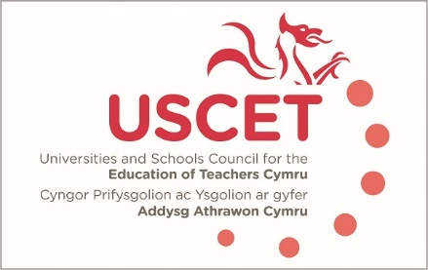

Agenda for the meeting of the University and Schools Council for the Education of Teachers (USCET) to be held on-line at 9.00am on Thursday 20 May 2021

- Welcome & introductions
- Minutes and matters arising
- Feedback from USCET working groups
- Reports from ITE providers:
  - Applications & recruitment
  - Covid 19 issues (placement availability, programme adjustments, student teacher assessments etc.)
  - Support for NQTs and continuing students in 2021/22
  - Welsh Government diversity monitoring
  - GCSE equivalencies
  - Partnerships and Central South Consortium: regional handbook to support ITE
  - Other issues
(10am, WG, Estyn & EWC colleagues join meeting)
- Reports from:
  - Welsh Government (inc. emerging ministerial priorities)
  - Estyn
  - Education Workforce Council
- Items for information:
  - Easter UCET newsletter
- Any other business
- Date of next meeting: tbc (on-line)

