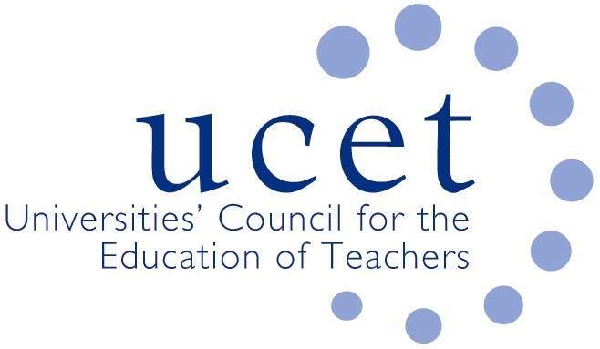

A Registered Charity (No 275082)

*Promoting Quality in Teacher Education*

**Minutes of the meeting of the School Reference Group held at 1pm on Wednesday 3 February 2021 via Zoom**

Present

Jake Capper (Marvel College)

Sean Cavan (SHU)

Max Fincher (UCET)

Richard Gill (Teaching School Council, item 1 only)

Julie Greer (Cherbourg primary)

Spencer Hennessy (Emmanuel College, SRG Chair)

Emma Hollis (NASBTT)

Jan Linsley (YITSA)

Nicola Lyons (Minster School TSA)

Kevin Mattinson, (BCU & UCET Chair)

Jackie Moses (UCET)

Margaret Mullholland (ASCL)

James Noble-Rogers (UCET)

Brian Rock (Ebor Hope TSA)

Emma Rodrigues (Yorkshire Rose TLA)

Di Swift (Keele & North Staffordshire SCITT)

Matt Varley (NTU)

Jenny Wynn (Bishop Grosseteste)

Andrew Young (Pathfinder TSA)

Apologies: Chris Buckley

Teaching Schools

Teaching School Council Chair Richard Gill was welcomed to the meeting. Those applying to be one of the new 81 Teaching School hubs (in addition to the 6 existing ‘test & learn’ hubs) had been informed of the results, and a public announcement was expected soon. The focus of the new hubs would be on teacher development with the intention of improving retention and quality. They were intended to have national coverage and would work with lead partners on ECF and NPQ delivery. Collaboration between hubs, schools and other partners would be essential to their success. The hubs would be supported by two TSC appointed experts – former ambition senior officers Melanie Renowden and Thora Eberts – during the start-up phase. The constitution of the Teaching Schools Council would be changed to reflect the new arrangements. It was hoped those schools losing TS designation would continue to be involved in ITE. The new Institute of Teaching was a separate development to that of teaching schools. The TSC position on the IOT was that it should: complement existing capacity and achieve additionality rather than compete; have clear published objectives and intentions to prevent misconceptions; and the research functions of the IOT needed to be clarified.

The following points were made during the discussion:

* Clarification was needed on whether de-designated teaching schools would need to undertake an exiting audit process.
* The recruitment of 1,000 ITE students by the IOT might imply a return to an allocations system and threaten the continued existence of some high quality providers (in response to a suggestion that some small SCITTS might already be financial unviable, it was pointed out by SRG members that decisions about viability should rest with the organisations themselves, and not with central agencies or government).
* The need for a market review of ITE was questioned given evidence about the quality of existing provision. The fact that some head teachers felt that not all NQTs were fully oven-ready, something that was common to all newly qualified professionals throughout the world, was not a sufficient reason to disrupt a highly effective system. Neither was it clear how any of the ‘solutions’ apparently under consideration would address any issues even if they were shown to exist. Evidence, not ideology, should drive practice and evidence should not be cherry picked.

Minutes of the previous meeting

The minutes of the meeting held on 14 October were agreed. There were no matters arising not already included on the agenda.

ITE market review & Institute of Teaching: Implications for the sector

Further details about the DfE review of the ITE market had been published on Saturday 2 January, although other than the names of Exert Advisory Group members little in the way of detail had been provided. UCET and NASBTT had met with the Chair of the Review group, as well as with senior officials and SPADs. No ITE providers had at the time of writing been spoken to, and requests for meetings had been rebuffed. Despite reassurances provided from some quarters, there was evidence that a contracting system under which ITE providers would have to bid for contracts from national agencies to deliver ITE curricula developed by other parties was a possible outcome of the review. This would it was noted be educationally unsound and financially unsustainable. The cost of the review and the establishment of the IOT was felt be morally unjustifiable in the current economic climate. The timescale for the review, with proposals to be published in the spring, was clearly not sufficient for genuine research to be conducted, options explored or meaningful discussions to take place.

UCET and NASBTT had issued statements, which appeared to have prompted DfE to widen the pool of people and organisations it was willing to discuss the review with. UCET had also invested a proportion of its reserves in the commissioning of a PR agency to advise and support the sector, and to help protect schools and teacher supply.

It was suggested that the focus of DfE’s teacher development activities should be on the provision of genuine professional support for new teachers and workload rather than on structural initiatives of this kind. Concern was also expressed about who would advocate on behalf of the sector and profession if ITE and CPD was all delivered through agencies operating under contractual relationships with government.

Covid 19 issues & recruitment to ITE

The following points on recruitment were made:

* Applications to ITE continued to be healthy. The upturn was not however expected to continue post-pandemic, and the retention of some of the additional recruits was likely to be an issue.
* The availability of school placements acted as a natural beak on recruitment.
* Changes to bursaries had had a negative impact on recruitment to English and geography, and had skewed some applications to subjects that attracted bursaries but might not be the best match for the individual concerned.
* SKE changes had made it more difficult for career changers with relevant experience to apply for some programmes.

On Covid 19:

* ITE was increasingly being delivered on-line, and in some cases this had been beneficial to the student teacher experience.
* The structure and timing of school placements had been adjusted in response to school closures and other Covid related issues. Some providers had moved to a single placement model, although the value of contrasting school experiences was acknowledged.
* Some programmes had been extended into the summer break.
* It was proving difficult to secure placements in some cases, and the position of students on undergraduate programmes was a particular concern.
* Where student teachers were in school, it was important that they received a genuine learning experience and were not treated as simply ‘another pair of hands’. ITE students were nonetheless a resource for schools and should be welcomed. The provision by students of one to one support for individual pupils was cited as an example.

Items for information

The group noted the:

* + UCET effective CPD paper
  + 2020 ITE census results
  + Note of consultative group meeting
  + SKE announcements
  + CCF exemplification resources
  + HMCI annual report
  + UCET December newsletter

Any other business

SRG members were invited to suggest contributions to the recent SEND resource/handbook for ITE providers. Interested colleagues should contact: [julie.greer@cherbourg.hants.sch.uk](mailto:julie.greer@cherbourg.hants.sch.uk) or [Margaret.Mulholland@ascl.org.uk](mailto:Margaret.Mulholland@ascl.org.uk).

Date of next meeting

19 May 2021, via Zoom.