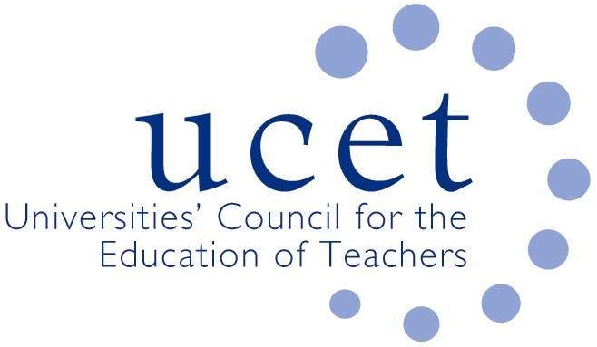
A Registered Charity (No 275082)

9-11 Endsleigh Gardens, London WC1H 0EH

T: 020 7621 6836
info@ucet.ac.uk

Promoting Quality in Teacher Education

The DfE review of the ITE market: the end of collegiality and the death-knell for teacher education?

The reports of the recommencement by DfE of a fundamental review into the shape and structure of the ITE market will be interpreted by some as a ‘slap in the face’ for a teacher education sector that has performed heroically in supporting schools through the Covid19 Pandemic at the same time as implementing the Core Content Framework and planning for the new OfSTED inspection methodology. More about the debt the country owes the ITE sector can be found in my September 2020 blog ‘ITE providers, the unsung heroes of the pandemic.’

The review, if the reports are correct, raises questions about the extent to which the more collegiate way of working that has developed between DfE and the sector in recent months might be coming to an end. Otherwise, why have organisations such as UCET and NASBTT been kept largely in the dark? Maybe DfE is only collegiate when it needs to be? Also, depending on the outcome of the review, it might lead to swathes of the ITE sector deciding that the game is no longer worth the candle and withdrawing from ITE (and, by implication, CPD and education research) altogether.

The government has reportedly referred to the need to weed out poor quality providers, and has claimed that ITE is not sufficiently research based. What evidence do they have for this? The answer is, none at all. In fact, they have plenty of evidence to the contrary. OfSTED has repeatedly found that the majority of ITE in this country is either good or outstanding. Does the government not trust the findings of its own inspectors? If they don’t trust them to make judgements about the quality of ITE, what about their judgements in relation to other sectors of education? And what of NQTs themselves, who when they were regularly surveyed were full of praise for their ITE programmes?

ITE is not of course perfect. We have been saying for years that only so much ground can be covered in sufficient depth on programmes that are in most cases only 9 months long. This and any other issues that do need to be addressed should be done so in a collegiate and professional way. That is how UCET has always tried to work.

The government has acknowledged that the boost in recruitment to ITE resulting from the Covid pandemic is likely to be short-lived. The structural reasons why the country is faced with periodic teacher supply problems will remain. Destabilising the teacher supply base at the current time would be nothing short of irresponsible.

The new ITE Core Content Framework has only been running for a couple of months. It is far too early to make judgements about its success or otherwise. The ITE sector has been working hard to implement the CCF. Some parts of the ITE sector welcomed the CCF. Others were more cautious. But it did allow room for interpretation, critical engagement and contextualisation. That is essential if the CCF is to work. The DfE must not confuse consistency with uniformity, or deny ITE providers and their partner schools freedom to interpret the CCF in a way that best meets their needs.

There have in recent times been a number of references made to reducing the number of accredited ITE providers. While it is true that the massive and unplanned expansion of School Direct in the years following the 2010 General Election did cause a lot of disruption and contributed to the teacher supply problems we face today (because rationed places were taken from providers that could fill them and given to those who could not), the case for reducing the number of accredited providers, as opposed to the number of organisations holding places (such as School Direct lead schools), has not been made.

But it may not need to be made. What the government appears to be considering could be the most destabilising thing that has happened to the sector for years. Anything that threatens the stability and autonomy of a sector that is already under significant pressure and could lead to many, possibly most, ITE providers (along with their partner schools) voluntarily withdrawing. That would be a disaster that we can ill-afford.

James Noble-Rogers
November 2020

https://www.ucet.ac.uk/12231/initial-teacher-education-providers-unsung-heroes-of-the-pandemic-september-29th-2020

