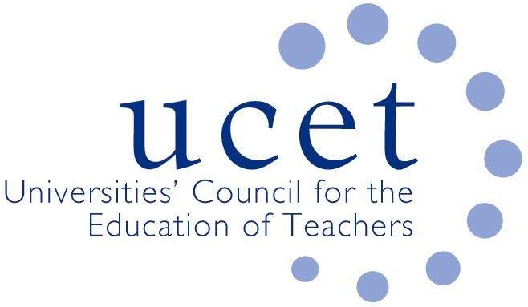
A Registered Charity (No 275082)

9-11 Endsleigh Gardens, London WC1H 0EH

E: info@ucet.ac.uk

Promoting Quality in Teacher Education

UCET’s deep concern about the likely destination of the DfE’s review of the ITE market

The Universities Council for the Education of Teachers (UCET) today expressed concern about the emerging direction of travel of the DfE’s review of ‘the ITT market. There are signs that DfE are heading towards recommendations that will have a huge and negative impact on both the quality of teacher education and on teacher supply.

Although the review group has been meeting since the autumn, much of its work has been shrouded in secrecy. To date not a single ITE provider has been consulted, although contact has been made with UCET and NASBTT. When news of the review group first broke in November 2020, a DfE spokesperson was quoted as saying that ‘’too much ITT was of low quality and not rigorously tied to the evidence’, despite there being no evidence to support that claim and plenty, from OfSTED and elsewhere, to demonstrate that the quality of ITE is extremely high. James Noble-Rogers said today: ‘It is almost as if the findings of the review are pre-determined, and based on unfounded assumptions, prejudice and dogma rather than on actual evidence’.

There is evidence that the DfE is planning to impose a strict and inflexible ITE curriculum. However, DfE appears to be confusing ‘consistency’ with ‘uniformity’. This would undermine the academic freedom of universities and would prevent all ITE providers from tailoring their programmes to meet the needs of different schools and local communities. This would go far beyond, and would in fact contradict, what was envisaged in the Core Content Framework for ITE, and in OfSTED’s new inspection framework where the importance of contextualising ITE to meet particular needs is recognised. DfE appears to be assuming that the CCF and the new inspection frameworks will fail to achieve their objectives even though they have only just been introduced.

The flexible and prompt response of the ITE sector to the Covid 19 Pandemic is testament to what the partnerships that currently exist between ITE providers and schools can achieve. This would not have been possible under a model of the kind that DfE may be considering. The DfE’s preferred approach to policy delivery in recent years has been through tendering whereby a small number of national providers are contracted to work with local delivery partners. Contractual relationships are by their nature inflexible and do not allow for shared decision taking, ownership or accountability.

James Noble-Rogers concluded that:

‘This is likely to trigger a number of unforeseen consequences. HEIs are currently involved in the delivery of more than 80% of ITE, and often recruit student teachers directly from their own undergraduate cohorts. Contracting models of the kind envisaged will be financially unsustainable. The imposition of prescribed curricula would undermine the very reason why many universities are involved in teacher education in the first place. It is extremely unlikely that many HEIs would be interested in being junior partners in the delivery of ITE programmes developed by someone else and would prevent them from providing intellectually robust and research informed programmes that will equip teachers to be thinking, questioning and reflective practitioners. This approach would destroy the teacher supply base, damage the quality of teacher education and would make England one of the few countries in the world without HE involvement in the way new teachers are educated and trained. That would do huge damage to the prestige of the teaching profession’.

[End]

UCET
26 January 2021

Contact: j.noble-rogers@ucet.ac.uk (07801 851 307)

Schools Week, 30 November 2020
HMCI annual report 2020

