19th January 2021

**Eligibility for SKE**

In December 2020 the Department confirmed, as part of the SKE package for academic year 20/21, that ITT candidates who have a degree in their chosen ITT subject awarded in the previous 5 years are not eligible for SKE. These candidates should have the required level of subject knowledge, or be able to top up their knowledge, without a DfE funded SKE course.

**The additional information below is to support ITT providers to assess whether a candidate is eligible.**

* An ITT candidate who has been awarded a degree that is a **direct match** to their chosen ITT subject in the previous 5 years is not eligible for SKE funding. Where the candidate has a **related degree that is not a direct match** the candidate could access SKE providing other eligibility criteria are met.
* The **‘previous 5 years’** is defined as the 5 academic years (AY) prior to the start of the current AY 20/21. For example, a candidate with a direct match degree awarded during AY 15/16 to 19/20 would not be eligible.
* The Department will be using JACS codes to determine whether a candidate has a degree that is a direct match to their chosen subject.  JACS codes are a recognized way of classifying academic subjects . We have been using JACS codes to record the JACS Principal Subject for SKE participants for several years and have expanded on this in the SKE claim form for AY 20/21 to include the JACS 4 digit codes . **Table 1** below sets out which JACS codes are considered a direct match for each SKE subject; **Table 2** shows an example of the full range of 4 digit codes that sit under a Principal Subject area (biology) and **Table 3** sets out a number of SKE subject examples.
* ITT providers are required to provide details of the candidate, including the candidates degree to the SKE provider in order for the SKE provider to make a claim. The claim form will allow SKE providers to select the JACS Group, JACS Principal Subject and JACS 4 digit code for each candidate. The form will flag if a candidate has a degree that is a direct match. If the SKE provider proceeds with the claim it will be rejected.

**Please note that SKE funding is only intended for participants who, without SKE, would be highly unlikely to meet the subject knowledge requirements of the** [**Teachers’ Standards**](https://eur02.safelinks.protection.outlook.com/?url=https%3A%2F%2Fwww.gov.uk%2Fgovernment%2Fpublications%2Fteachers-standards&data=04%7C01%7CKevin.Mattinson%40bcu.ac.uk%7C1437f7ae290e46af1e2f08d8b6fd8cbe%7C7e2be055828a4523b5e5b77ad9939785%7C0%7C0%7C637460547420961494%7CUnknown%7CTWFpbGZsb3d8eyJWIjoiMC4wLjAwMDAiLCJQIjoiV2luMzIiLCJBTiI6Ik1haWwiLCJXVCI6Mn0%3D%7C1000&sdata=Bes7EkW%2FJp30HT40tUzSNolrZ1TnhYFlC7YegsDhXM4%3D&reserved=0) **by the time their ITT course is complete.**ITT Providers should continue to assess each candidate on an individual basis taking into account the eligibility criteria for SKE set out on [**gov.uk**](https://eur02.safelinks.protection.outlook.com/?url=https%3A%2F%2Fwww.gov.uk%2Fguidance%2Fsubject-knowledge-enhancement-an-introduction&data=04%7C01%7CKevin.Mattinson%40bcu.ac.uk%7C1437f7ae290e46af1e2f08d8b6fd8cbe%7C7e2be055828a4523b5e5b77ad9939785%7C0%7C0%7C637460547420951539%7CUnknown%7CTWFpbGZsb3d8eyJWIjoiMC4wLjAwMDAiLCJQIjoiV2luMzIiLCJBTiI6Ik1haWwiLCJXVCI6Mn0%3D%7C1000&sdata=Th8P7L1ZxJpfnFMVlFDsmosGLc2NXBRcvBe%2BAxs41t8%3D&reserved=0).  All candidates have the opportunity to continue to learn and develop their subject knowledge during their ITT course. There should not be an assumption that candidates who have a related degree that is not a direct match to their chosen ITT subject need a SKE course**.**

**Examples**

**Table 1** below summarises which JACS codes are considered a direct match to each SKE subject.

|  |  |  |  |
| --- | --- | --- | --- |
| **SKE subject** | **JACS Group** | **JACS Principal Subject** | **JACS 4 digit code** |
| Biology | Biological sciences | (C1) Biology | (C100) Biology |
| Chemistry | Physical sciences | (F1) Chemistry | (F100) Chemistry |
| Computing | Computer science | (I1) Computer science | (I100) Computer science |
| Design & technology | n/a | n/a | n/a |
| English | Languages | (Q3)English studies | (Q300) English studies |
| Mathematics | Mathematical sciences | (G1) Mathematics | (G100) Mathematics |
| Modern languages | Languages | (R1) French studies | (R110) French language |
| Modern languages | Languages | (R2) German studies | (R210) German language |
| Modern languages | Languages | (R3)Italian studies | (R310) Italian language |
| Modern languages | Languages | (R4) Spanish studies | (R410) Spanish language |
| ***There are many languages covered in the JACS codes, a full list is supplied in the SKE claim form.*** | | | |
| Physics | Physical sciences | (F3) Physics | (F300) Physics |
| Primary maths | n/a | n/a | n/a |
| Religious education | Historical and philosophical studies | (V6) Theology and religious studies | (V600) Theology & religious studies |

**Table 2** below shows the full range of 4 digit codes that sit under biology. Biology ITT has a JACS 4 digit code of C100, so those who have obtained a degree that matches to C100 in the last five years would be ineligible for funding for a biology SKE course. Candidates with other degrees such as C111 Parasitology, C130 Cell Biology or C140 Environmental Bio could be eligible providing other eligibility criteria are also met.

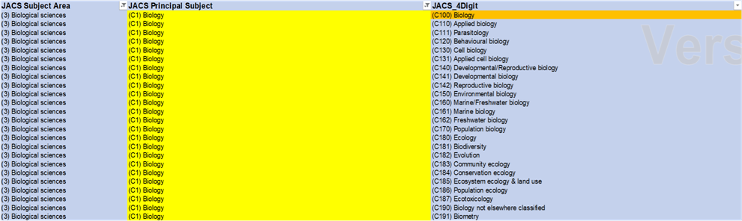

**Table 3** below sets out a number of subject examples

|  |  |  |
| --- | --- | --- |
| **Subject area** | **Example Question** | **Response** |
| Biology | Candidate has an Applied Biology degree obtained within the last 5 years and is applying for a biology ITT course. Are they eligible for a biology SKE course? | **Yes**. ‘Applied Biology’ is a different degree to ‘Biology’. As the candidate does not have a direct match degree, they could be eligible for biology SKE if other eligibility criteria are met. |
| Design and Technology | Candidate has a Textiles degree obtained within the last 5 years and is now applying for an ITT place on a D&T course. Are they eligible for a D&T SKE? | **Yes.** Candidate does not have a D&T degree and so could be eligible for a D&T SKE if other eligibility criteria are met. |
| MFL | Candidate has a Spanish degree which they obtained within the last 5 years and is applying for ITT  Spanish.  Are they eligible for SKE in both Spanish and in a second language? | **No**. The candidate is not eligible for SKE in Spanish as they have a direct match degree achieved within the last five years .  The candidate could be eligible for SKE in a second language subject provided they do not have a direct match degree in this subject achieved within the last 5 years and if other eligibility criteria are met. |
| English | Candidate has an English Language degree obtained within the last 5 years. Are they eligible for SKE in English? | **Yes.** ‘English Language’ is a different degree to English studies’ As the candidate does not have a direct match degree, they could be eligible for English SKE if other eligibility criteria are met. |
| Computing | Candidate has an Information Systems degree obtained within the last 5 years and is applying for a computing ITT place. Are they eligible for SKE in computing ? | **Yes**. ‘Information Systems’ is a different degree to ‘Computer Science’ As the candidate does not have a direct match degree, they could be eligible for Computing SKE if other eligibility criteria are met. |
| Primary Maths | Are there any degrees which would preclude a candidate from accessing primary mathematics SKE? | **No**. |