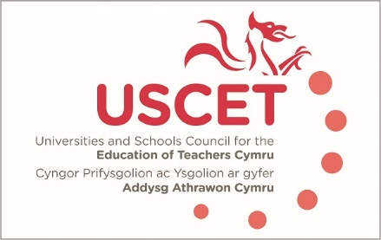

Agenda for the meeting of the University and Schools Council for the Education of Teachers (USCET) to be held on-line at 10am on Thursday 4 February 2021

- Welcome & introductions
- Minutes and matters arising
- Reports from ITE providers
- Covid 19 related issues:
  - ITE placements and days in school
  - Programme adjustments, including the provision of remote learning
  - Assessment of student teachers
  - Other Covid related issues
(11am, WG, Estyn & EWC colleagues join meeting)

- Covid policy issues:
  - Latest WG guidance
  - Feedback from USCET members & earlier discussions
- Reports from:
  - Welsh Government
  - Estyn
  - Education Workforce Council
- Items for information:
  - Minutes of previous meeting
  - December UCET newsletter
- Any other business
- Date of next meeting: 20 May 2021 (on-line)

Papers

Minutes of previous meeting
WG advice for ITE providers (if available)
USCET contingency planning survey results
UET December newsletter

