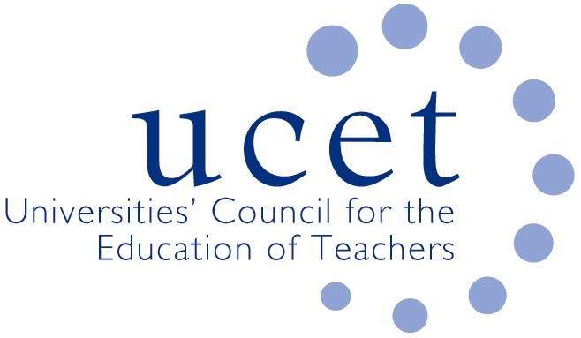
A Registered Charity (No 275082)

9-11 Endsleigh Gardens, London WC1H 0EH

E: info@ucet.ac.uk

Promoting Quality in Teacher Education

UCET statement on the DfE review of the ITE market and the Institute for Teaching

Market review

The ITE sector has behaved heroically during the pandemic and continues to make sure that schools have access to a steady supply of excellent new teachers. All objective indicators demonstrate that the quality of teacher education in this country is extremely high. For example, earlier this month HMCI reported that 100% of age-phase ITE partnerships in England were judged to be good or outstanding. Any plans to make changes to the highly effective system currently in place should be based on robust evidence. Change for the sake of change rarely leads to positive outcomes. ITE providers should be nurtured, not threatened.

We are not convinced that the case for a review at this time has been made. If the review is to go ahead, it must not be rushed and should take the sector with it. The highly effective teacher supply base we currently have, 80% of which involves HEIs as either lead providers or partners, must not be put at risk. ITE programmes must continue to have both academic and practical components. ITE providers and their partner schools must, within agreed national frameworks, have the freedom to develop curricula that can be tailored to meet the needs of particular schools, student teachers and local communities. A one size fits all curriculum would not work for anyone. Consistency is to be valued. Uniformity is not.

Institute for teaching

We do not see the case for investing a substantial amount of scarce public money in a new Institute for Teaching, especially in the current economic climate. The Institute will not lead to a net increase in new teachers as those recruited would simply be taken from existing high quality providers, potentially threatening their viability. Neither is there any evidence that it will improve the synergy between ITE and early and ongoing professional development, something which UCET has been arguing for years. UCET has developed a clear set of principles that should underpin effective and high quality ITE and CPD, and we would be happy to discuss this work with DfE in order to help them develop a more cost effective and intellectually robust way of achieving their aims.

UCET
2 January 2021

Contact: j.noble-rogers@ucet.ac.uk

