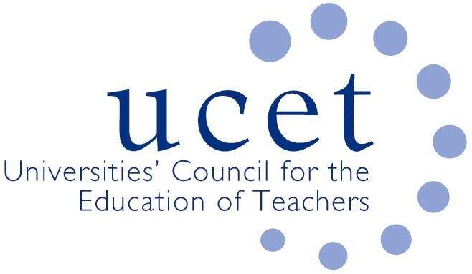
A Registered Charity (No 275082)

9-11 Endsleigh Gardens, London WC1H 0EH

E: info@ucet.ac.uk

Promoting Quality in Teacher Education

COVID 19: INSTITUTIONAL CONTINGENCY PLANS

Introduction

HEI teacher education providers have, since the beginning of the Covid 19 pandemic, been adjusting the design and delivery of their postgraduate and undergraduate programmes to ensure that student teachers are able to meet the agreed teacher competencies (following the approach in regards different competencies agreed by the taskforce) during ever changing circumstances and to ensure that as far as possible equity in terms of outcomes and quality of experiences are maintained. Contingency plans have been developed to address a range of different scenarios. Throughout the process, institutional plans have been shared and discussed across the sector in order to ensure a consistent, albeit not uniform, approach. Partner schools have been closely involved at all stages.

Common themes

Summaries of the different approaches taken by each of the HEIs are attached as an annex to this paper. Common themes and approaches include:

Engagement with schools & placements

Placements will take place as usual in school wherever possible, with priority given to postgraduate students and those coming towards the end of undergraduate programmes. The following measures will be taken when this does not prove possible:

- Securing alternative school placements if host partner schools are not able to host a student or students
- Securing placements in alternative educational settings other than schools, both on-line and face to face.
- On-line placements, delivering synchronous and asynchronous leaning experiences.
- Student teachers supporting pupils and groups of pupils remotely, either individually or in groups.

Assessment of student teachers

- Maintenance by students of portfolio of work and activities, with reflections on the work and activities and their relation to the teacher competencies.
- Ensuring wherever possible tutor visits to schools to observe students, although the frequency of visits might be reduced and organised within year group or subject bubbles.
- Remote observation of students, and remote engagement between mentors and students.

Programme content

- All student teacher activities mapped against the teacher competencies.
- On-line lesson planning, synchronous and asynchronous.
- A mixture of blended and face to face learning.
- Preparation of on-line resources for host schools.

Conclusion

The attached summaries are living documents and will be kept under constant review and amended, through proper consultation, as appropriate.

UCETNI
December 2020

