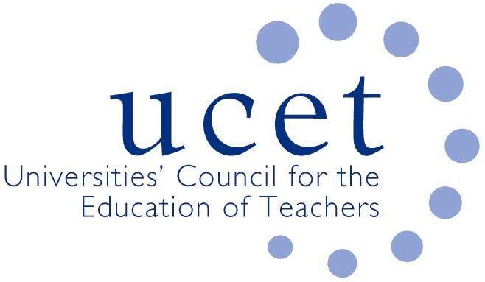
A Registered Charity (No 275082)

9-11 Endsleigh Gardens, London WC1H 0EH

T: 020 7621 6836
info@ucet.ac.uk

Promoting Quality in Teacher Education

UCET NI Committee

10.00am, Tuesday 29 September 2020

Via Zoom

Meeting notes

- Welcome and introductions

Chair -Roisin McPhilemy (Open University)
Linda Clarke (Ulster Uni)
Ann Heaslett (Stranmillis) (left at 11.30)
Martin Hagan (St Mary’s)
Jennifer Roberts (Queens)
David Barr (Ulster)

James Noble Rogers (UCET)
Jackie Moses (UCET)

- Minutes & matters arising.

May 19th event
- still postponed but will revisit

Covid updates
- Not much change and too early in year to assess impact on this year’s programmes/students.

- Covid 19:
  - Reports from member institutions (inc. placements)

Updates
St Mary’s – Martin Hagan – they have adopted a hybrid/blended approach, mixed with synchronous and asynchronous online work. Not sure how it will work, one early impression is that the wearing of face masks and lack of movement doesn’t make for a very pleasant experience.

PGs have secured school placement
UG not doing day school visits. Will start to look at block placement once this first week is out of the way. Lots of uncertainty but having to think creatively and laterally but nothing to report yet.
Seems partner schools are willing to have trainees as need additional help in classroom

Stranmillis – Anne Heaslett – they are now into their second week – similar approach to St Mary’s in that they are using a blended method. Priority given to first year students. All year groups have a part of the week face to face. They have left space for day visits on timetable for EYs PG placements, however, these are not currently taking place. Mixed message from schools, some are happy to have students, some feel that they now cannot cope, the situation being kept under review. They are seeing significant developments and innovation in approaches to online learning and this will form a significant part of staff development throughout the year. Almost certain that elements of online learning will remain.

Queen’s – Jennifer Roberts – they are into 5th week of PG programme. This week is a ‘quality online learning week’. They are currently working on getting placements organized for the cohort and are experiencing mixed feedback from schools (some schools do not feel have space in classroom for additional adult). Working closely with schools to try to understand the issues and come up with solutions.

They are generally finding that the student cohort is very engaged with different approach to teaching & learning.

Ulster – Linda Clarke – They are also teaching in a blended format; they have some recorded lectures and online synchronous teaching. Students seems very much engaged. Students being brought on campus in smaller groups. Working with schools to look at different approaches to observation and other ways of addressing some of the problems that are currently being encountered, especially in more modern schools where classroom appear to be smaller.

James Noble-Rogers – asked how HEIs were approaching Risk assessments
It was acknowledged that this is cumbersome, and a mammoth task in many ways. Would welcome any ideas to reduce this. Other concern is long and constant discussion with unions around this. The insurance position is also a difficult one but probably one that needs to be looked at a bit later once things settle down a little.

UCET are looking at holding an event on how to assess students if mentors are not allowed onsite, invites to this will follow

  - Letter from Department for Education to schools

A copy was enclosed with meeting agenda. It was felt that this was an encouraging letter and supportive of HEIs and work they do.
Important to keep eye on this and address any changes as they occur.

  - UCET summary of institutional plans

This were enclosed with the meetings papers and it was felt that this was a helpful and supportive document.

  - Feedback from 22 September meeting

Feedback from task group ITE provision for Student Teacher School Placements is delayed as the meeting on 22nd Sept meeting was postponed, this has now been scheduled for next week.

- UCET issues:

  - UCET strategy

The UCET Strategy has now been published and is on the website. It has been well received and draws on the work of IBTE.

  - 3-4 November UCET conference

The UCET Conference is on the 3rd & 4th Nov, it will be online, it was hoped that we would be able to have some live elements with some of the keynote addresses, but this is no longer possible.

  - UCET summer newsletter

The UCET summer newsletter has been included with meeting agenda

- Arrangements for NIHELG meeting

  - Learning Leaders Strategy
  - Competencies Work
  - IT Allocations
  - Induction of new teachers

- Date of next meeting
- 12th January 2021

