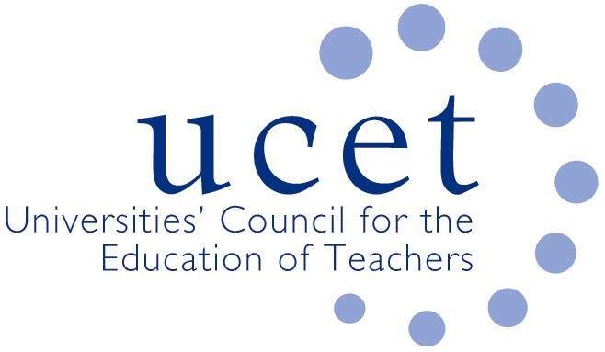
A Registered Charity (No 275082)

9-11 Endsleigh Gardens, London WC1H 0EH

E: info@ucet.ac.uk

Promoting Quality in Teacher Education

UCET 2020 DECEMBER NEWSLETTER

At the end of another challenging term and calendar year for the UCET community, it is perhaps time to look back and reflect on what we have achieved during the Covid 19 pandemic. Without the heroic efforts of the ITE sector, which demonstrated extraordinary levels of professionalism, adaptability and resilience, education throughout the UK would be in a perilous state. The contribution we made as a sector was set out in a blog published by JNR published in September, a copy of which can be found at: https://www.ucet.ac.uk/12231/initial-teacher-education-providers-unsung-heroes-of-the-pandemic-september-29th-2020-29-sep-2020
This has been recognised by officials and ministers. Let us hope they continue to do so in the months ahead during, for example, meetings on the re-instigated review of the ITE market about which DfE issued a holding statement in November. We will, with partner organisations, be monitoring the progress of the review carefully and would expect to be involved in proposals as they are being developed and not presented with them as a fait accompli. Care must be taken to ensure that the review does not undermine the stability and sustainability of the sector or prevent the development and delivery of academically-robust teacher education programmes that can be adapted to meet the varying needs of different communities, and provide (within agreed frameworks) a degree of choice to both partner schools and student teachers.

With the support of UCET members, we have continued to engage with statutory authorities across the UK. In England, we have been influential in discussions with DfE about the extension of relaxations made to the ITE requirements, where all those made in respect of 2019/20 (other than that relating to ‘trajectory assessments’) have been carried forward into the current year. Details of the current requirements can be found at: https://www.gov.uk/government/publications/initial-teacher-training-criteria/initial-teacher-training-itt-criteria-and-supporting-advice
Guidance on the implications of rules about students returning home for Christmas for final year undergraduate and postgraduate ITE students, which UCE pressed for immediately the policy was announced, were finally published on 24 November (a long time after the corresponding statement for Wales) and can be found at: https://www.gov.uk/government/publications/higher-education-reopening-buildings-and-campuses/student-movement-and-plans-for-the-end-of-autumn-2020-term#exemptions.
Other discussions with DfE (in addition to regular updates) have covered: the development of a new international PGCE qualification; the recognition of overseas teacher qualifications; ITE funding; diversity & equality issues; student support; ITE placements; and resources to support the development of curricula related to the new Core Content Framework which, as you will recall from its introductory statement, is intended to be something that can be delivered flexibly and approached from an appropriately critical angle.

Recruitment to ITE in 2020/21 and applications for 2021/22 are, as expected, buoyant because of the coming recession, and UCET members have done an excellent job processing large numbers of applications and developing new and innovative ways of interviewing prospective students and processing applications. However, as even the government recognises, the impact of Covid 19 on ITE recruitment is likely to be short-lived, and the underlying reasons why we are faced with periodic teacher supply problems remains. That is why UCET objected to reductions in bursaries https://www.tes.com/news/exclusive-teacher-training-bursaries-cut-50 and SKE funding as being short term and failing to take account of longer term needs. JNR was pleased to advise NFER on its recent report on the impact of Covid 19 on recruitment to ITE https://www.nfer.ac.uk/media/4143/the_impact_of_covid_19_on_initial_teacher_training.pdf.

On the post-compulsory front, following discussions between DfE and UCET, it seems likely that long standing issues about the eligibility of students on in-service PCET programmes to student loans, particularly in the Huddersfield area, have been resolved. Discussions have taken place with the Education & Training Foundation about possible revisions to the DET criteria in the light of the pandemic. JNR was pleased to represent UCET members on the ETF’s ITE forum, and both JNR and Post 16 Chair Karen McGrath are pleased to have been invited to attend meetings of the Trailblazer group to discuss revising the current occupational standards for teaching in the FE and learning & skills sector. JNR was also delighted to attend two meetings of Huddersfield’s PCET partnership.

The holding of UCET meetings on-line has continued to work well, and attendance at forums and symposia has increased. We have also been able to hold more ad-hoc meetings, for example on how to quality assure ITE remotely and on risk assessing student placements. The UCET conference, which had a record attendance, was also held via Zoom. We are very grateful to Andy Goff and his colleagues from ONVU Learning for their invaluable technical support, and to keynote speakers: Ian Menter (Oxford) & Jo Helgetun (UC Louvair); Mark Boylan (SHU); Joseph Mintz (UCL) & Peter Hicks (MMU); Paul Howard-Jones (Bath Spa); and Jo McIntyre (Nottingham) & Clare Brooks (UCL) and to everyone else who contributed and made the event such a success.

In Wales, JNR and USCET colleagues have been in regular contact with Welsh Government to discuss the delivery of ITE programmes during the Pandemic. We have carried out a survey of the contingency plans that members of USCET are putting in place, and we have been negotiating about programme adjustments, recruitment issues and support for students not on a trajectory. In Northern Ireland, a cross-sector Task Force has been established, which includes JNR and representatives of each UCETNI member institution, and has been giving careful consideration to placement and student assessment issues. JNR also attended a meeting with the Northern Ireland Education Minister Peter Weir to discuss the funding of SCoTENs. Jackie Moses continues to represent UCET at meetings of the Scottish Deans of Education, and JNR was pleased to have a meeting with the group’s Chair, David Smith.

In early December, UCET hosted a meeting from representatives of key players across the education sector to consider what, from a blue-skies perspective, the ideal content, structure and delivery of teacher education (ITE and CPD) should look like. The meeting was a success and we hope that there will be more to come. The discussions were informed by the work of the Intellectual Basis of Teacher Education Group, the conclusions of which are also reflected in the new UCET strategy for 2020-25 which can be found at: https://www.ucet.ac.uk/11742/ucet-strategic-plan-2020-2025-template
The December meeting also drew on a paper produced by a sub-group of the CPD forum on the content, structure and delivery of CPD programmes, a copy of which is at: www.ucet.xxxxxx. Also on the CPD front, a sub group has been meeting to discuss the internal institutional pressures facing CPD colleagues within education departments, and UCET facilitated a meeting for members to discuss possible involvement in an ECF national roll-out bid.

Covid 19 is also having an impact on the carrying out of education research. While in the short term this is perhaps understandable, going forward the importance of education research cannot be overlooked. We have been in contact with Universities UK about the issue, and have shared with them the recent UCET IBTE and Building Research Informed Teacher Education Communities papers, as well as the results of a snapshot survey into the impact of Covid on research which is available at: www.ucet.xxxx. A sub-group of the Research & International Forum was established to consider Covid related issues, and another new sub-group has also recently been set up to consider equality and diversity.

We are pleased to announce that, since the last newsletter, the following people have been co-opted as members of the UCET Executive Committee: Caroline Daly (UCL); Vini Lander (Leeds Becket); and David Littlefair (Northumbria). They are all welcome and we are very lucky to have them on board.

Wishing you all as happy a Christmas as possible, and we look forward to meeting you all face to face next year.

UCET
December 2020

