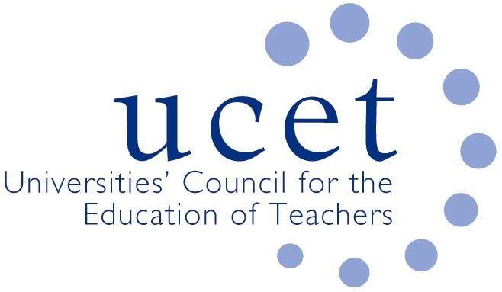
A Registered Charity (No 275082)

9-11 Endsleigh Gardens, London WC1H 0EH
info@ucet.ac.uk

Promoting Quality in Teacher Education

Initial teacher education providers: unsung heroes of the pandemic

The Covid 19 epidemic has created unprecedented challenges for all sectors of education. Early years settings, schools, further education colleges and universities have all excelled themselves and done the individuals and the wider community they serve proud. These efforts have been lauded by pretty much everyone, other than of course the usual professional naysayers.

But there is one essential part of the education sector whose efforts have been largely ignored. This is the teacher education sector which has managed to supply the country with the brilliant teachers that it needs in spite of the enormous challenges it has faced in recent months.

By way of context, accredited teacher education providers such as universities and SCITTs supply the UK’s schools and colleges with tens of thousands of new teachers every year. According to all objective indicators, from formal inspection reports to surveys of student teachers and NQTs themselves, the quality of teacher education is extremely good. Add to this the contribution many providers make to the early and ongoing professional development of teachers, to education research and to policy development and implementation, it is clear that we have a sector worthy of celebration.
With the closure of most schools from March onwards, ITE providers and their partner schools and colleges performed magnificently in developing new and innovative ways of preparing new teachers. With traditional school placements no longer available, on-line and digital learning came to the fore. Robust and reliable ways of assessing student teachers against their trajectory towards qualified teacher status were developed and shared across the sector through organisations such as UCET and NASBTT. Alternative approaches to recruiting new student teachers and assessing their potential were developed, made even more challenging by the surge in applications to teacher education programmes in 2020/21 following the outbreak of the pandemic. Direct support was given to those schools that remained open and to those providing remote learning. And student teachers themselves needed to be nurtured, reassured and given increased pastoral support.

With the partial re-opening of schools in September came new challenges. School placements had to be secured, often from schools that were sometimes initially nervous about having additional adults on the premises until they realised the huge contributions that students can make, and until the critical worker status of student teachers was confirmed. ITE programmes had to be re-conceptualised, making use of the welcome flexibilities made to the ITE requirements in some parts of the UK and drawing on the collective expertise of providers, schools and colleges. Risk assessments to keep student teachers safe in a huge variety of different placement contexts had to be developed and kept under constant review. Arrangements to support students in the event of local school closures had to be drawn up. And at the same time, the sector had to prepare for the introduction of a new ITE core content framework and a new inspection system, both of which would at any time have been hugely demanding. These initiatives should of course have been delayed to allow ITE providers, schools and colleges to focus on more pressing concerns. But they are (currently) both going ahead and the sector is, as one would expect, responding professionally and collegiately.

Those graduating in 2019/20 and 2020/21 and taking up posts as NQTs will be some of the best ever. They will have skills and experiences that will be of particular benefit to schools and colleges in these difficult times, not least in terms of remote learning, adaptability, resilience and resourcefulness. Most of the credit for this goes to the student teachers themselves. But ITE partnerships, and those who support them, deserve some praise as well. The ITE sector should take a bow.

James Noble-Rogers

Executive Director
UCET

